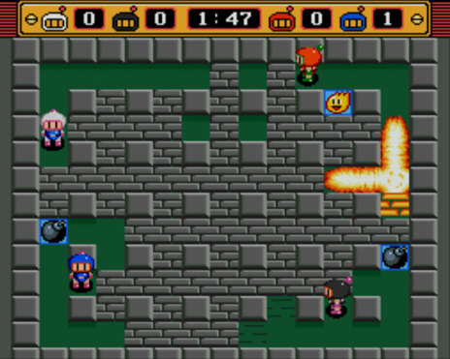

[3]

# **Project Analysis**

## Project Proposal

For my project, I want to recreate an old school version of the game Bomberman in python. When looking into this, there are not many 2D versions of this game which allows the older versions of Bomberman as seen back on the Super Nintendo Entertainment System (SNES). For my project, I want to make a 2D version of the game which will, at first, allow 2 players to battle it out in a small arena. In order to do this, I will use pygame and the project will be object oriented.

Once the arena is created, I will add two objects (players) which will be encoded to enable them to play bombs, pickup power ups and move around the map. The power ups, which will also be objects, will have a random chance of spawning underneath each of the brick blocks. These are then easily picked up by a player simply running over them. The power ups then improve and enhance a player’s ability to win the game.

The objective of the game is simple – last player standing wins. . The aim is to be the first to win 3 rounds and this is done by hitting another player with the explosion of a bomb. The rounds will be 3 minutes long and if the players do not finish the round in the given time, the walls will begin to close in by slowly filling in the empty spaces, circling around the edge and moving inwards. Only certain blocks will be destructible, and this will be seen by the blocks with the design which is in a brick format. The map design is going to begin with a 15x13 grid in which there is a clear evidence between the breakable and non-breakable blocks around the map.

To begin with, I will stick to keeping the design simple. However, after creating the first basic design, there are many optional extras which I could add. One of the biggest improvements I could make is making the game connectable over LAN. This would make massive improvements to my game as it would allow many more players to connect and play. However, in order to be able to make this, I would first have to add in the option to have up to 4 players – another possible improvement I could make. Two other ideas I could implement are a computerised opponent with one set difficulty to begin with and making an alternative map which would allow the user to choose which map they would want to play. If all the improvements are added, the prime end result would be a game with 4 players, across a LAN connection, which has a computer player option and a choice of multiple maps. These maps may not only be set design, but it is a possibility that the maps could be randomised to make a dynamic design which will further enhance the games capability and allow it to show a higher quality game

## Agile methodology

When creating my game, I will use agile methodology in order to create my project. This will mean I can go back and revisit all my code over and over in order to improve and ensure my code functions properly aswell as being efficient. I must keep going back to review my original plans to guarantee that I am creating the project which I want and make certain that criteria will be wholly satisfied. It also means that I can go back to review and improve my design when I begin the creation of my project. This is useful as I may find further information which would guide my project, making it better suited and more appropriate for the criteria I am aiming to accomplish. I will not be using the waterfall methodology as requires a more structured design and one specific end result which can only be achieved through one method. In this method, each module will just be created then the programmers will move on. This means the original idea is set then the programming team would just create that and move on to testing and so on. From this I can see that waterfall methodology would not be as useful to me, resulting in agile methodology being the best way to create my project. Time efficiency is also very important. I feel that deciding to use the agile methodology allows me to create an original idea which I can begin to create but also improve at the same time in order to get an end result with a much more organised time structure giving me more hours to improve later on in the project.

## End users

### Project Sponsor

My project sponsor is my teacher – Fred Salle. He is a former IT technical project manager and a professional member of the BCS. Throughout the project he will be able to give me guidance and monitor my progress. This will be extremely beneficial as it will allow me to achieve the best outcome and provide him with my finished piece.

### Classmates

One of my most useful end users will be my classmates. This will be one of most beneficial end users to me as they will be able to give me instant feedback. Also, they will show more interest in the game as it has been made by one of their friends so it becomes more relevant to them. Furthermore it will be a game that they can play against their other friends allowing them to enjoy the game and see how it meets the criteria.

### Nostalgic Game Players

Many people play games nowadays for the nostalgia. This is why I feel that my game will be enjoyable as it is an old classic – the original Bomberman being brought out in 1983[[1]](https://en.wikipedia.org/wiki/Bomberman_(1983_video_game)). This means many people would want to play the game with their friends as they used to play it as a child. The reminder of these happy days from their youth would make the game much more fun for anyone who remembers the old games.

## 5 aims

1. Dynamically create power-up drops
   1. A power up will be randomly generated when a destructible brick block is destroyed. There will be 4 power-ups these are bomb increase, destruction increase, roller blades and boots.
      1. **Bomb increase** – When picked up, this power up gives the player an extra bomb allowing the player to drop multiple bombs at once
      2. **Destruction increase** – When picked up, lengthens the destruction range of the bomb by 1 block to a limit of 6 blocks.
      3. **Roller Blades** – When picked up, increases the speed of the player by 1 to a limit of 8.
      4. **Boots** – When picked up, allows a player to walk in to bombs and ‘kick’ them, sending the bomb in the direction of movement until reaching a block.
2. Allow two users to simultaneously use the keyboard to play against each other
   1. This will be the two players who spawn either side of the map. Player one will be controlled using WASD and bomb placements using spacebar. Player two will use the arrow keys and enter to drop bombs.
3. Create a login which allows players to securely make an account on the game.
4. Create a menu which enables me to access different functions such as and login screen and play game.
5. Create a LAN connection which would allow two players to play against each other on different screens.

## Academic Research (3 previous solutions)

The aim of my project will be to solve the lack of 2D battle games with an arena (like my design) available. There have been a few attempts to solve this deficiency, however there is yet to be any successful efforts. I have gathered three clear examples of efforts to create these games which have shown clear room for improvement and therefore handed me the idea to make my own attempt.

### Bomber Blast

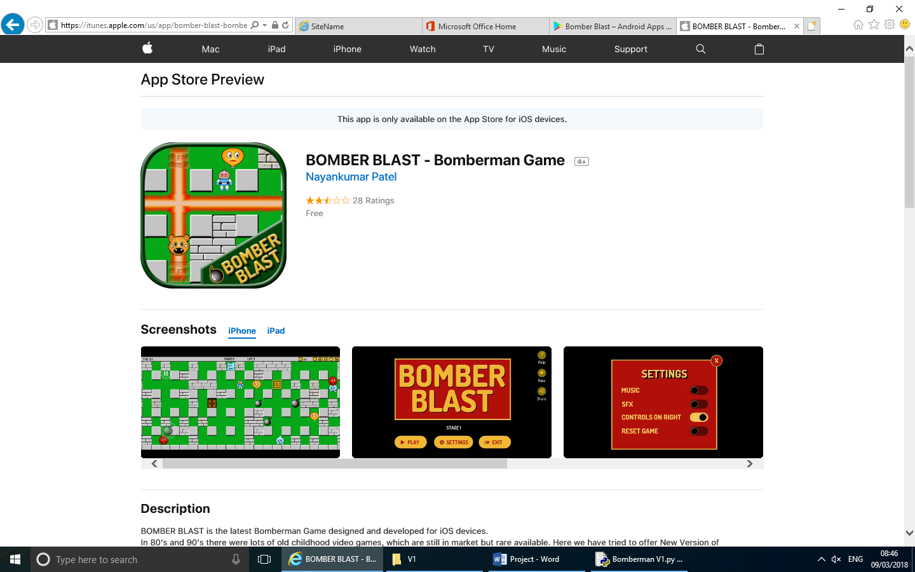

[4]

Bomber blast is a basic 2D PvE game which allows a player to fight through missions in a Bomberman-style fashion against a slowly increasing difficulty of enemies. It is available on iOS and android and is free on the apple and google play stores.

When first opening up the game, the start-up screen was a simple, but bold design providing me with a first impression that the game was going to have simple but well thought out textures. However, when I began to play the game, the design just used block colours and the stages stuck with the same level design through all levels. This meant that the game began to get very tedious and not as enjoyable due to the lack of variation.

A further noticeable issue with the game was the amount of ads that appear when playing. Each time I start up the game, there is a 30 second advert with there often being one once I then start up the level. Moreover, in the game, whenever you pick up an extra time power up, it results in the game pausing to play an advert aswell as an ad being played when you die. It is evident that there are too many ads which make the game almost unplayable and from a user’s perspective can look like the creator has only made the app with the intention of gaining money.

The controls are seemingly very simply. In order to move, just touch the screen and drag in the desired direction then tap to place a bomb. Although these are very basic and regularly controls, within bomber blast, there are some slight problems. While moving, the game is rather unresponsive and a player can begin to unintentionally move in the wrong direction when trying to move or place a bomb. This can cause a lot of frustration and may deter people from playing the game.

Overall, I feel that this game includes a lot of bugs and there are many areas of improvement that can be made. A reduce in ads would need to be seen, aswell at an alternative stage/map. Afterwards, a simple patch would be required to fix the controls. However, despite these issues the game is still enjoyable and has therefore advised me to create my game as it will address the issues to create a game which will hopefully have no bugs and will also be fun for people to play.

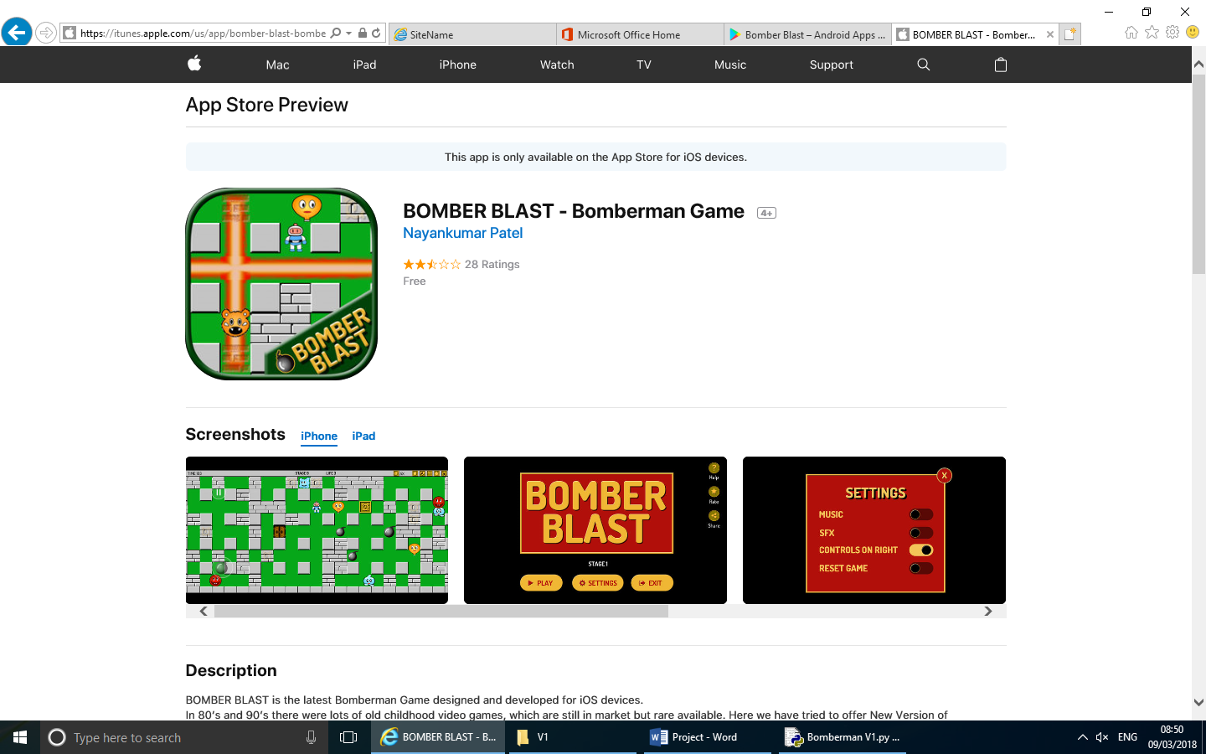

[5]

### Game of bombs

[6]

Game of bombs is an online enlarged Bomberman – style game. It allows multiple players to play on an extremely large map. This is a game which is created to allow many players to compete against each other all at the same time across the internet. Many features of the typical Bomberman game exist in this – a typical destructible map, powerups and player vs player bombing.

One of the main advantages of the game is its efficiency to function with multiple players and bots in the map. This means that a player can enjoy this enlarged map as there are many players as well as respawning meaning you can just keep playing until the times up and you don’t have to sit and watch until the start of the next round. This makes the game more enjoyable for players who tend to die more regularly.

### Bomb Tag

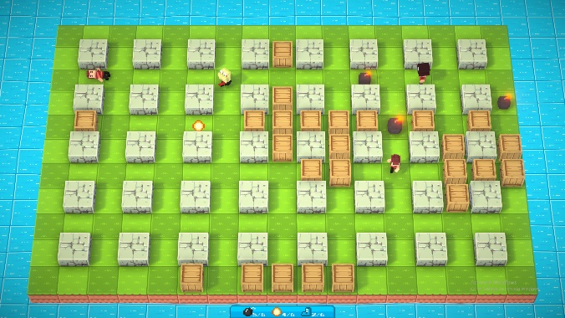 Bomb Tag is a free game on steam which is runnable on almost all computers. It is an online game which creates fast aced rounds. There are a variety of maps to be played on which allows the game to be more diverse. There are two different biomes – snow and grass – with each one having 3 different designs (A, B, C). Once in the map, there can be u to 8 players with each player being able to grab power-ups once in game. There are 3 different types of power-up – extra bomb, bomb range and speed boost. When picked up, these increase your chances of winning massively.

[7]

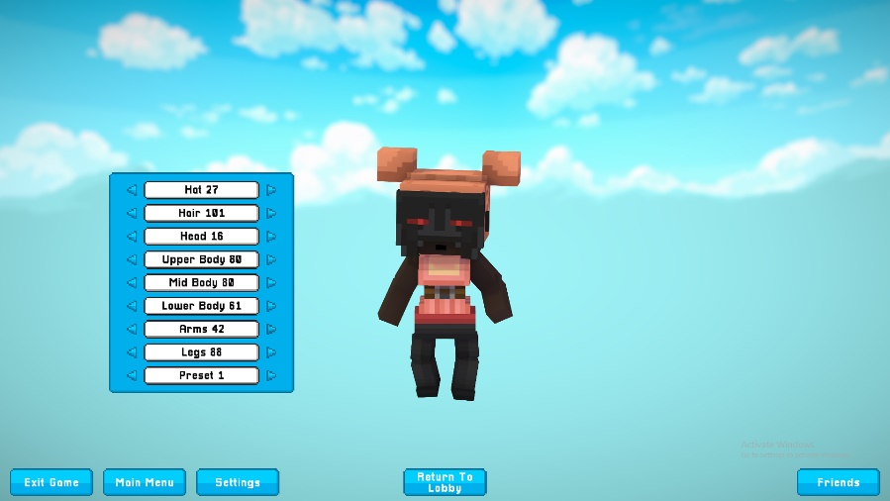Furthermore, bomb tag has a player customisation page which has 8 different areas on your person that can be customised. There are a wide range of outfits that can be worn, however only some are free. The rest can be achieved through buying a player customisation pack. This idea has influence me into thinking a map editor/customisation would be a good plan as it would allow players to add their own take into the game.

[8]

## Copyright images

Due to my game being a take from the original Bomberman, I will require the use of the Bomberman players meaning I will have to use some copyrighted images. To comply with the copyright laws, I will ensure that my project is never used publicly and that all images used will be done so for academic purposes only.

## Hardware / Software

My project will require a computer with a connected keyboard and monitor. A laptop may also be adequate. This will be the only hardware that I require. In terms of software, I will need python 2.7 and pygame inside of python. It will also require a minimum of Windows 7 operating system. This will allow me to create my object within the game and allow me to use certain keys to move certain ways or control the player to do specific actions.

## Survey

I completed a survey in order to gain feedback on a couple of areas which I wanted to be able to see the best ways for me to work on and improve my project. I sent this out to classmates and peers outside of college. I received 11 responses which I have then viewed in a chart format, allowing me to see where I should develop my game primarily.

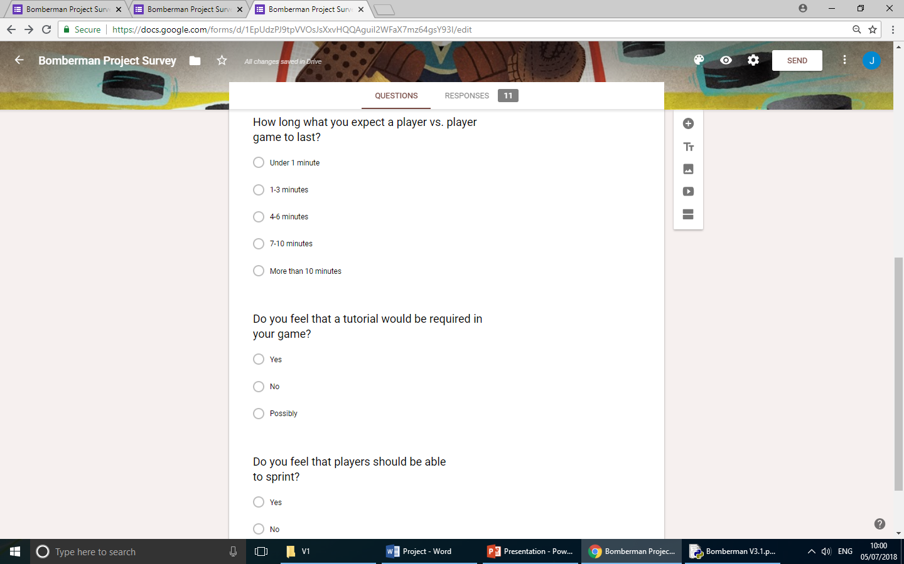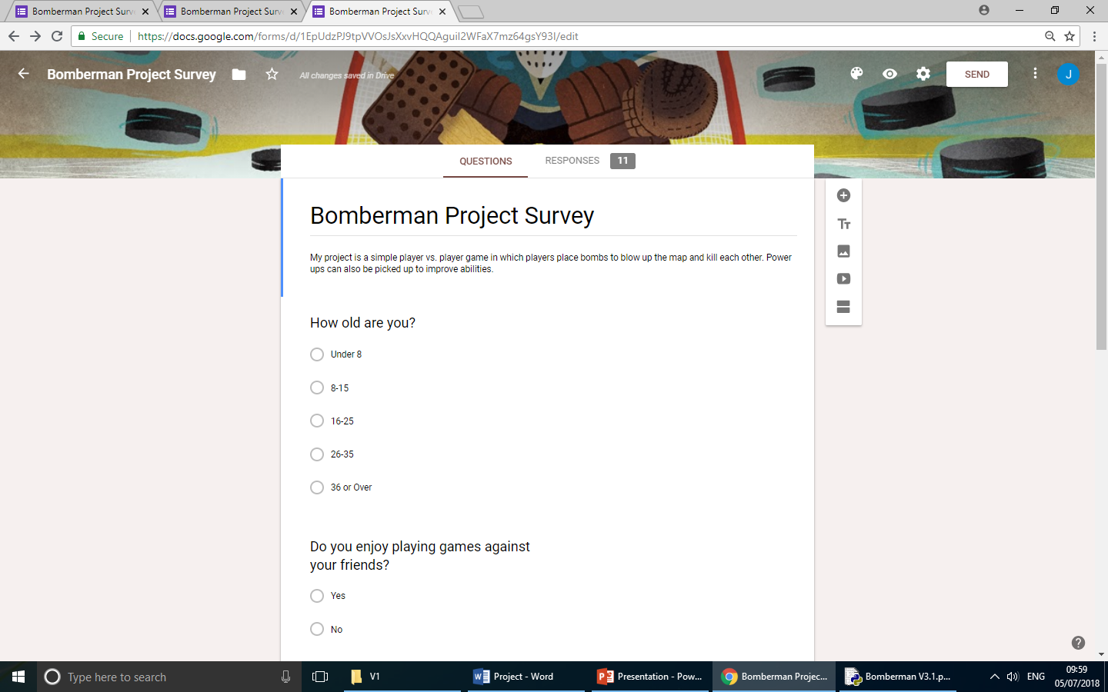

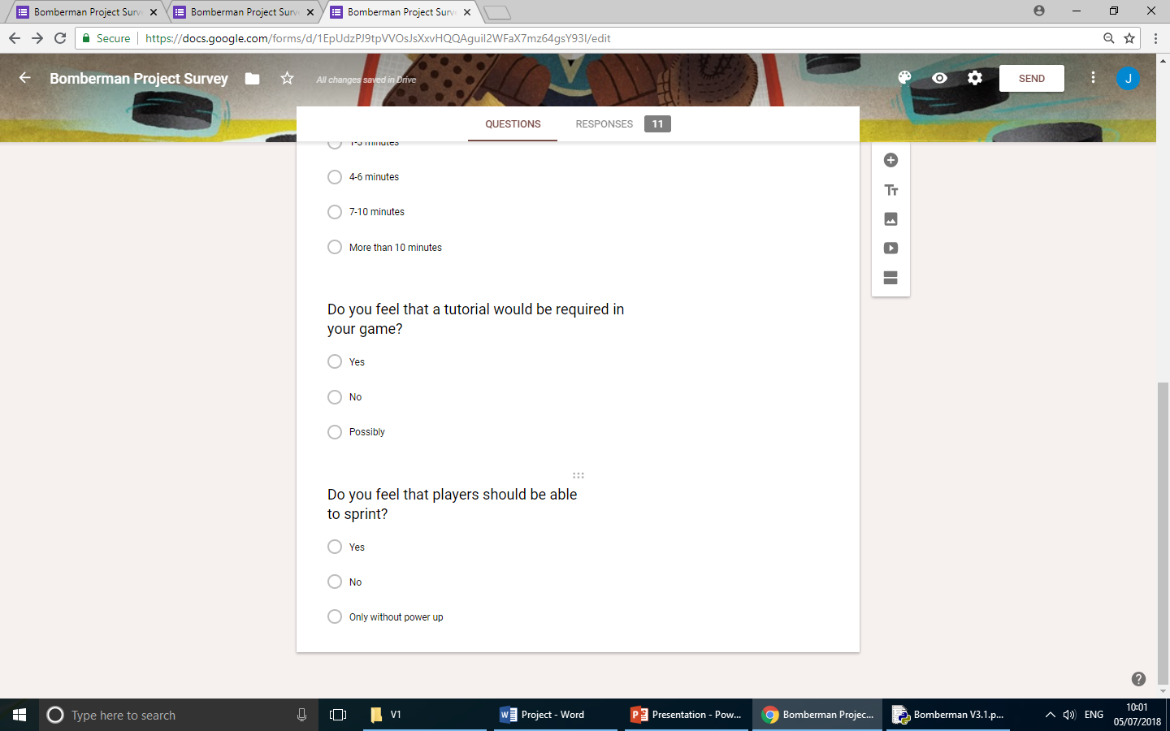

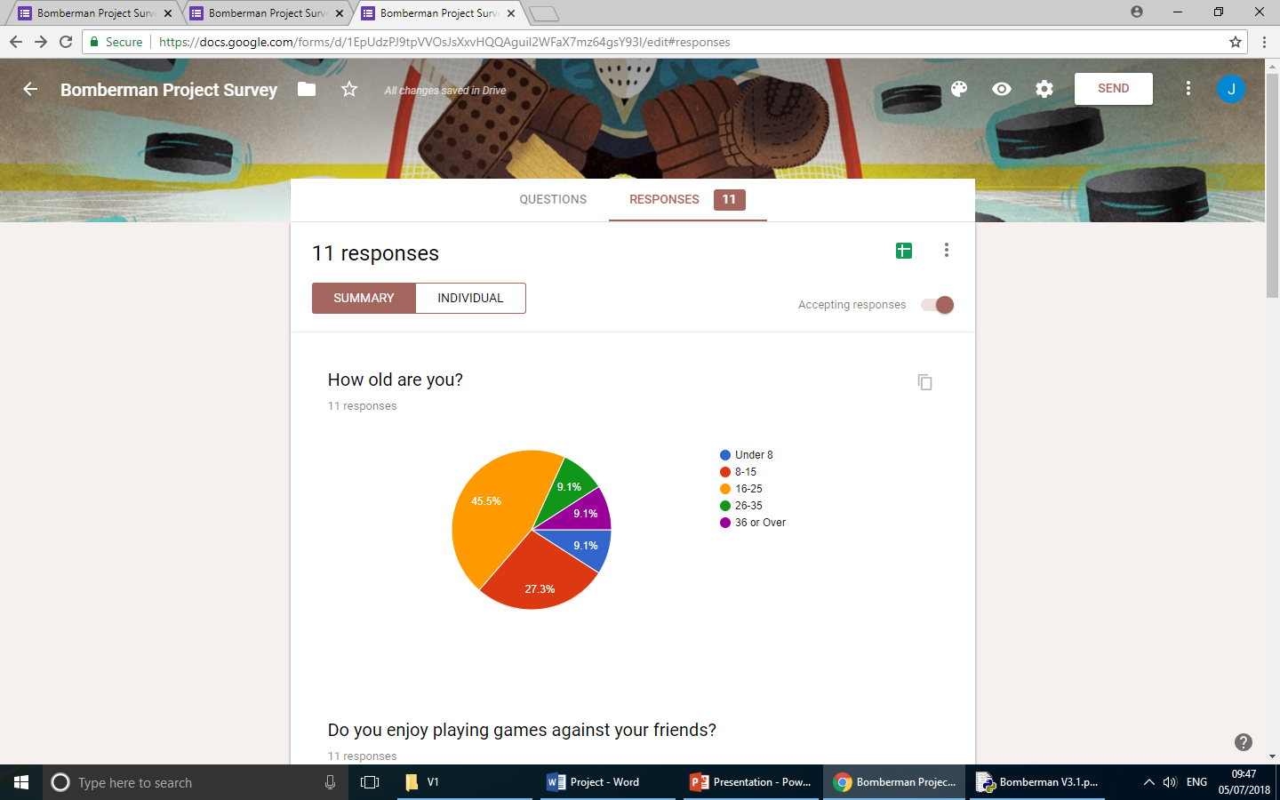

From this question, I wanted to see what target audience I am reaching mostly. This makes it easier to see which people I will be aiming my improvements to satisfy.

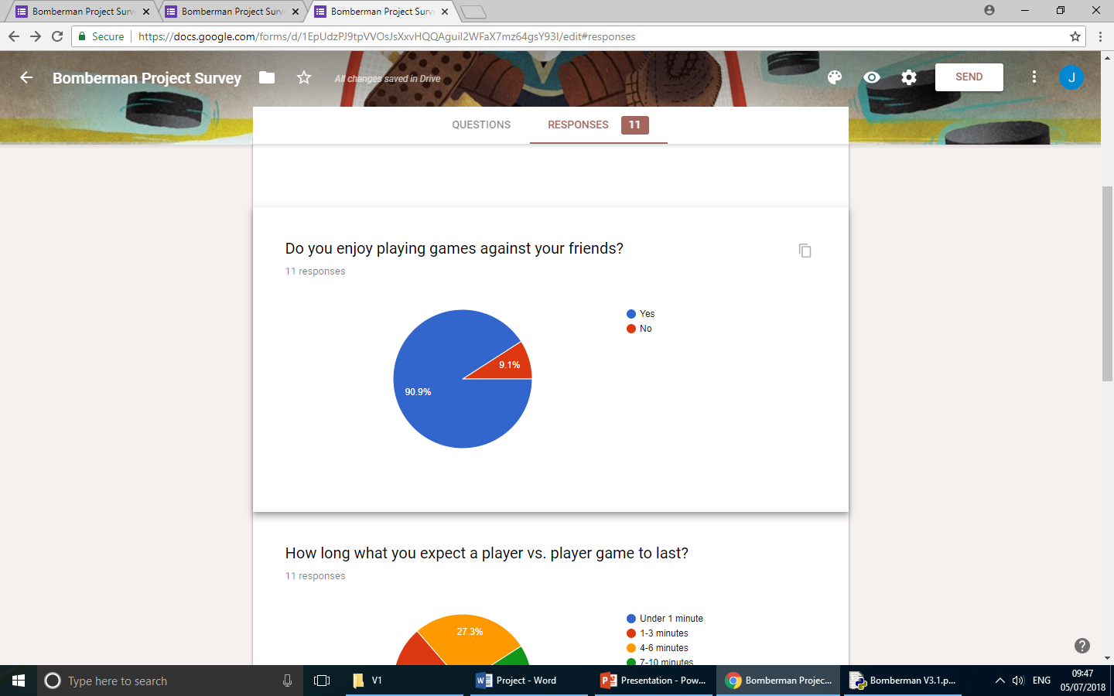

My survey showed me that it would be best to make my game player vs. player. This means it is not as important for me to add a computerised players as I originally though.

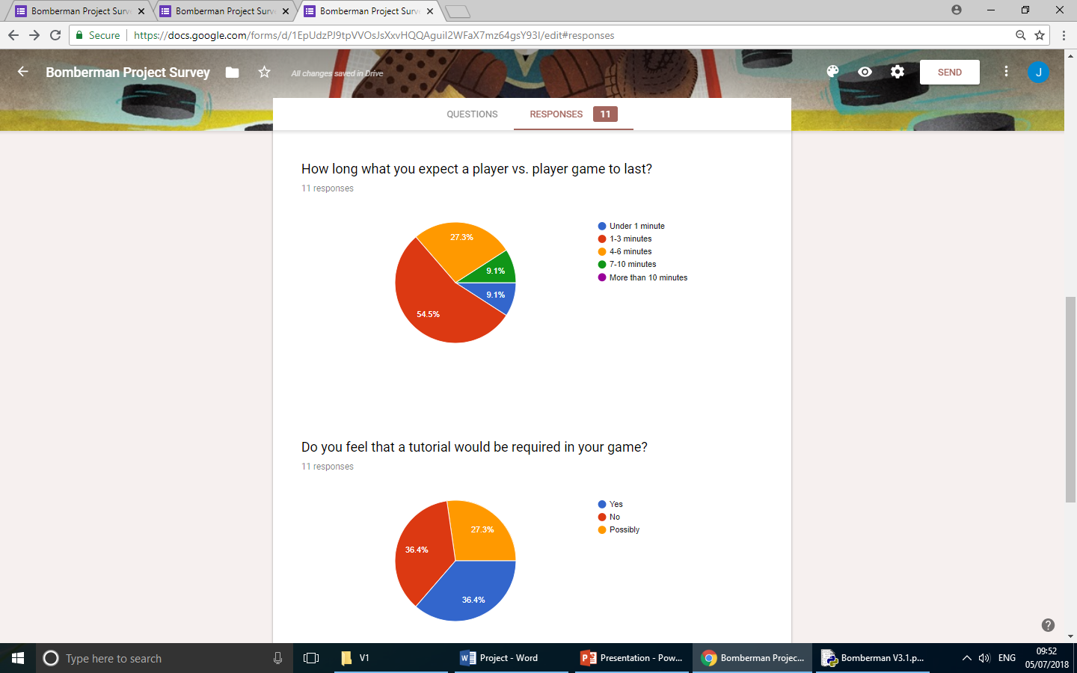

From this question, I found that the best time for me to make my game would be around 3 minutes long.



As my game is quite simple with basic controls, I was uncertain on whether I should add one or not. From the survey I can see that there is no definitive result gained, therefore I will not prioritise adding a tutorial, but I can possibly add one at a later stage of my game.

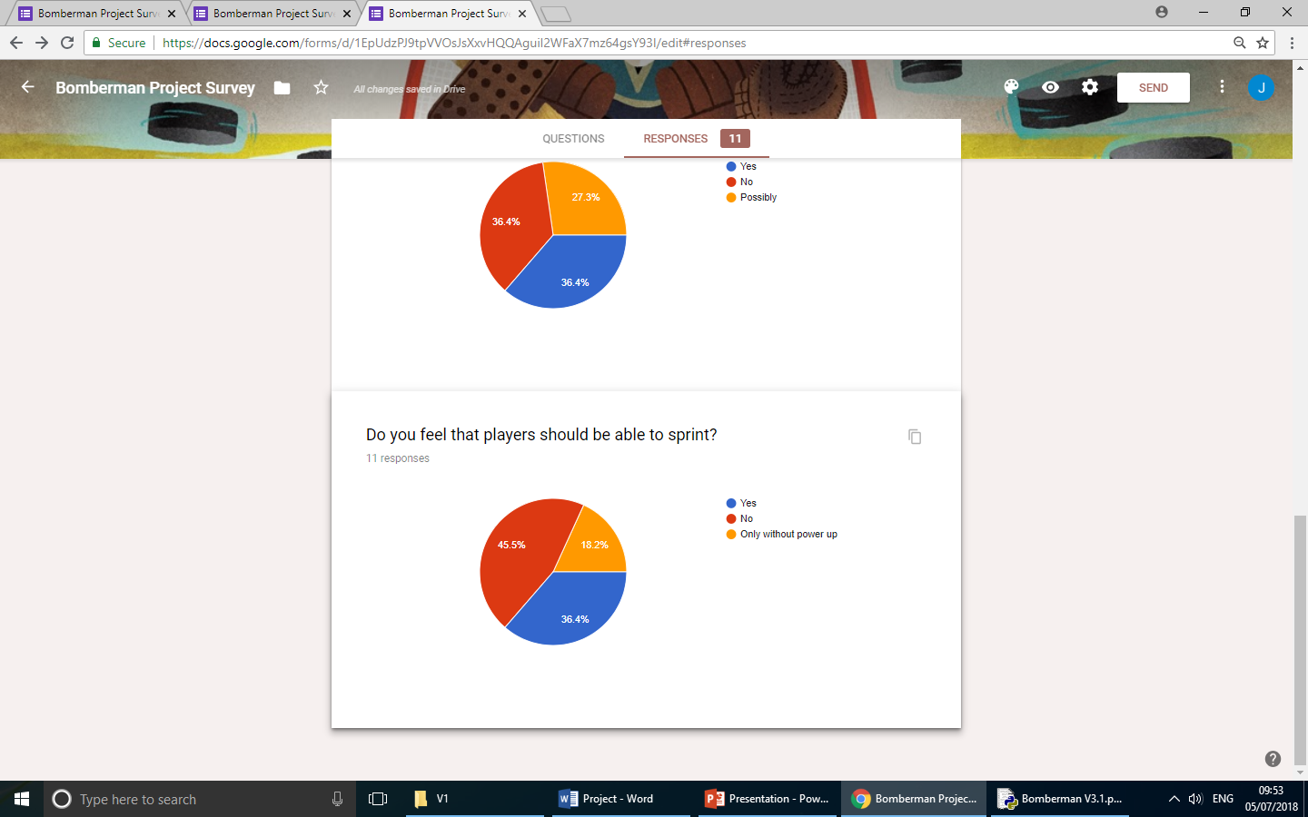Originally in my game, I had sprinting as part of the movement. However I moved this in order to allow the speed power up to have a bigger impact. The survey supported this opinion and sprinting will not be re-added.

# **Design**

### Stage 0 Design (Prototype)

#### Wireframe



#### Pseudocode

Import random and pygame

class Wall

SUBROUTINE

Add to walls

Create rectangle in x,y size 30,30

ENDSUBROUTINE

class Player

SUBROUTINE

Player 🡨 Rectangle at 30, 30 size 60,60

ENDSUBROUTINE

SUBROUTINE

move(x axis, y axis):

if x is not 0 THEN

get amount to move in x axis

ENDIF

If y is not 0 THEN

get amount to move in y axis

ENDIF

ENDSUBROUTINE

SUBROUTINE

Move in one axis(x axis, y axis)

Move player along x axis

Move player along y axis

In wall array

if player collides with a wall THEN

if x > 0 THEN

player is touching wall on right

ENDIF

if dx < 0 THEN

player is touching wall on left

ENDIF

if dy > 0 THEN

player is touching wall below

ENDIF

if dy < 0 THEN

player is touching wall above

ENDIF

ENDIF

ENDFOR

ENDSUBROUTINE

set title to "Bomberman V1”

screen size 🡨 960,720

clock 🡨 time clock

walls 🡨 array

player 🡨 Player

colour 🡨 (12,25,0)

level 🡨 [

"WWWWWWWWWWWWWWWW",

"WS W",

“W W W W W W W W W W W W W",

"W W",

“W W W W W W W W W W W W W",

"W W",

“W W W W W W W W W W W W W",

"W W",

“W W W W W W W W W W W W W",

"W W",

“W W W W W W W W W W W W W",

"W W",

“W W W W W W W W W W W W W",

"W W",

“W W W W W W W W W W W W W",

"W SW",

“W W W W W W W W W W W W W",

]

x 🡨 y 🡨 0

In level rows:

In each column of each row:

if column = "W"THEN

Place a wall at x,y

ENDIF

x += 30

ENDFOR

y += 30

ENDFOR

x🡨0

running 🡨 True

speed 🡨 5

while running, clock 🡨 60

Get event:

if event 🡨 QUIT THEN

running 🡨 False

ENDIF

user_input 🡨 key pressed

if user_input 🡨 SHIFT THEN

speed 🡨 10

else

speed 🡨 5

ENDIF

if user_input[W] THEN

player moves up at rate of speed

ENDIF

if user_input[S] THEN

player moves down at rate of speed

ENDIF

if user_input[A] THEN

player moves left at rate of speed

ENDIF

if user_input[D] THEN

player moves right at rate of speed

ENDIF

Fill screen with green

In walls array

Draw rectangles where shown on tile map in grey

Spawn player rectangle in given ‘colour’

Display screen

END WHILE

Quit.

### Stage 1 Design (Creating a map and a player)

#### Wireframe

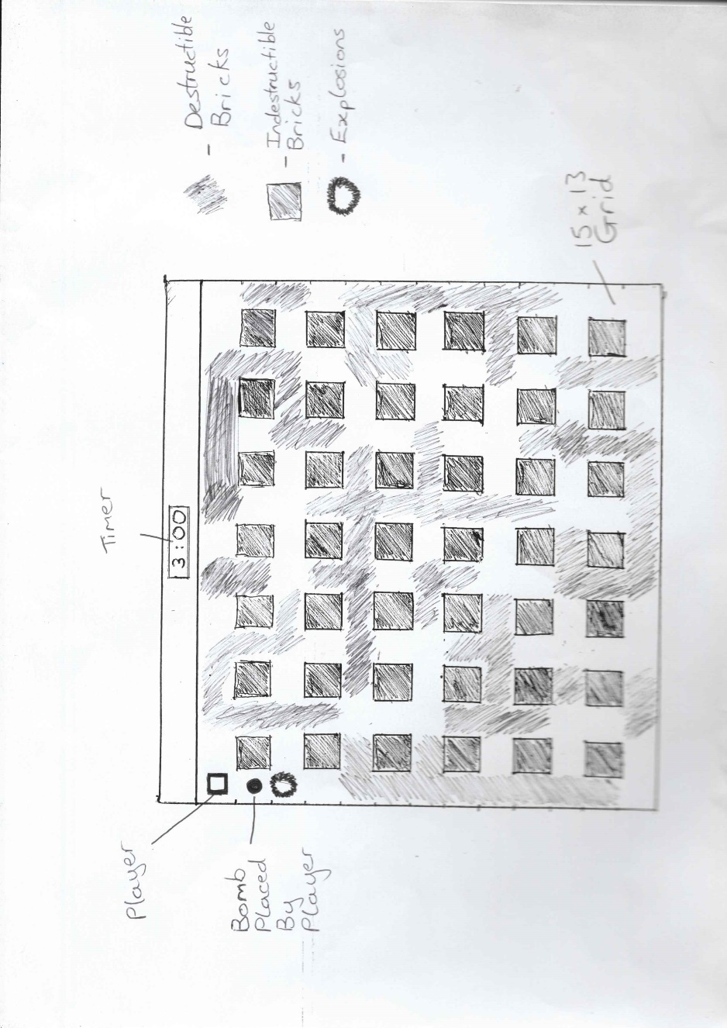

#### Pseudocode

import random, pygame, time

black 🡨 0 0 0

class Wall

SUBROUTINE

Add to walls

Rectangle in x,y size 40,4 0

ENDSUBROUTINE

Class Start

SUBROUTINE

add to start

Rectangle in x,y size 40,40

ENDSUBROUTINE

class Brick

SUBROUTINE

Add a rectangle to brick size 40 by 40

ENDSUBROUTINE

class Player1

SUBROUTINE

Spawn rectangle at 40,40 size 40,40

Create bomb array

Speed 🡨 3

Bomb limit 🡨 1

Placed 🡨 True

Create rectangle array

Explosion length 🡨 1

ENDSUBROUTINE

SUBROUTINE

movement

if x is not 0 THEN

get amount to move in x axis

ENDIF

If y is not 0 THEN

get amount to move in y axis

ENDIF

ENDSUBROUTINE

SUBROUTINE

Move in one axis

Move player along x axis

Move player along y axis

In wall array

if player collides with a wall THEN

if x > 0 THEN

player is touching wall on right

ENDIF

if dx < 0 THEN

player is touching wall on left

ENDIF

if dy > 0 THEN

player is touching wall below

ENDIF

if dy < 0 THEN

player is touching wall above

ENDIF

ENDIF

In brick array

if player touches brick

if dx > 0 THEN

player is touching brick on right

ENDIF

if dx < 0 THEN

player is touching brick on left

ENDIF

if dy > 0 THEN

player is touching brick on below

ENDIF

if dy < 0 THEN

player is touching brick on above

ENDIF

ENDIF

ENDSUBROUTINE

SUBROUTINE

If W is pressed THEN move up

ENDIF

If A is pressed THEN move left

ENDIF

If S is pressed THEN move down

ENDIF

If D is pressed THEN move right

ENDIF

If bomb array < bomb limit +1:

if Space pressed and Placed 🡨 True THEN

x 🡨 (x/40) *40 + 20 rounded

y 🡨 (y/40) *40 + 20 rounded

Placed 🡨 False

print bomb array -1

Add bomb to map

ENDIF

if Space not pressed THEN

Placed 🡨 True

ENDIF

ENDIF

In bombs array

up 🡨 True

down 🡨 True

left 🡨 True

right 🡨 True

if bomb is exploded THEN

place centre part of explosion

In explosion range

if right is true THEN

place explosion to the right

if explosion touches brick THEN

remove brick touched by explosion

right 🡨 False

if right is true THEN

keep placing explosions to the full explosion length

if left is true THEN

place explosion to the left

if explosion touches brick THEN

remove brick touched by explosion

left 🡨 False

if left is true THEN

keep placing explosions to the full explosion length

if down is true THEN

place explosion downwards

if explosion touches brick THEN

remove brick touched by explosion

down 🡨 False

if down is true THEN

keep placing explosions to the full explosion length

if up is true THEN

place explosion above

if explosion touches brick THEN

remove brick touched by explosion

up 🡨 False

if up is true THEN

keep placing explosions to the full explosion length

remove bomb from array and despawn

Update rectangle array to screen

remove explosion after 1 second on screen

class blow rectangle

SUBROUTINE

create an array to add explosion rectangles to

create a timer to spawn and remove the explosion

ENDSUBROUTINE

SUBROUTINE

update screen

draw the explosion rectangles

check time of explosions using the timer

class bomb

SUBROUTINE

Exploded 🡨 false

Create bomb time

ENDSUBROUTINE

SUBROUTINE

Draw black circle to represent bombs

ENDSUBROUTINE

SUBROUTINE

After 3 seconds on bomb timer, explode the bomb

ENDSUBROUTINE

class timer

SUBROUTINE

Set font size and type

Create time set to 180 seconds

ENDSUBROUTINE

SUBROUTINE

Update timer every seconds, counting down 1 at a time

Place timer onto screen

Close game when timer reaches 0

ENDSUBROUTINE

Set game caption to Bomberman

Set screen size

Run fps clock in background

Q 🡨 0

walls 🡨 Array

bricks 🡨 Array

starts 🡨 Array

bombs 🡨 Array

Create player 1

colour 🡨 black

level 🡨 [

"WWWWWWWWWWWWWWWWWWW",

"WS BBBBBBBBBBBBBBBBBBBBBBBBBBW",

"W WBWBWBWBWBWBWBWBWBWBW",

"WBBBBBBBBBBBBBBBBBBBBBBBBBBBW",

"W WBWBWBWBWBWBWBWBWBWBW",

"WBBBBBBBBBBBBBBBBBBBBBBBBBBBW",

"W WBWBWBWBWBWBWBWBWBWBW",

"WBBBBBBBBBBBBBBBBBBBBBBBBBBBW",

"W WBWBWBWBWBWBWBWBWBWBW",

"WBBBBBBBBBBBBBBBBBBBBBBBBBBBW",

"WBBBBBBBBBBBBBBBBBBBBBBBBBB SW",

"WWWWWWWWWWWWWWWWWWW",]

x 🡨 y 🡨 0

In level rows:

In each column of each row:

if column = "W"THEN

Place a wall at x, y

ENDIF

x += 30

ENDFOR

y += 30

ENDFOR

x🡨0

running 🡨 True

speed 🡨 5

while running, clock 🡨 60

Get event:

if event 🡨 QUIT THEN

running 🡨 False

ENDIF

Accept user input

Set background colour

In starts array

Draw start point rectangles onto screen

In bricks array

Draw brick rectangles onto screen

In walls array

Draw wall rectangles onto screen

Accept player movement inputs

Update timer on screen

Draw player onto the screen

quit

### Stage 2 Design (Adding a second player)

#### Pseudocode

(Two subclasses of player made using same code as seen before)

Added to player 1 and 2 -

In walls array

If explosion collides with a wall, then

Explosion is stopped on block next to wall

Also, added player 2 with separate movement keys –

If down arrow pressed, then

Move down

If right arrow pressed, then

Move right

If up arrow pressed, then

Move up

If left arrow pressed, then

Move left

If return key pressed, then

Place bomb

### Stage 3 Design (Adding a powerups)

#### Wireframe

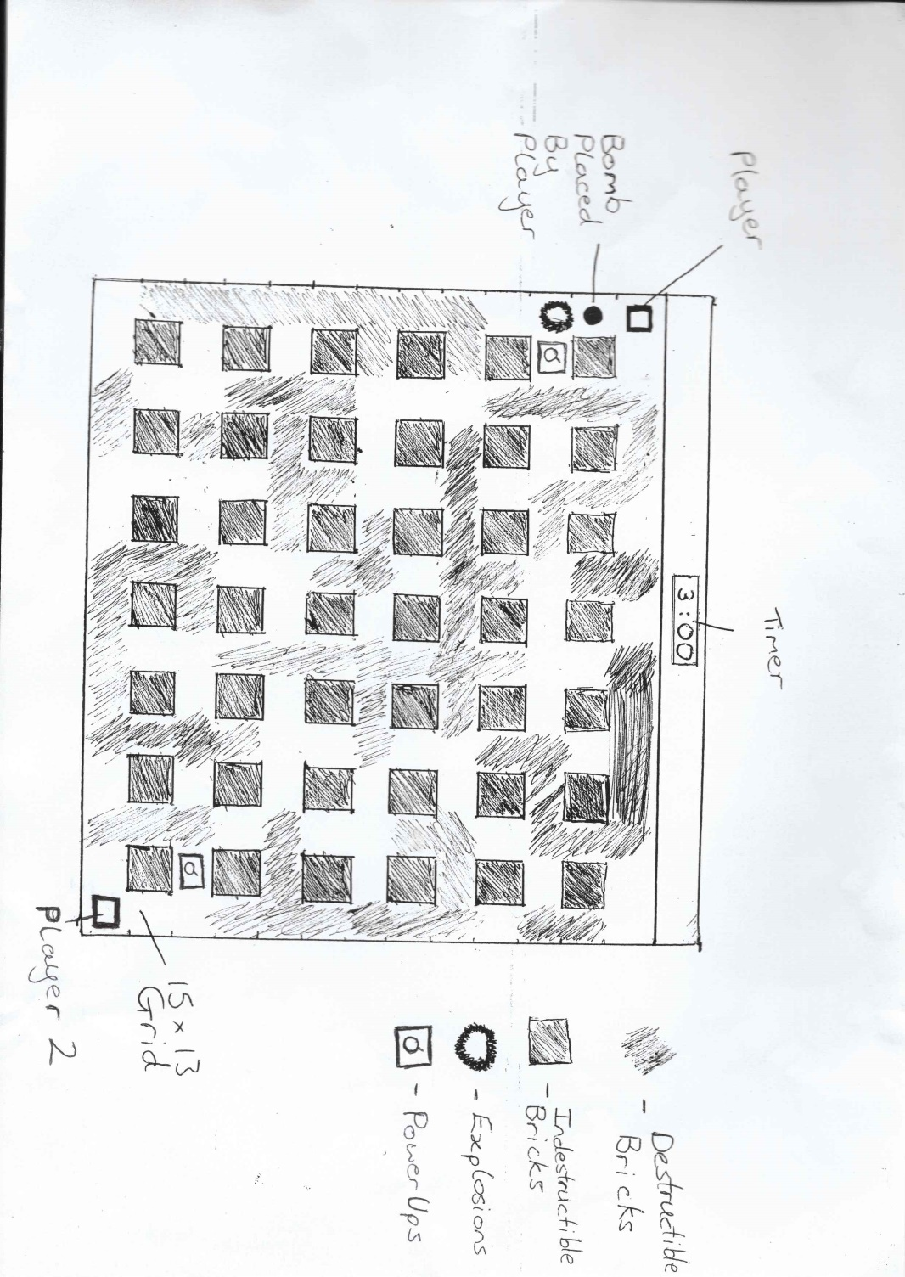

#### Pseudocode

Class powerup

SUBROUTINE

Create a powerup rectangle

Set start image for powerup

ENDSUBROUTINE

SUBROUTINE

Choose a random number between 0 and 3

If the number is 0 then

Spawn a powerup

ENDSUBROUTINE

SUBROUTINE

Draw the powerup onto the screen

Add selected powerup image onto rectangle

ENDSUBROUTINE

Subclasses of powerup

Extend bomb

SUBROUTINE

Powerup image 🡨 bomb powerup image

If player has less than 7 bomb limit, then

Add one to bomb limit

ENDSUBROUTINE

Extend range

SUBROUTINE

Powerup image 🡨 explosion powerup image

If player has less than 7 explosion range, then

Add one to explosion range

ENDSUBROUTINE

Extra speed

SUBROUTINE

Powerup image 🡨 speed boost image

If player has less than 7 speed, then

Add one to speed

ENDSUBROUTINE

Kickers

SUBROUTINE

Powerup image 🡨 bomb kicker image

If player does not have kickers then

Add kickers to player

ENDSUBROUTINE

Added into player class –

If explosion collides with brick then

Remove brick and stop explosion in that direction

Select random number between 1-4

Powerup with that number chosen

Extra Bomb 🡨 1

Extend range 🡨 2

Speed boost 🡨 3

Kickers 🡨 4

Create powerup using class

### Stage 4 Design (Creating a menu)

#### Pseudocode

Account screen

Import pygame and import hashing from encryption

Set screen size

Initialise pygame

Inactive colour 🡨 grey

Active colour 🡨 white

Class account

Subroutine

Font 🡨 consolas, size 32, bold

End subroutine

Subroutine

Write onto screen ‘Enter Username’ in white

Write onto screen ‘Enter Password’ in white

End subroutine

Class login

Subroutine

Colour 🡨 inactive colour

Active 🡨 false

End subroutine

Subroutine

If mouse is clicked then

If mouse is over input box

Active 🡨 True

If key is pressed then

If active 🡨 True

If backspace is pressed

Remove last letter from string

If return is pressed

Store what is in input box

End subroutine

Subroutine

Set box width to a 200 characters maximum

Boxes are Active colour if active 🡨 true

Otherwise boxes are inactive colour

End subroutine

Subroutine

Draw boxes onto screen

End subroutine

Subroutine

Try to open text file with stored username/password

If error is found

Close game

Username 🡨 encrypted username

Password 🡨 encrypted password

If username and password are same as stored

Accept inputs

End subroutine

While running

If event 🡨 Quit

Close game

If key pressed 🡨 return and username box selected

Move to password box

If key pressed 🡨 return and password box selected

Compare inputs to stored values

If inputs are accepted move to title screen

Quit

Title Screen

Import pygame

Home screen 🡨 main screen image

Class buttons

Subroutine

Clicked 🡨 false

Import image

Paste image onto screen

End subroutine

Function play

Import Bomberman game and open file

Function stop

Quit

Create and spawn two buttons, one play, one quit

While running

If event 🡨 quit

Quit

If mouse clicked on button

Complete either play or quit action

Quit

Encryption code

Subroutine

Logical Xor two binary strings together, return result

End subroutine

Subroutine

Logical And two binary strings together, return result

End subroutine

Subroutine

Logical Or two binary strings together, return result

End subroutine

Subroutine

Logical Not two binary strings together, return result

End subroutine

Subroutine

Logical Add two binary strings together, return result

End subroutine

Subroutine

Left rotate all numbers

End subroutine

Subroutine

Left shift all numbers

End subroutine

Subroutine

Set hashing constants

Turn letters into 8 bits numbers

Add 0’s then extend message into a multiple of 512

Break into 32 bit groups

Make 80 groups of 32 bits

Process the data using gates

Add together

Receive result

End subroutine

## Data Flow Diagram

### Level 0

The data flow diagram shows how the user interacts with the game in order to get certain outcomes.

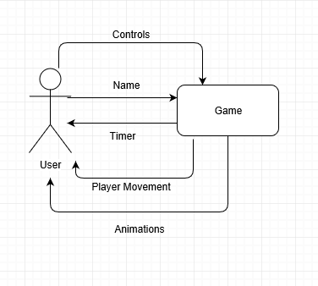

## Hierarchy Chart

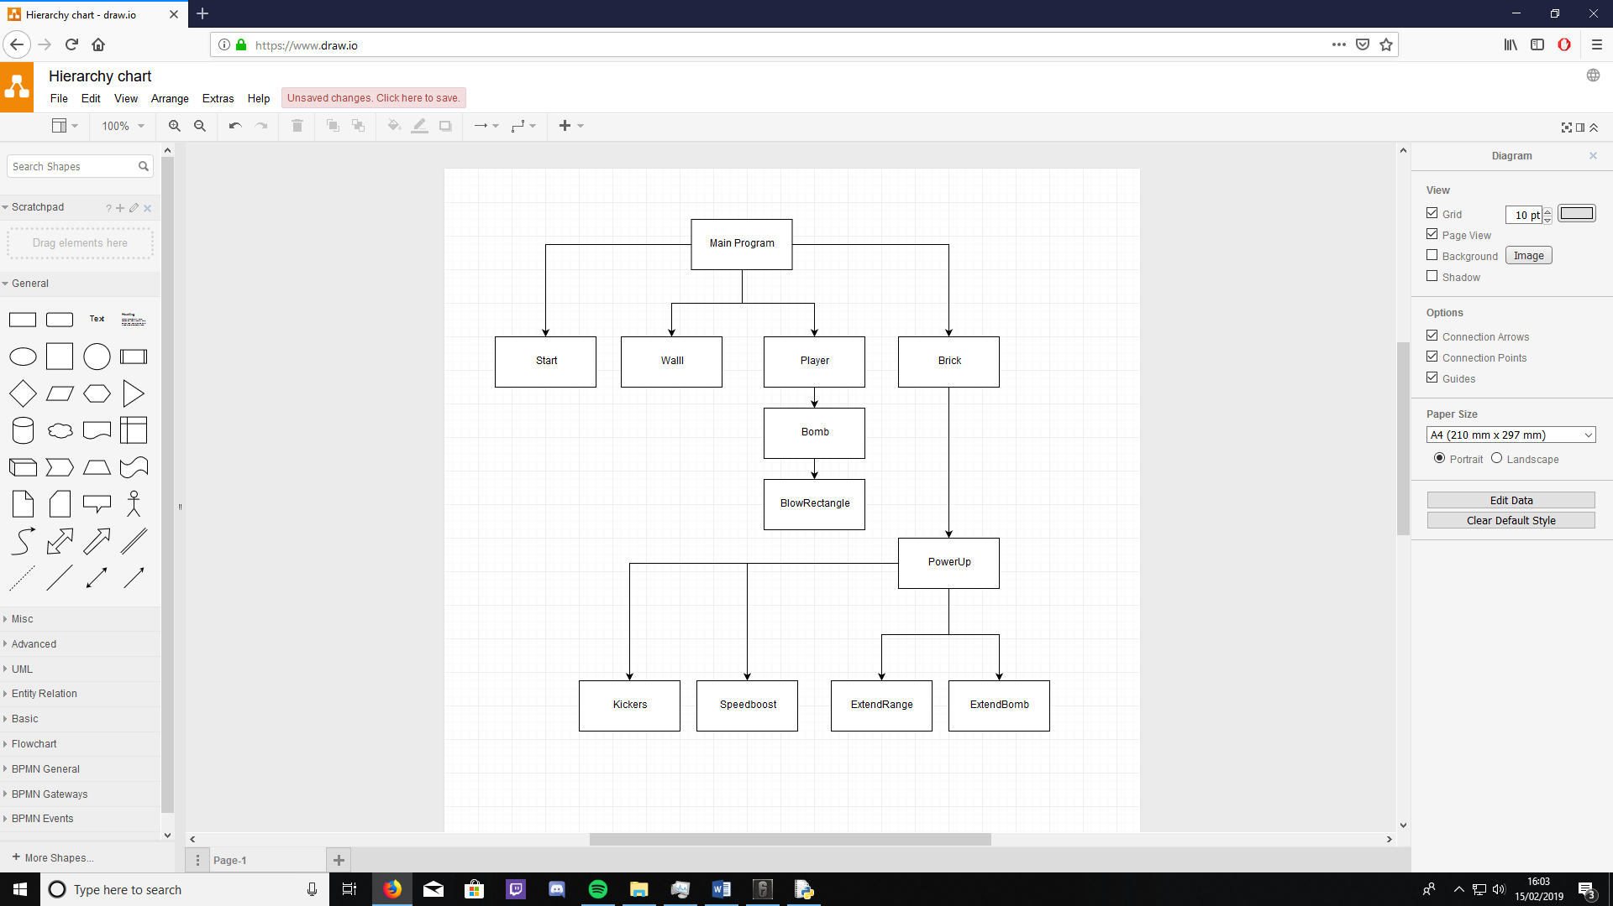

This hierarchy chart shows which classes call each other and how the work down from top to bottom.

## IPSO CHART – Input, process, storage, output

|  |  |  |  |
| --- | --- | --- | --- |
| **Input** | **Process** | **Storage** | **Output** |
| Player movement control | Move the player | N/A | Player movement on map |
| Bomb placed | Spawn bomb, explode bomb | Add/remove to temporary array | Bomb collision. Player death, update map for removing blocks and powerup spawning |
| Menu option pressed | Start game , quit game or login | Image files used in game, username and password details | Begin the game, close the application or allow user login |
| User login details | Allow user to attempt login against stored names/passwords | Saved names and passwords | Either correct login details and move to menu or output to user “incorrect details” |

# **Technical Solution**

## **Code**

### Stage 0 (Prototype)

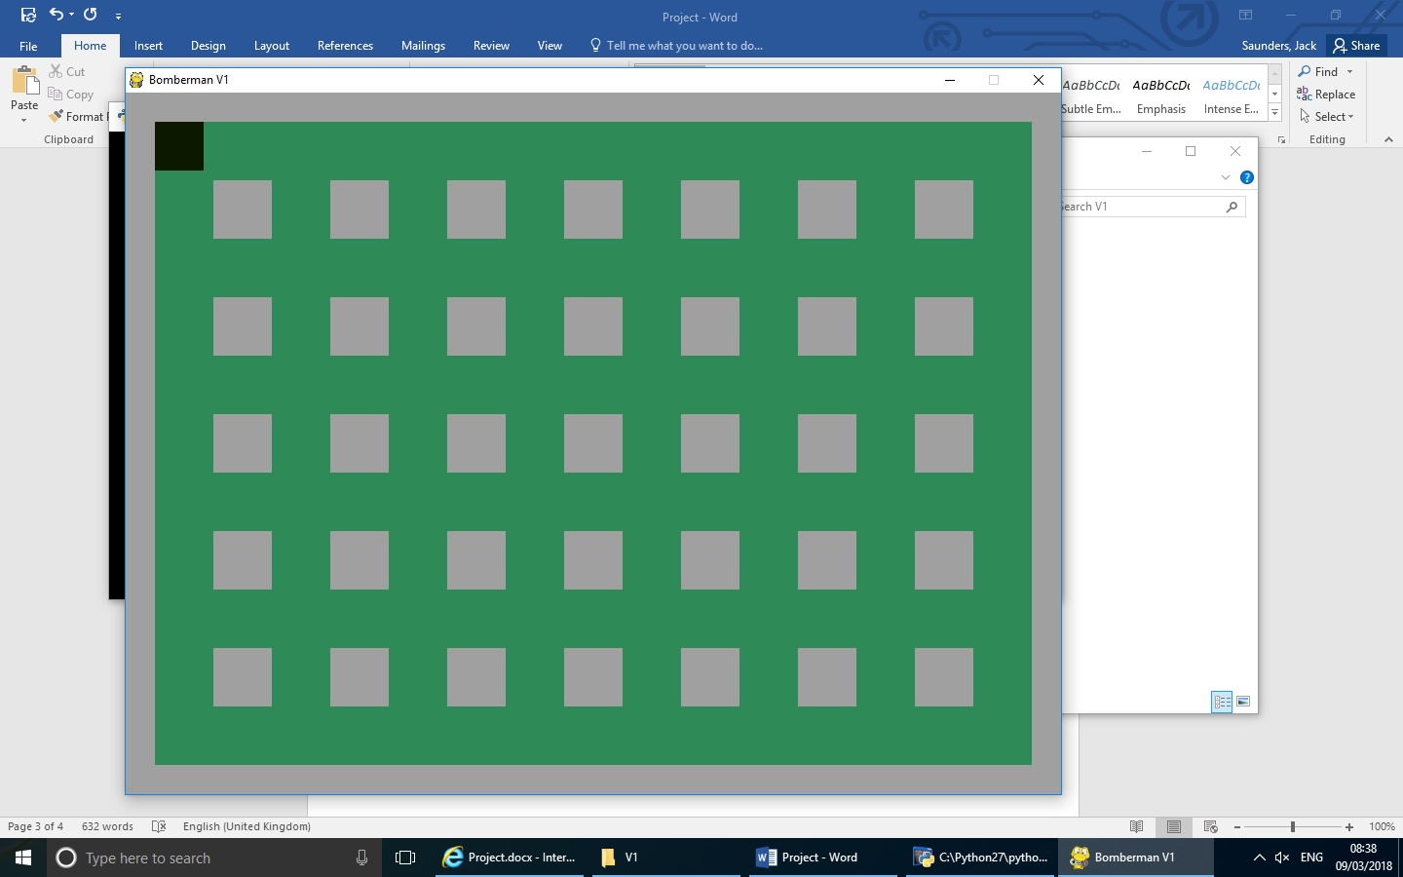This is the very first stages of creating my game. Here we see a simple map design which has a block that can move around and in between the blocks. A user can input the W,A,S and D keys in order to move a player in that direction This sets me up to then add in players, bombs and randomized blocks which can be destroyed.

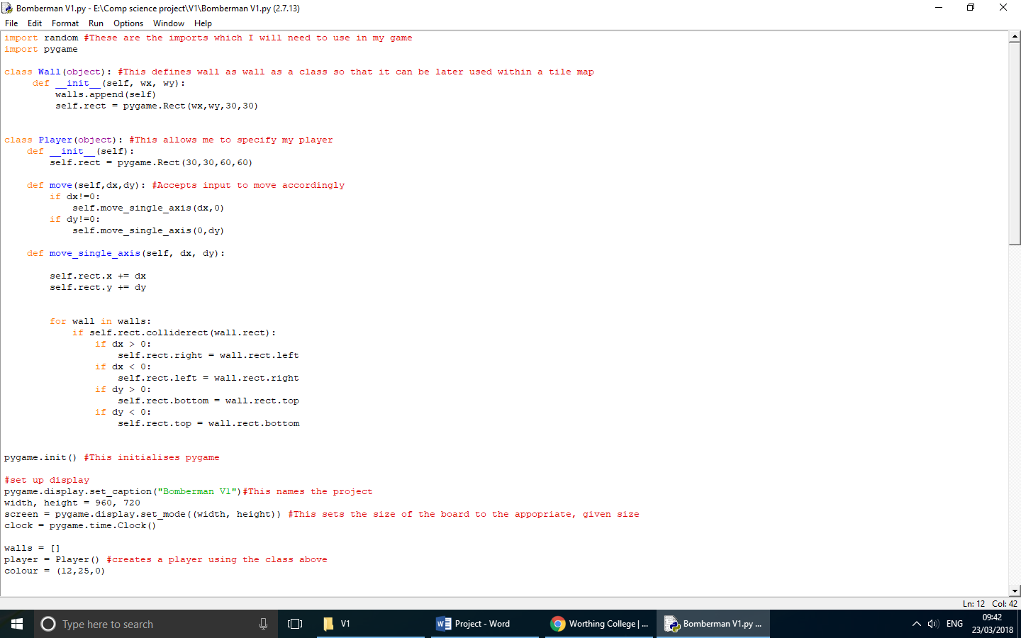

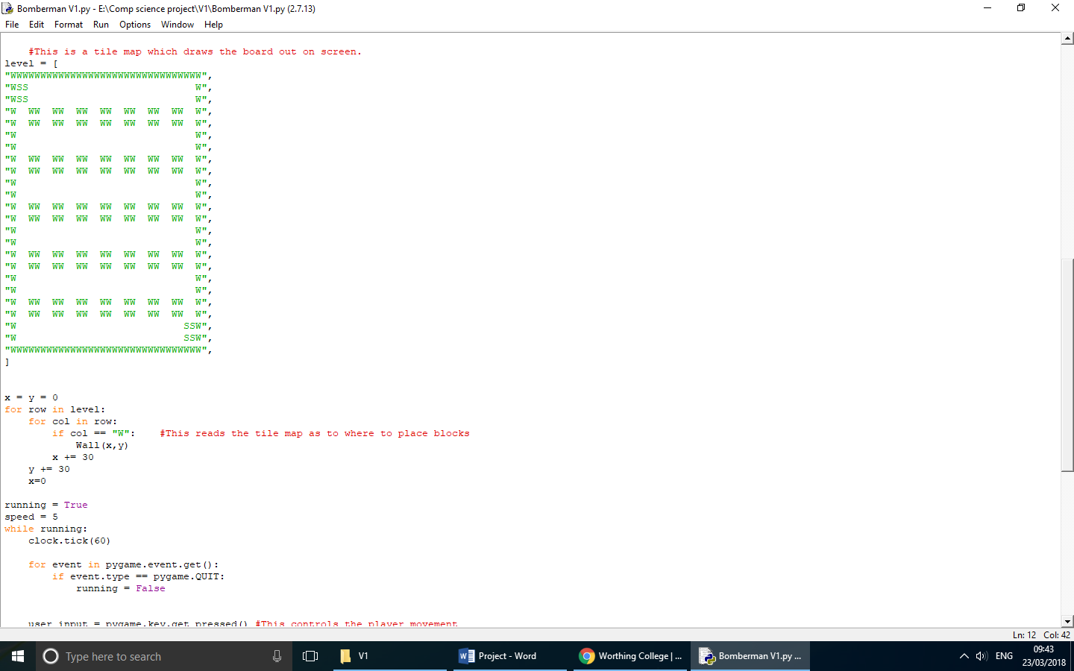

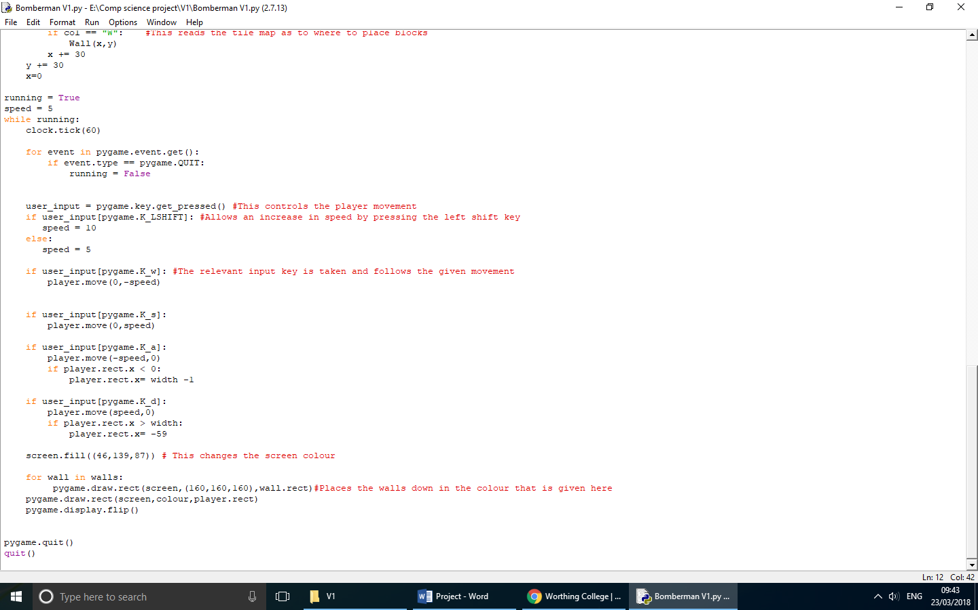

### Stage 1 (Creating a map and a player)

In this stage of my code, I wanted to be able to see the early stages and development of the map aswell as implementing the bombs for the player. Originally, I planned to create the destructible bricks and then also finish allowing the player to place bombs which would explode and remove the destructible bricks as well as not affecting the walls and sorting collision with the player. I also wanted to create at timer which would appear at the top of the screen.

When creating my stage 1, I realised that my original aims for this stage were a bit too much and unrealistic for me to complete. Therefore, I reviewed and changed my aims to just complete creating the timer, creating the destructible bricks using the tile map and then create the bombs which would explode the destructible bricks. I decided that it would be best for me to leave the rest of the collision with the bombs for a later stage as it will still allow me much more space to improve my code. I also later decided that I felt the speed increase when shift was pressed was not a required or useful attribute the game as it would make the speed increase power ups have less value to a player

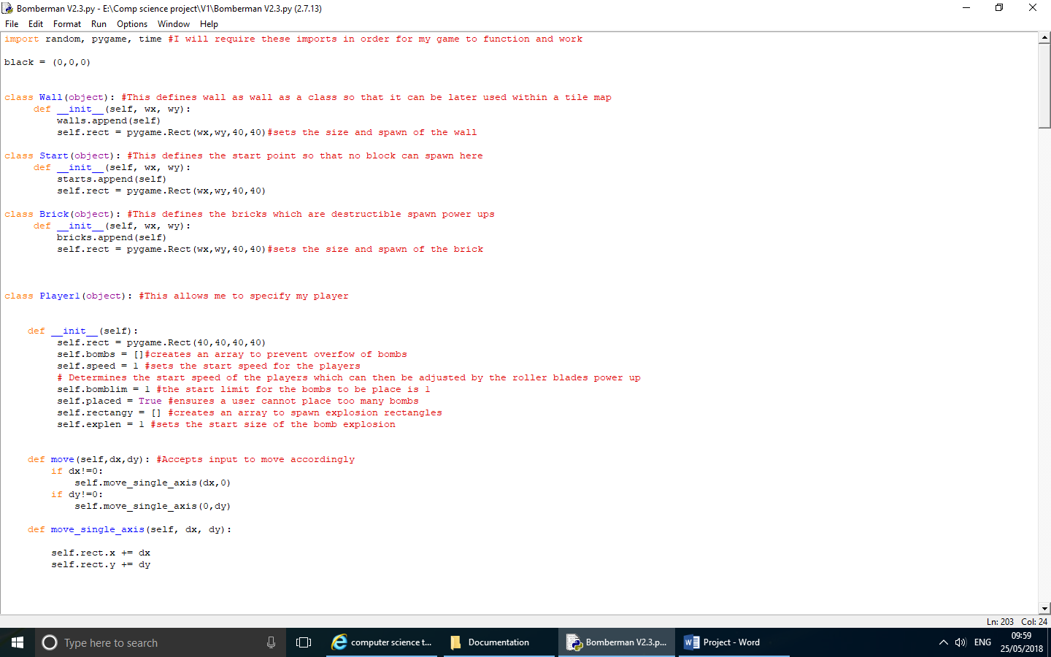

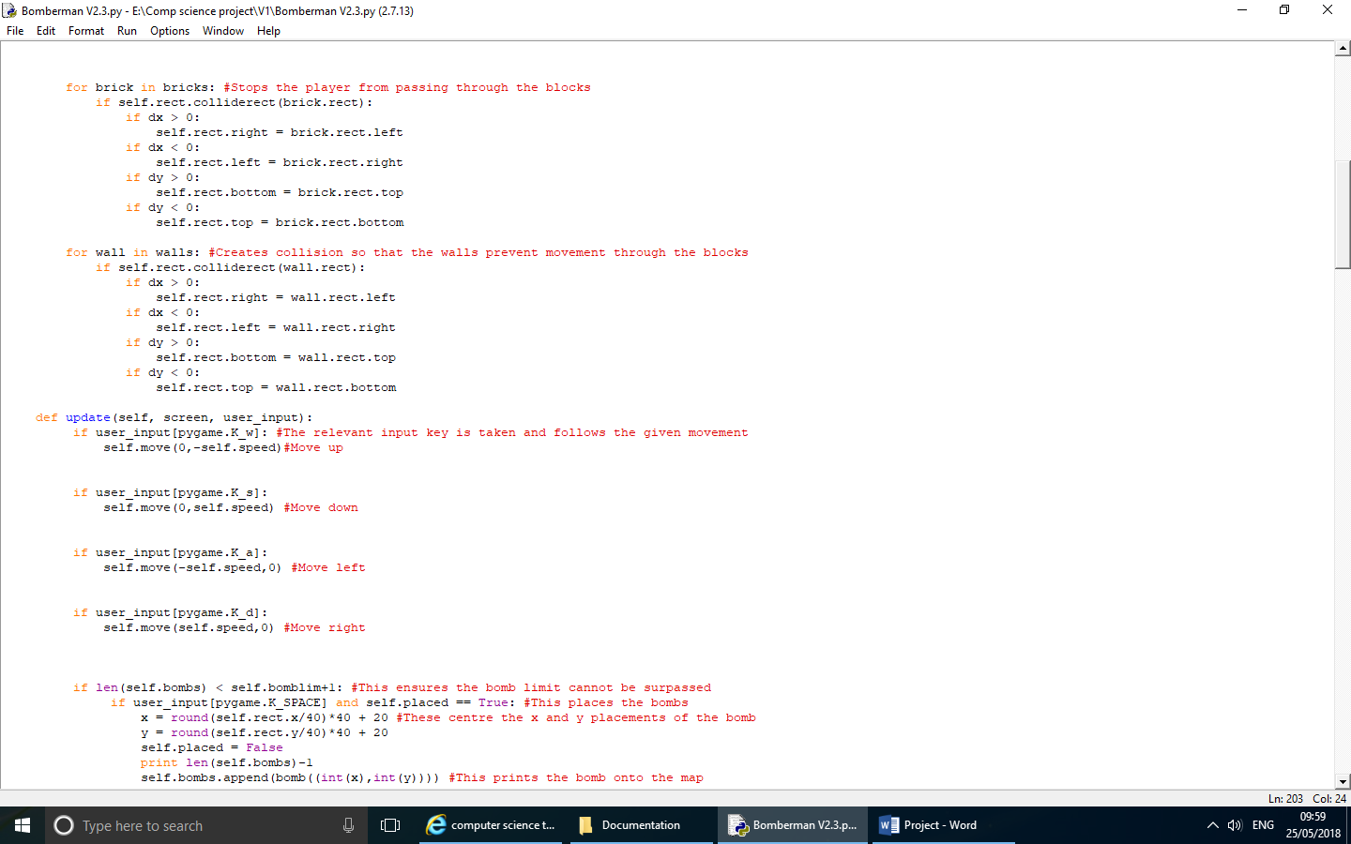

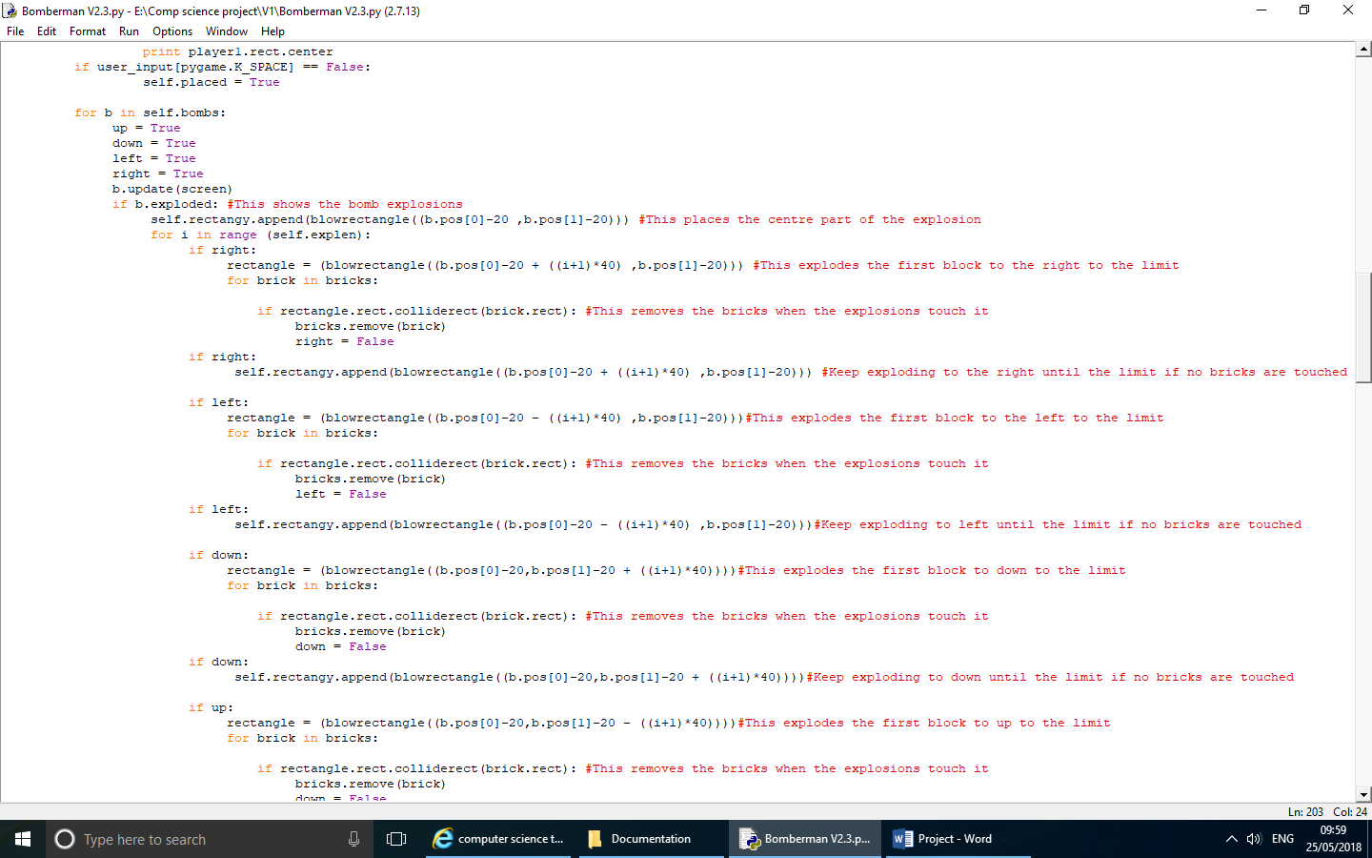

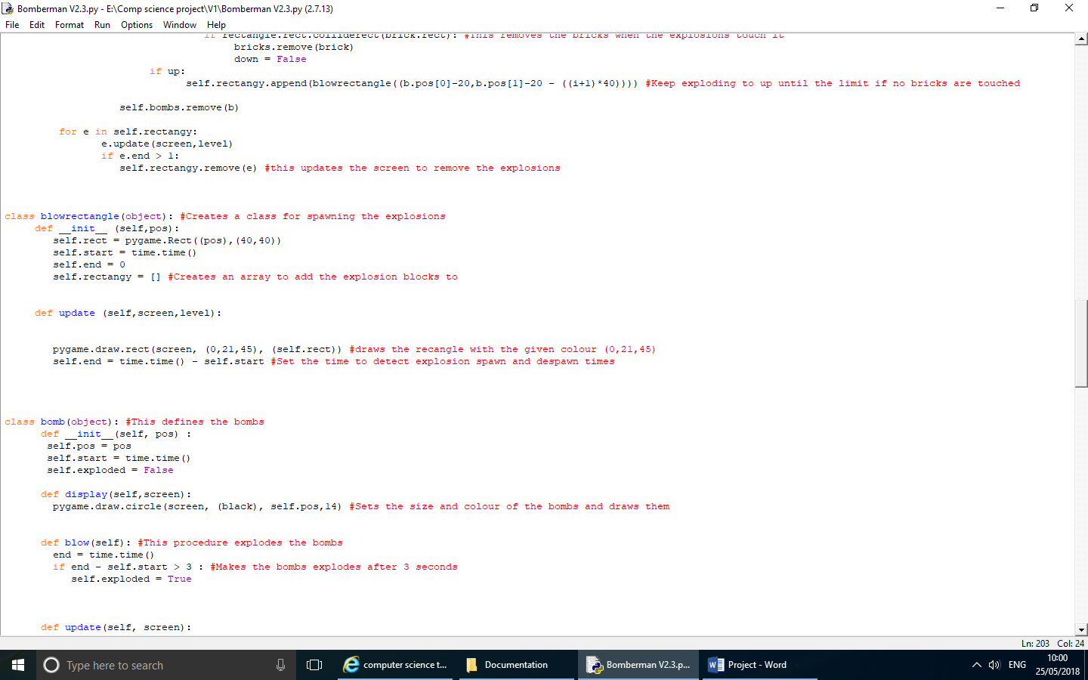

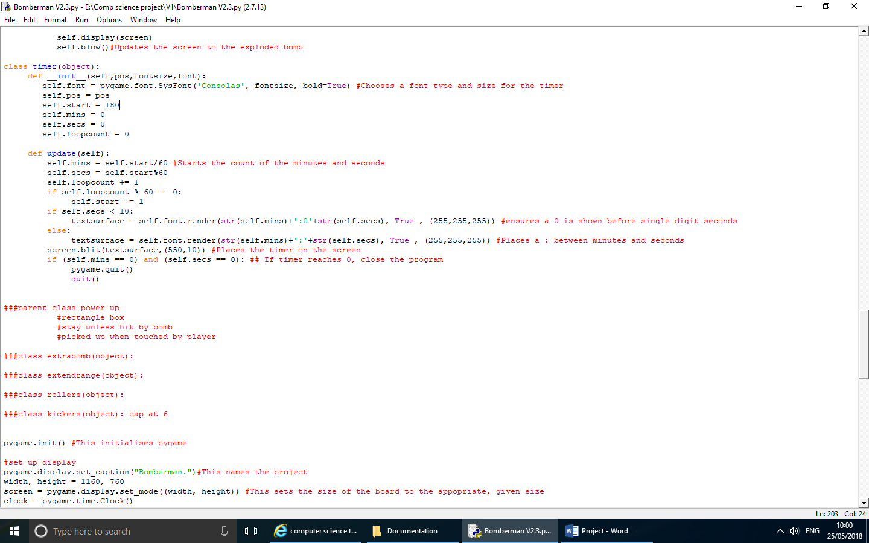

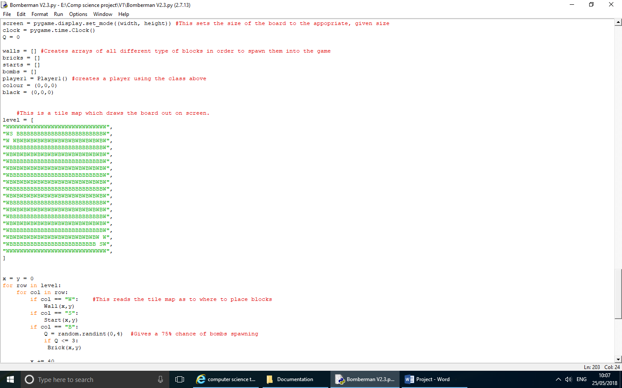

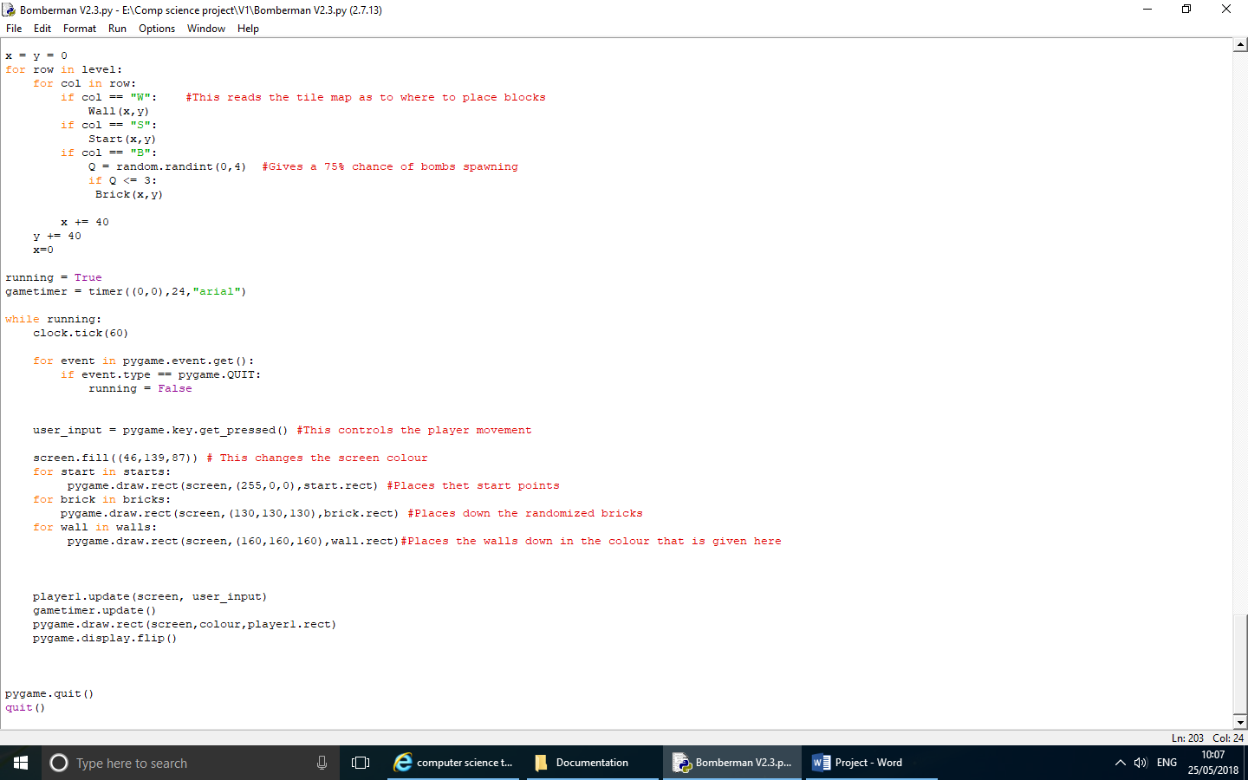

### Stage 2 (Adding a second player)

For Stage 2, my first aim was to fully complete the collision of the explosions. This would mean that the bombs would explode and destroy the destructible bricks but be blocked by the indestructible walls. I also have aimed to create and complete the addition of a second user-controlled player to my game. My code throughout this stage is very inefficient. For example, I have recreated a class for player 2 when I could’ve passed variables into one player class, create 2 instances. This is something I decided would be good to add in stage 3 for a more efficient code. By successfully adding a second player, I was able to meet one of my five original aims – allowing two players to simultaneously play on a single keyboard.

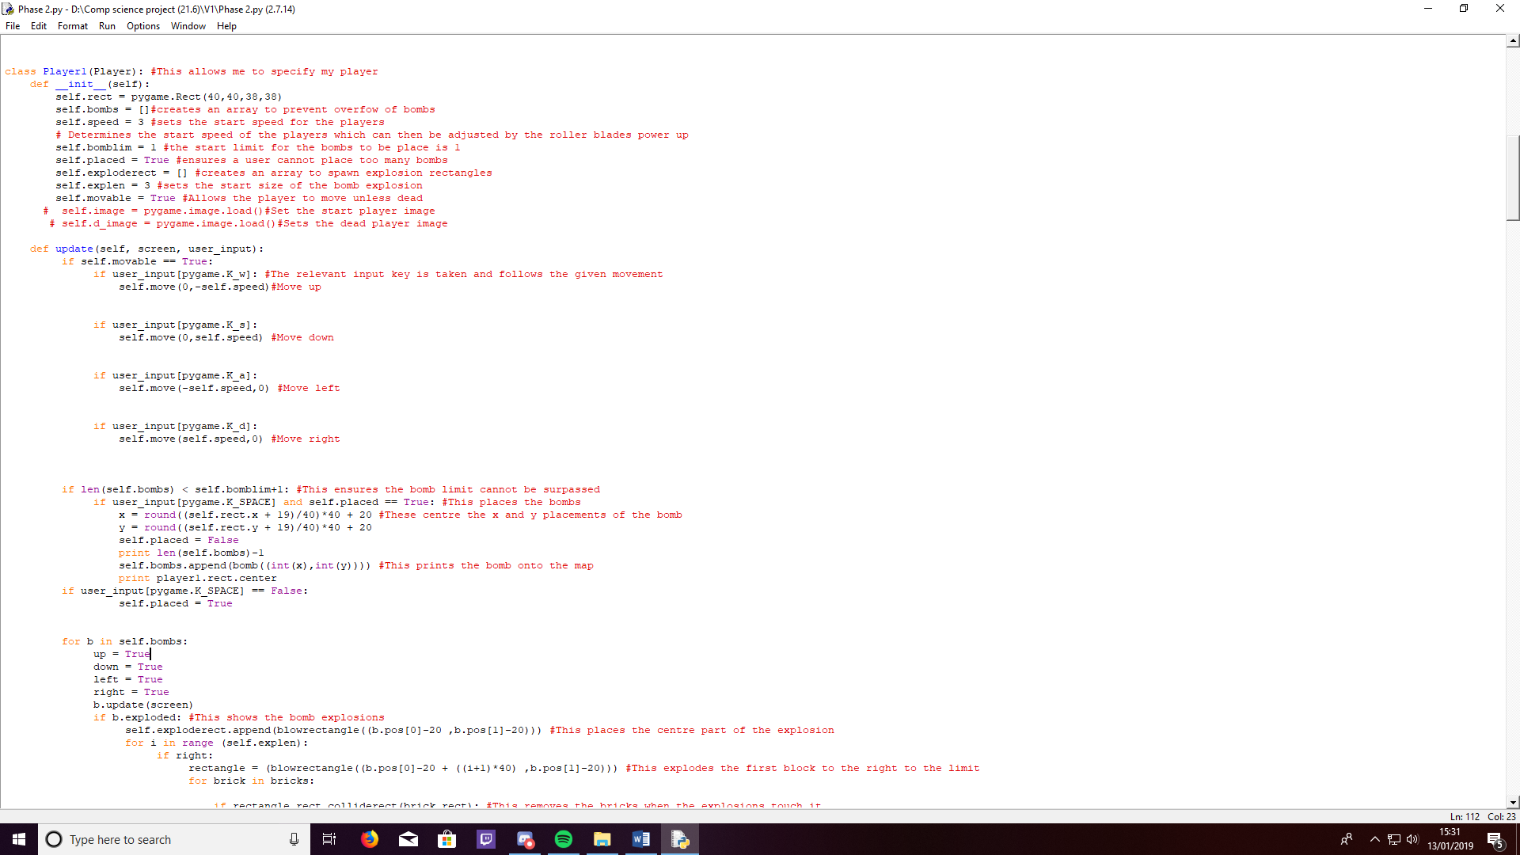

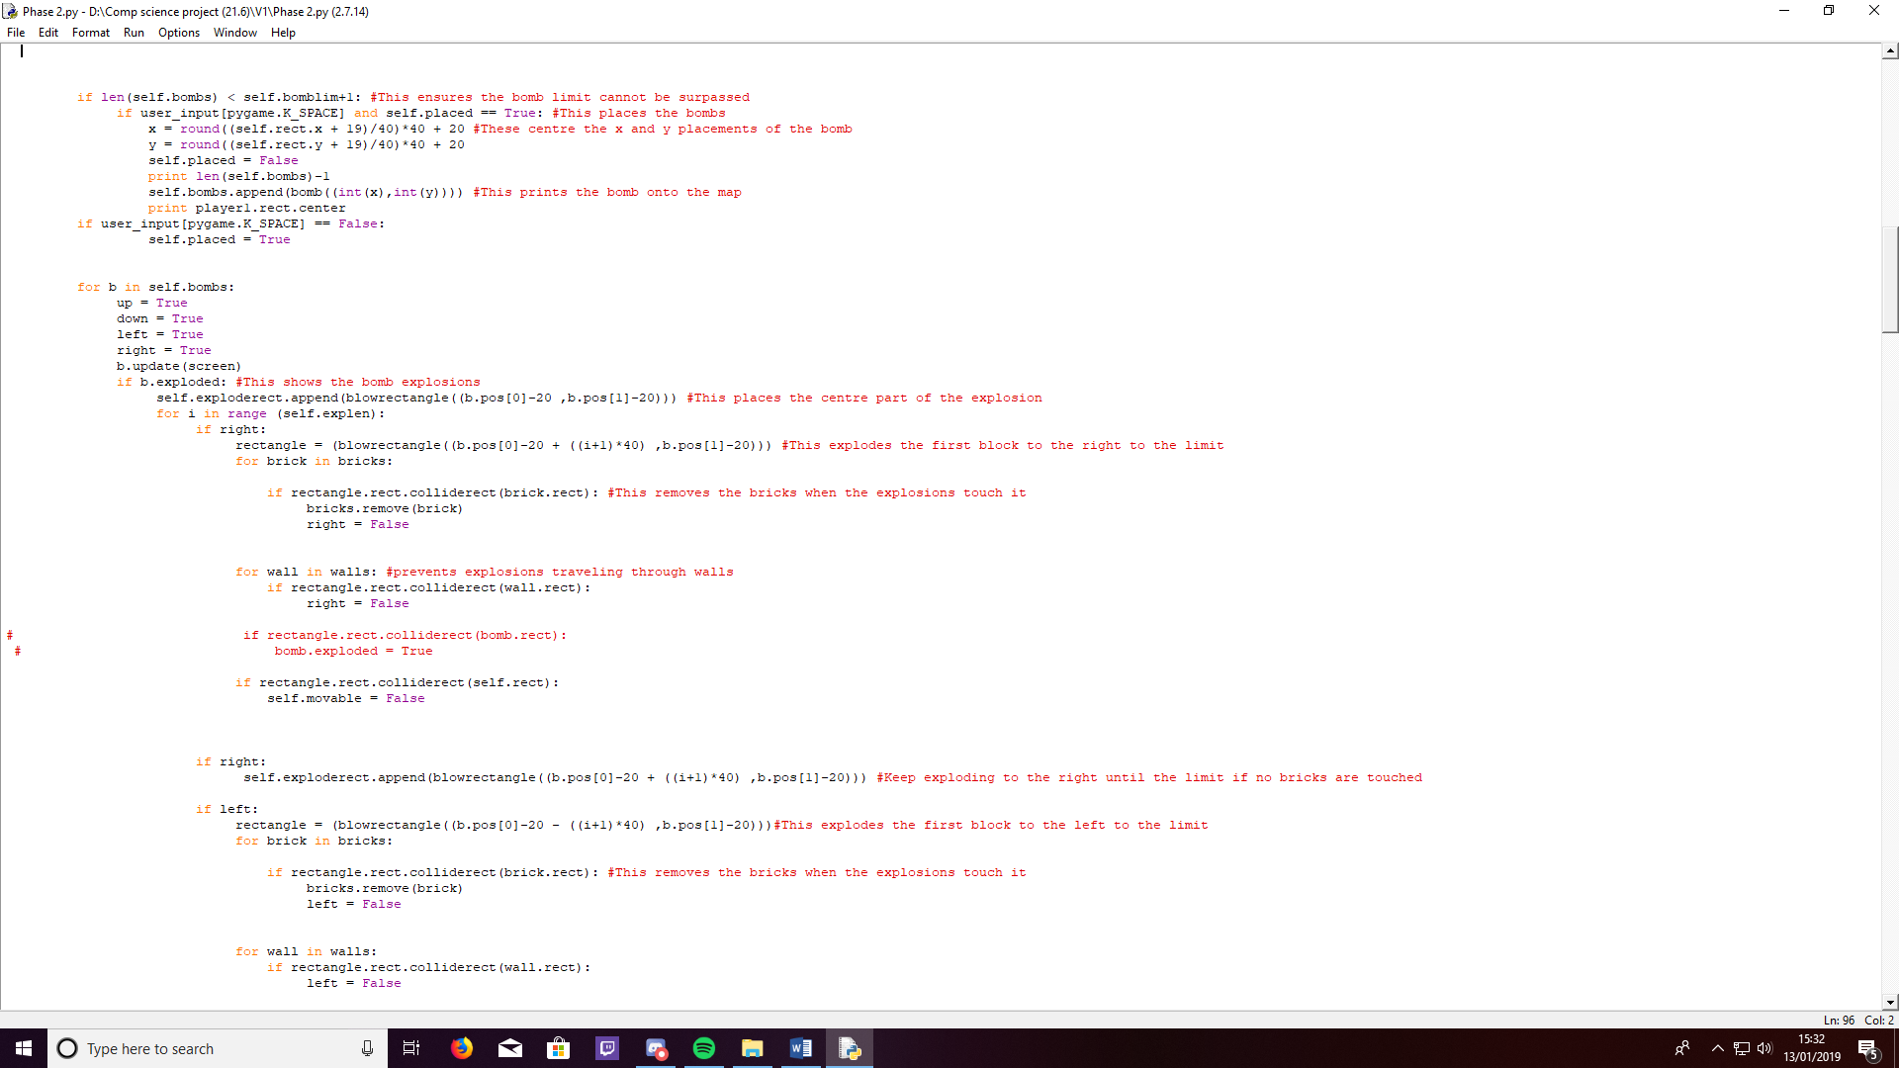

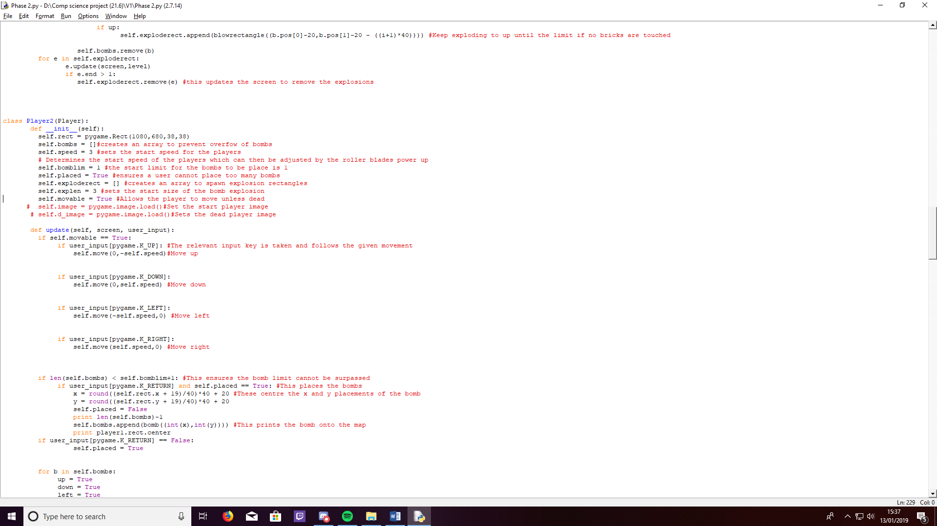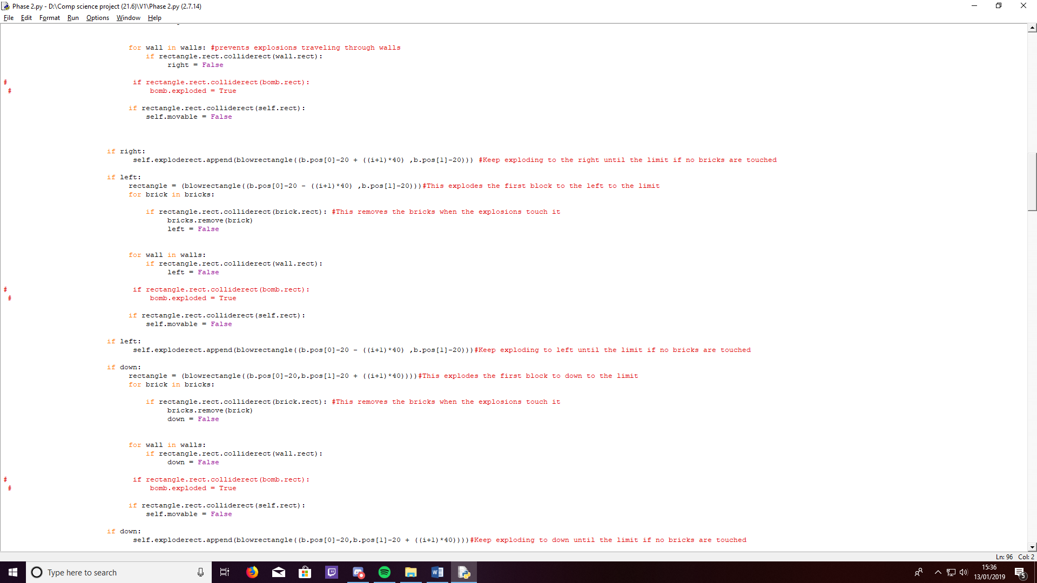

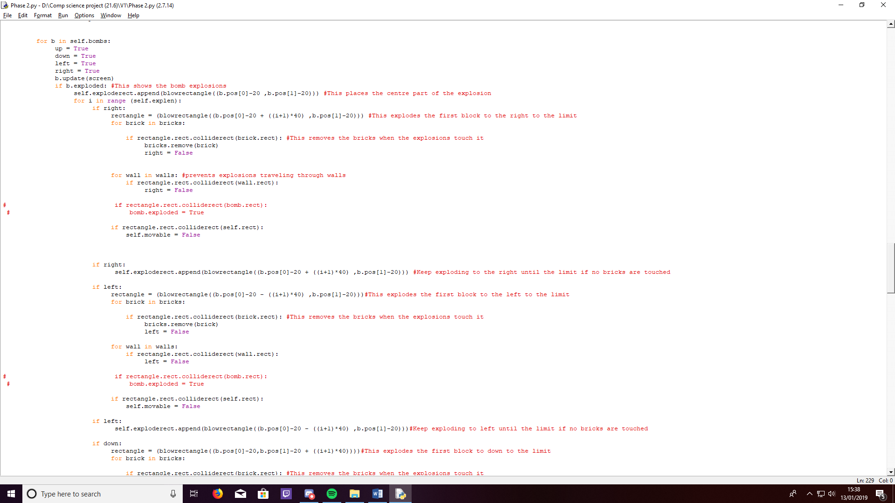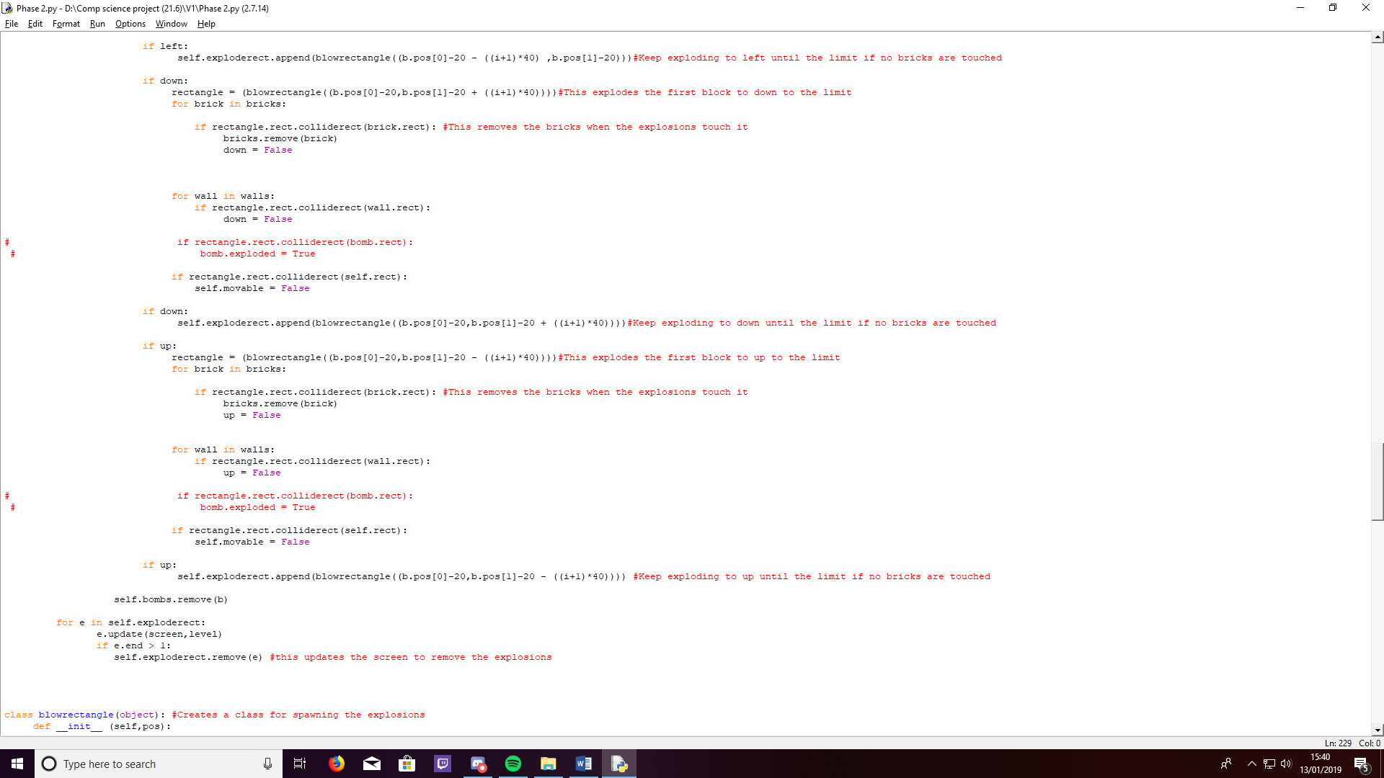

### Stage 3 (Adding powerups)

For Stage 3, I aimed to add in powerups to my game, these would adjust the players’ abilities in order to make the gameplay faster and more intense. There are four types of powerups that can spawn. I also improved the efficiency of the player class in this stage by creating two instances which accept different inputs rather than having two separate classes. It is now also shown when a player has won the game. This is done by updating a variable in the player class to show a player has died. At this stage, we can see that I have addressed and succeeded in meeting another of my original five aims. I have added all four powerups to my game which both players can pick up and benefit from.

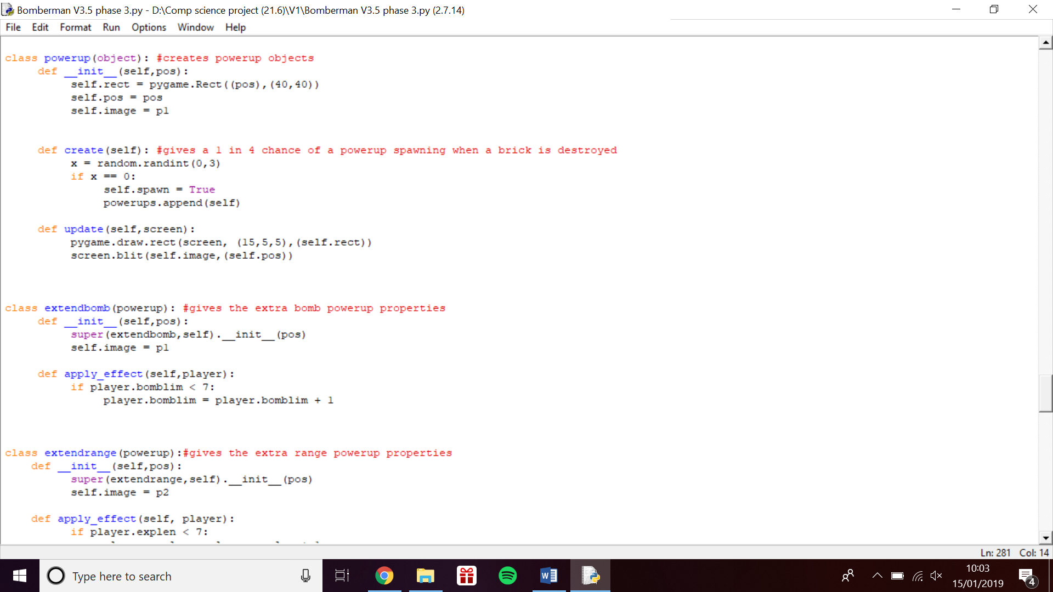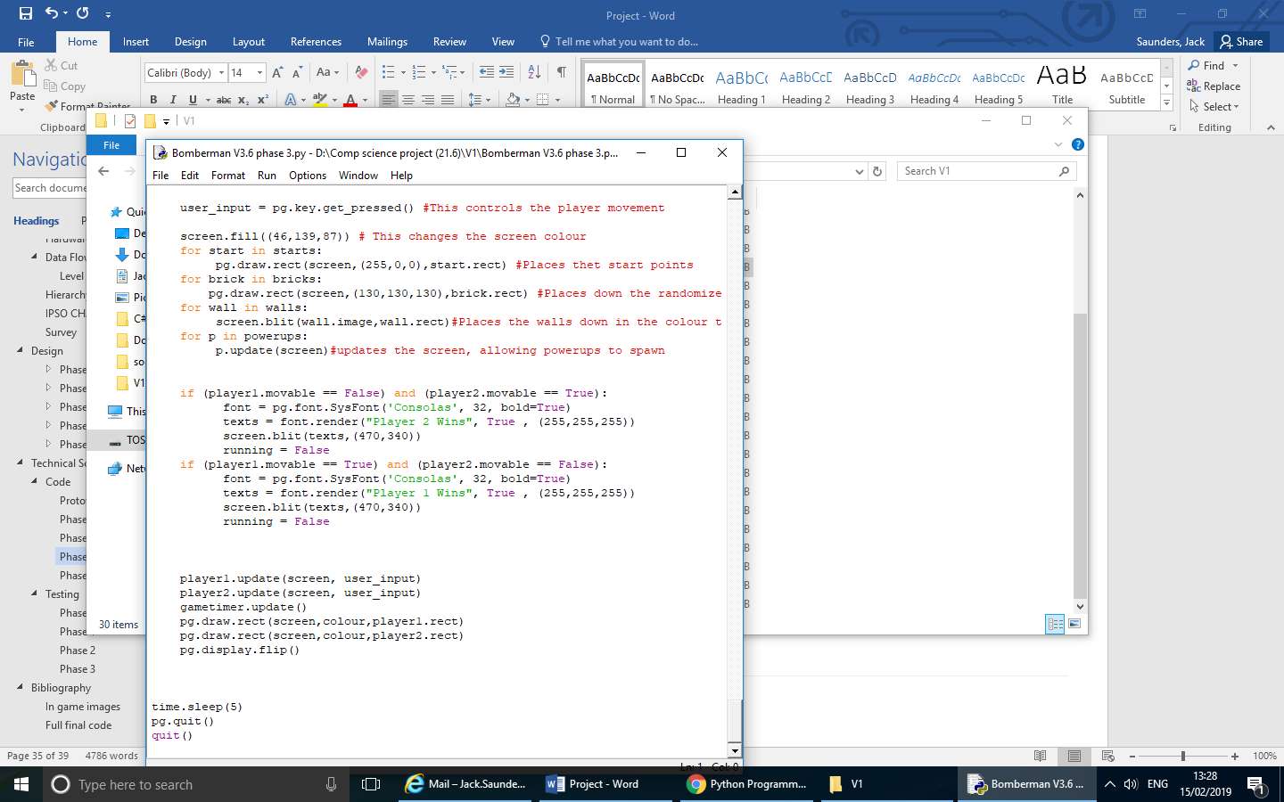

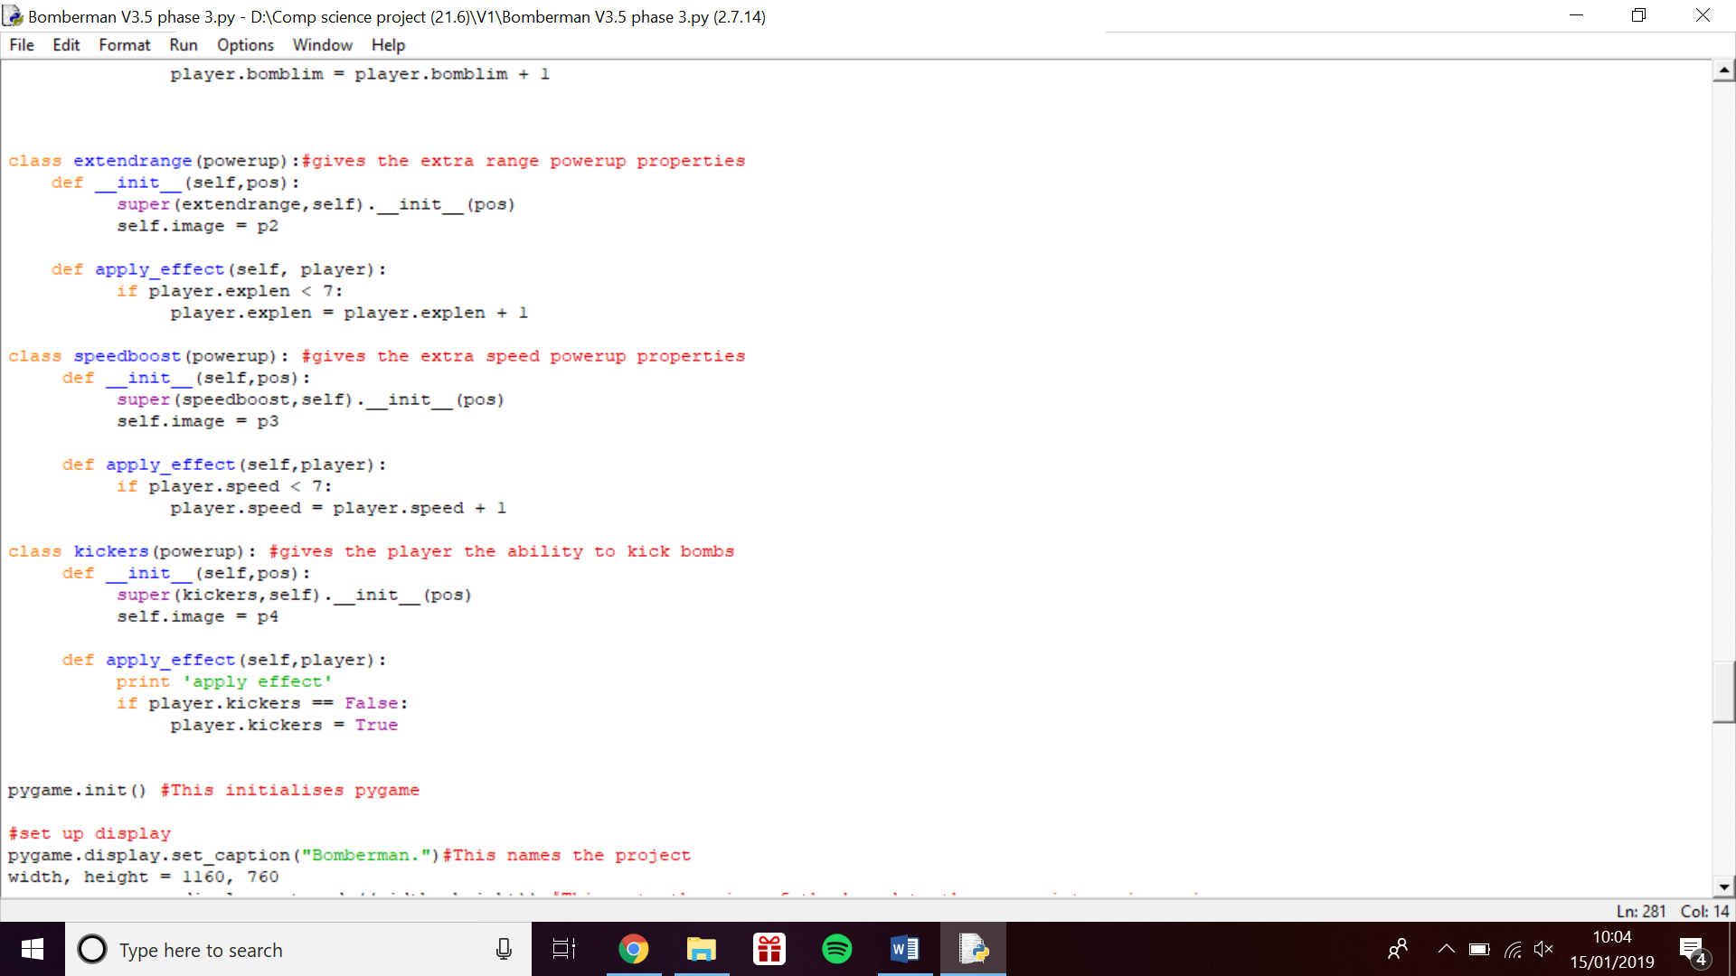

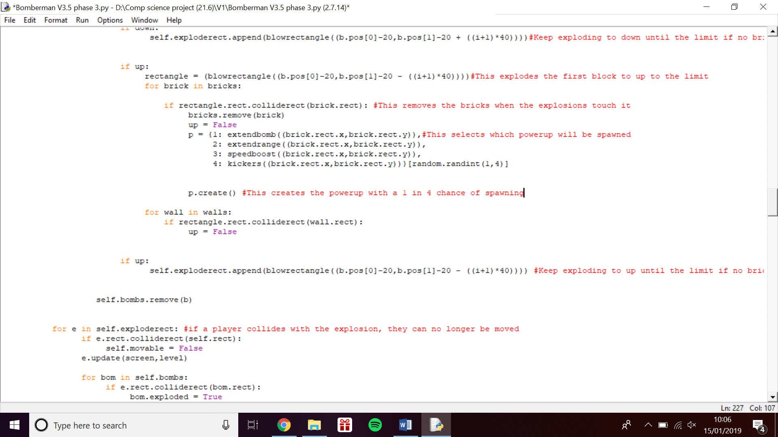

The same code has been used for each direction (up, down, left, right) of the explosions.

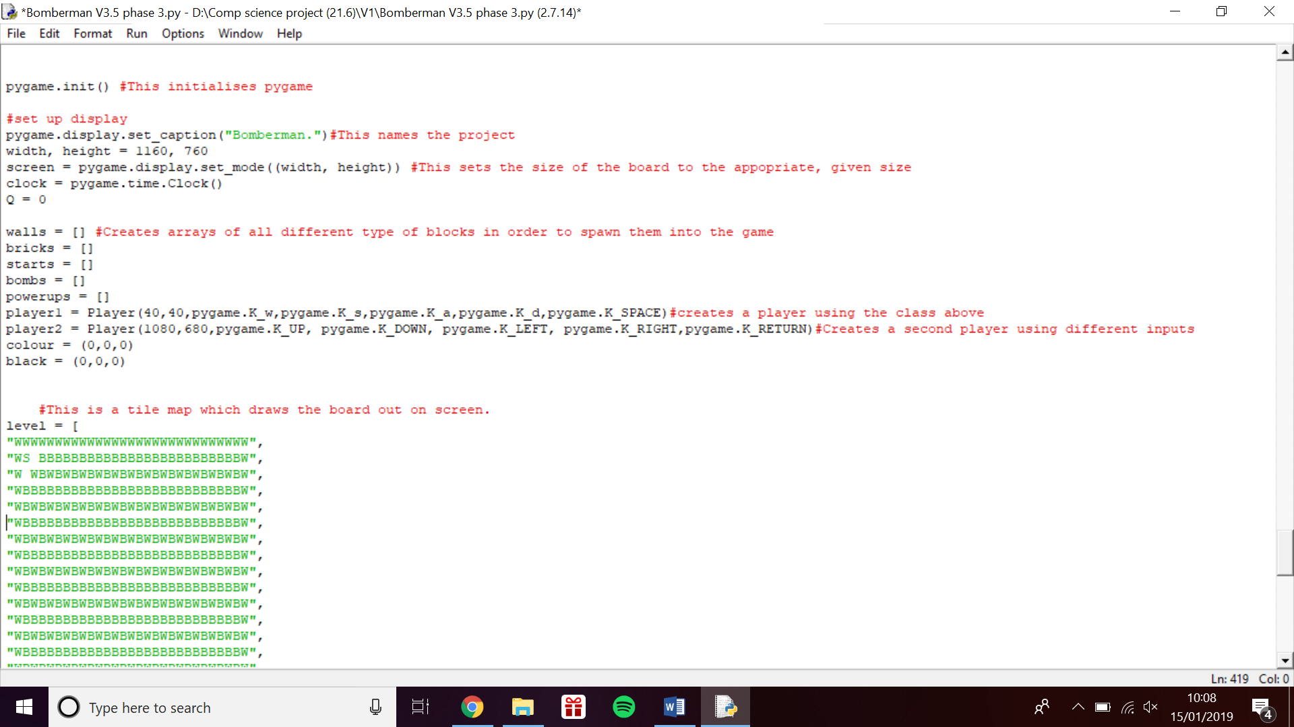

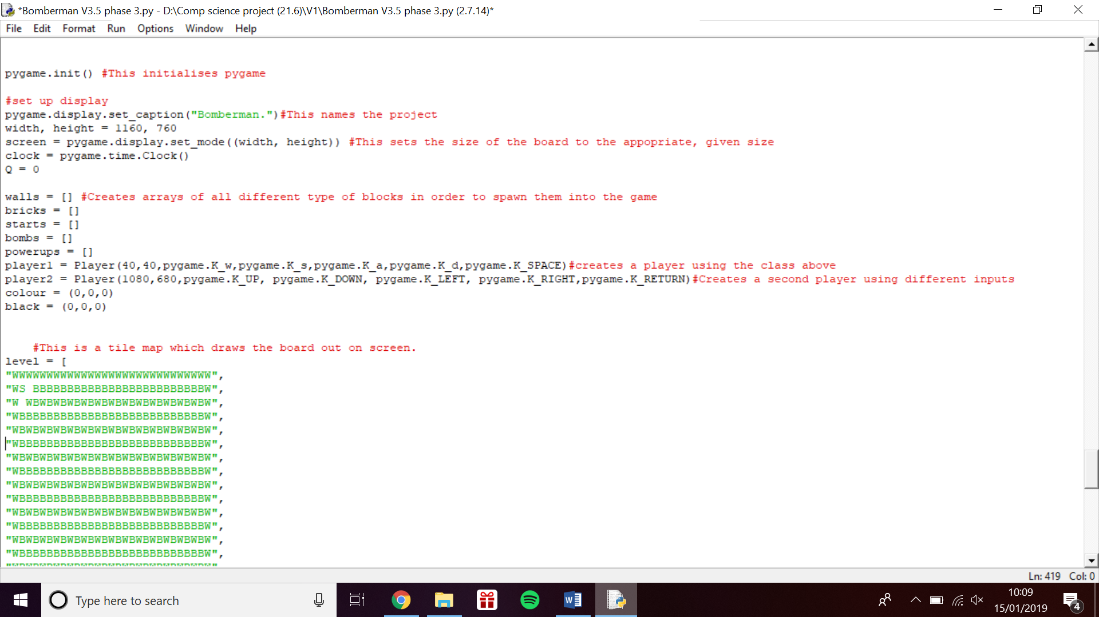

### Stage 4 (Creating a menu)

Throughout stage 4, I hoped to add in a simple title screen to my game as well as adding an account login page. This would mean I will have a fully functioning game at the end of this stage. For this stage I found useful code from the internet [[9]](https://stackoverflow.com/questions/46390231/how-to-create-a-text-input-box-with-pygame). After adding this code to my work, I adjusted it by taking out variables which were not relevant to me and turning the function into a class so I could create multiple instances. At this point I completed two more of my aims. I was able to complete the addition of the start menu, aswell as implementing a simple hashing algorithm which would encode the user’s login and ensure only the correct information allowed login.

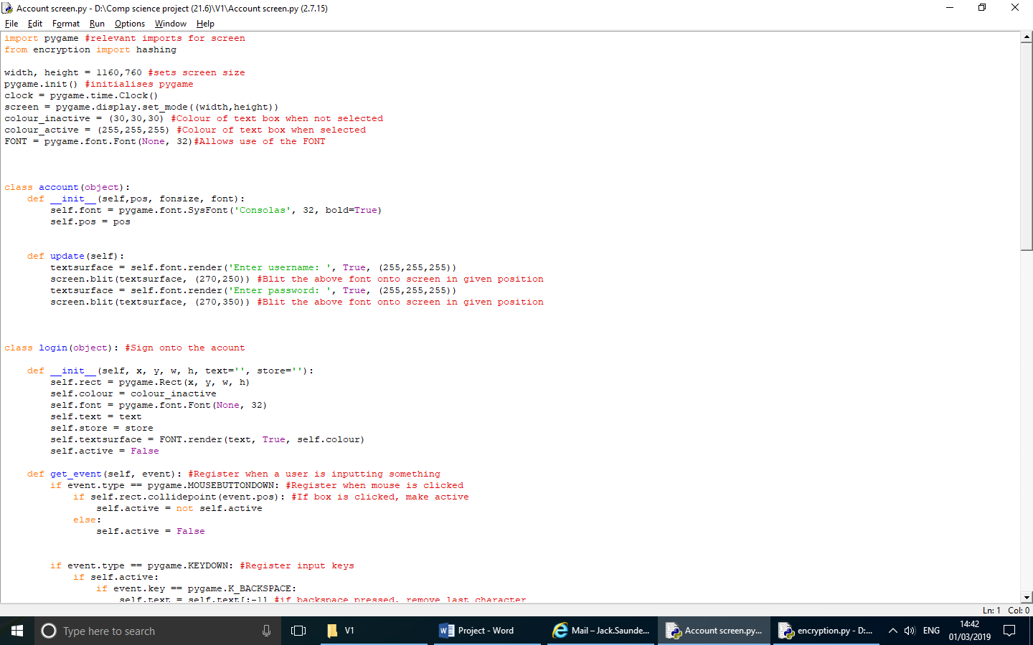

This is the code for the login which is the first page to be accessed when the game is opened.

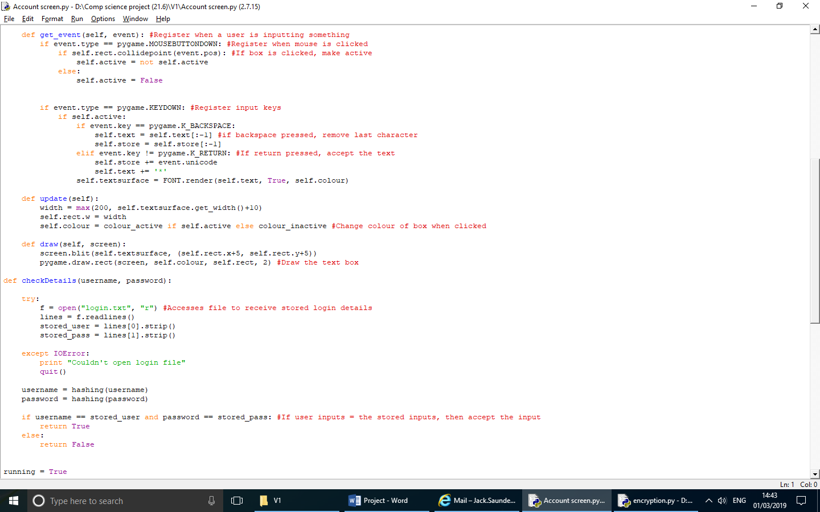

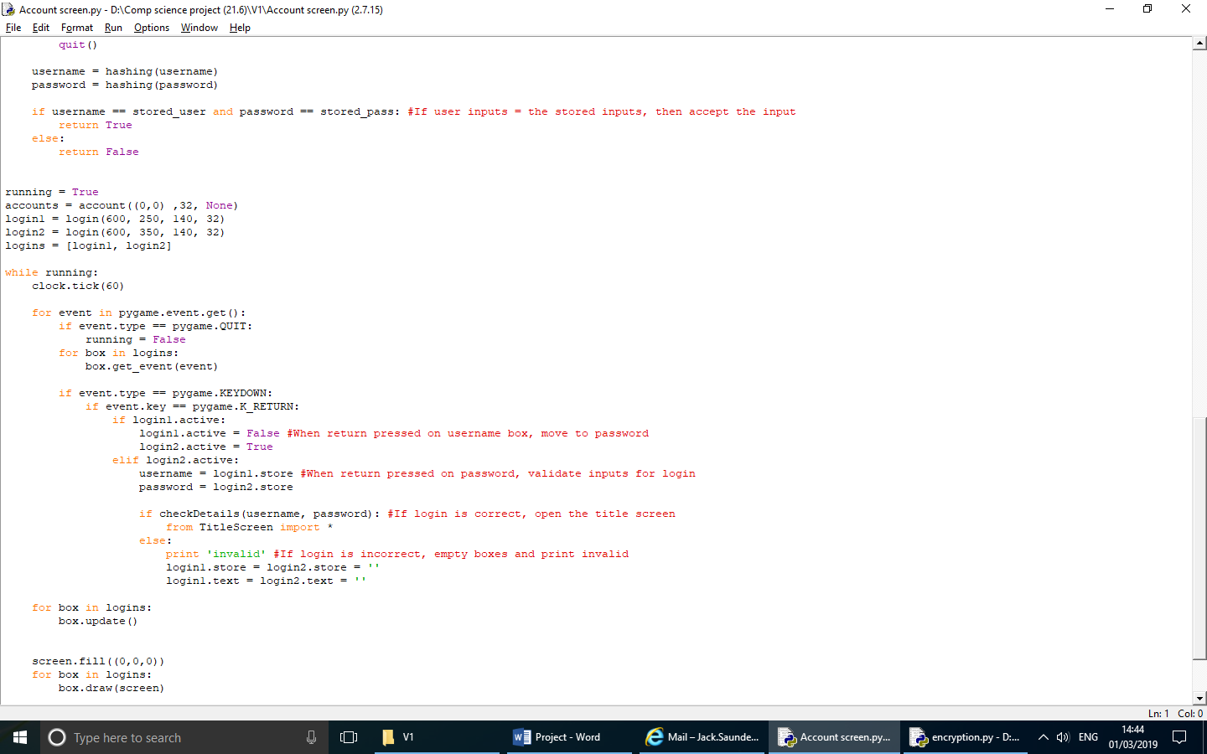

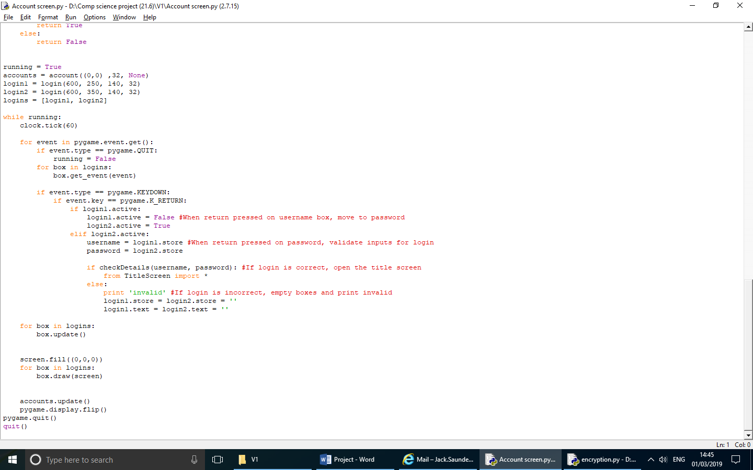

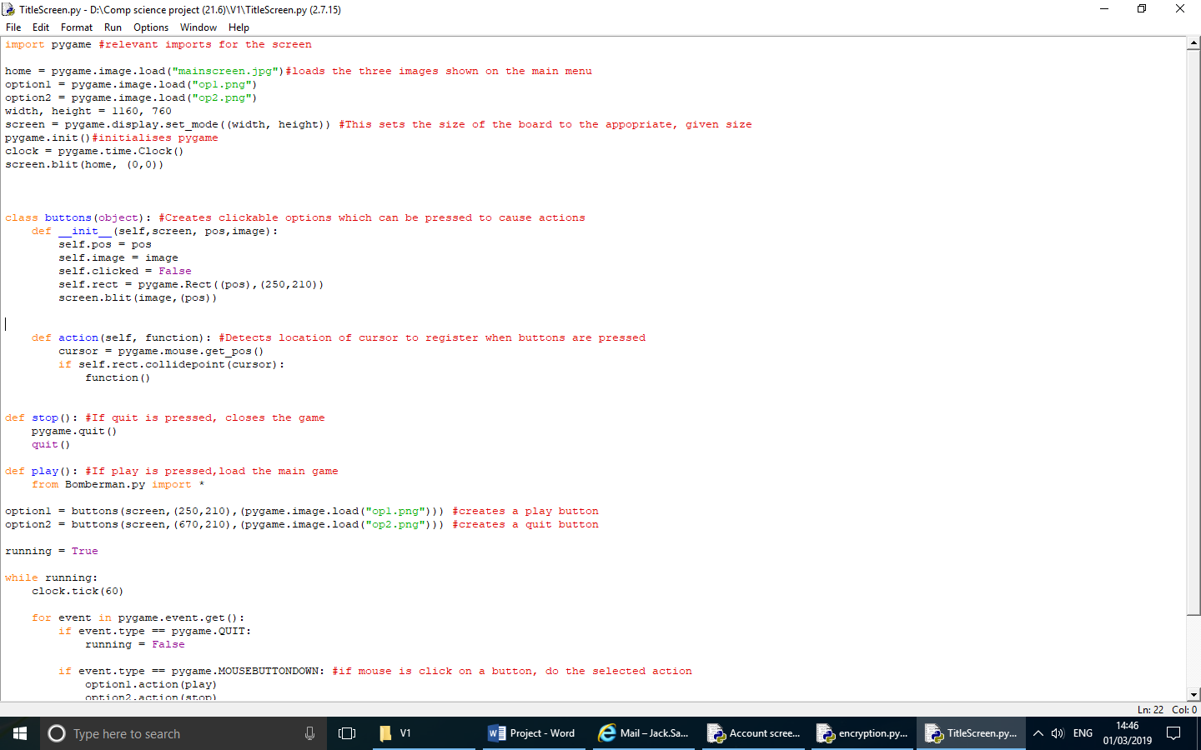This code creates the title screen which will later allow access to the full game.

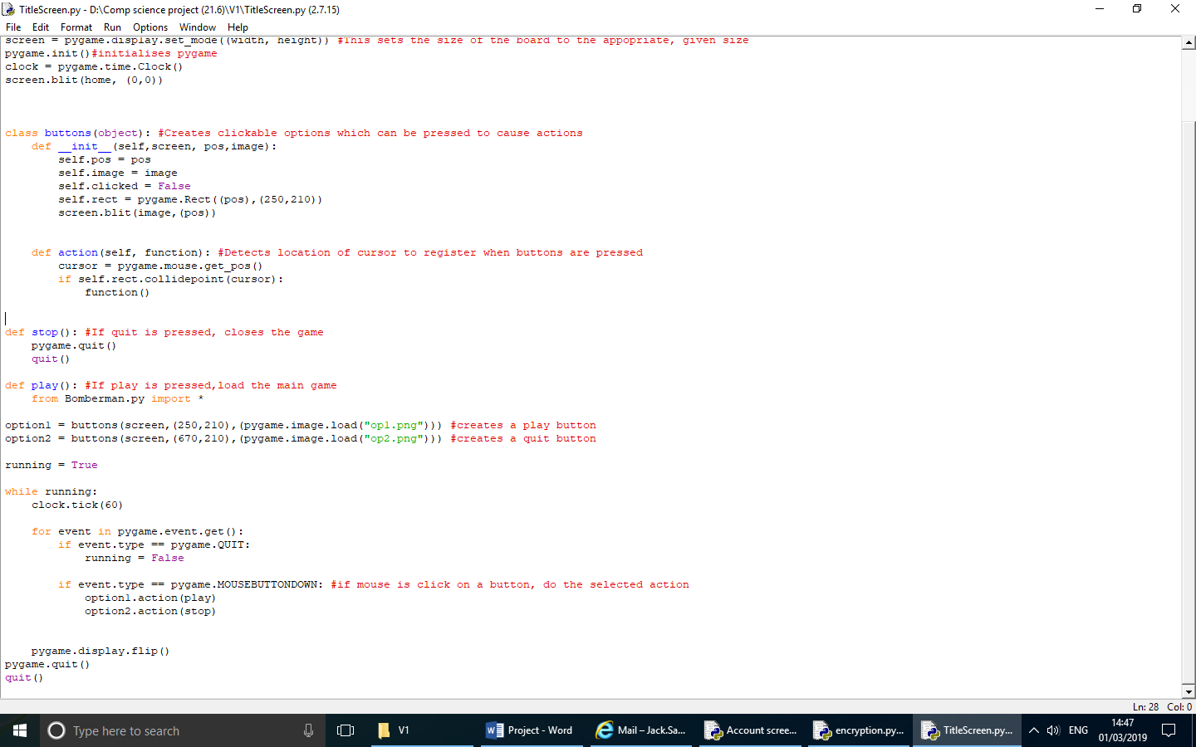

This code creates an encryption which will be used on the login data in order to secure the details the user entered for their login.

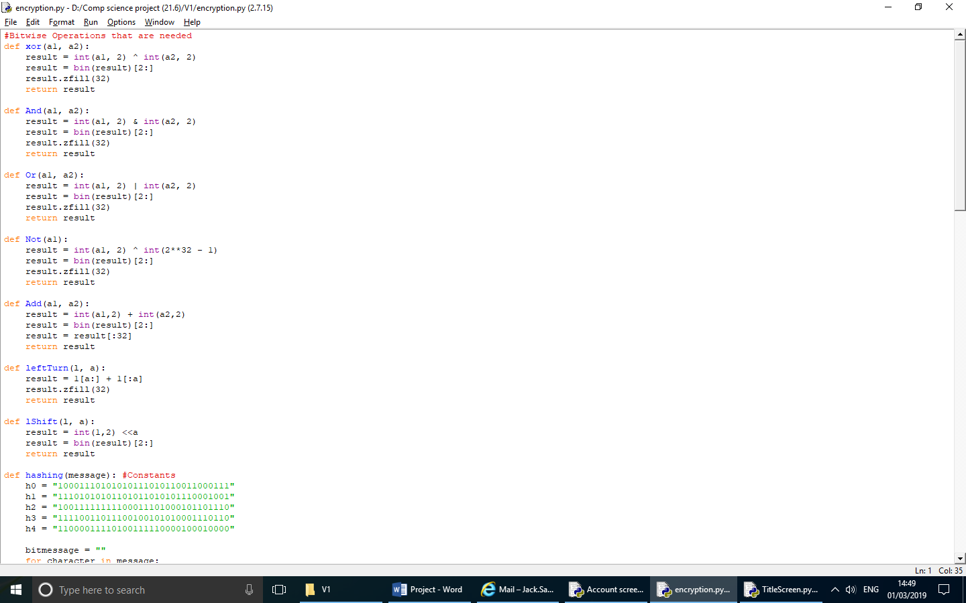

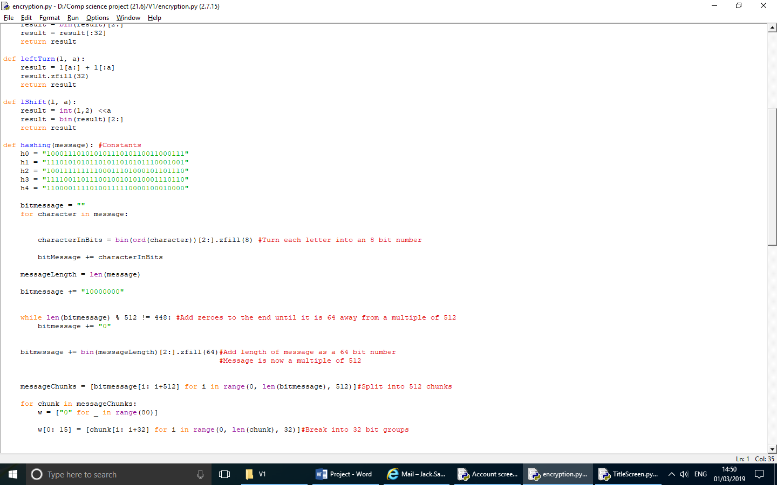

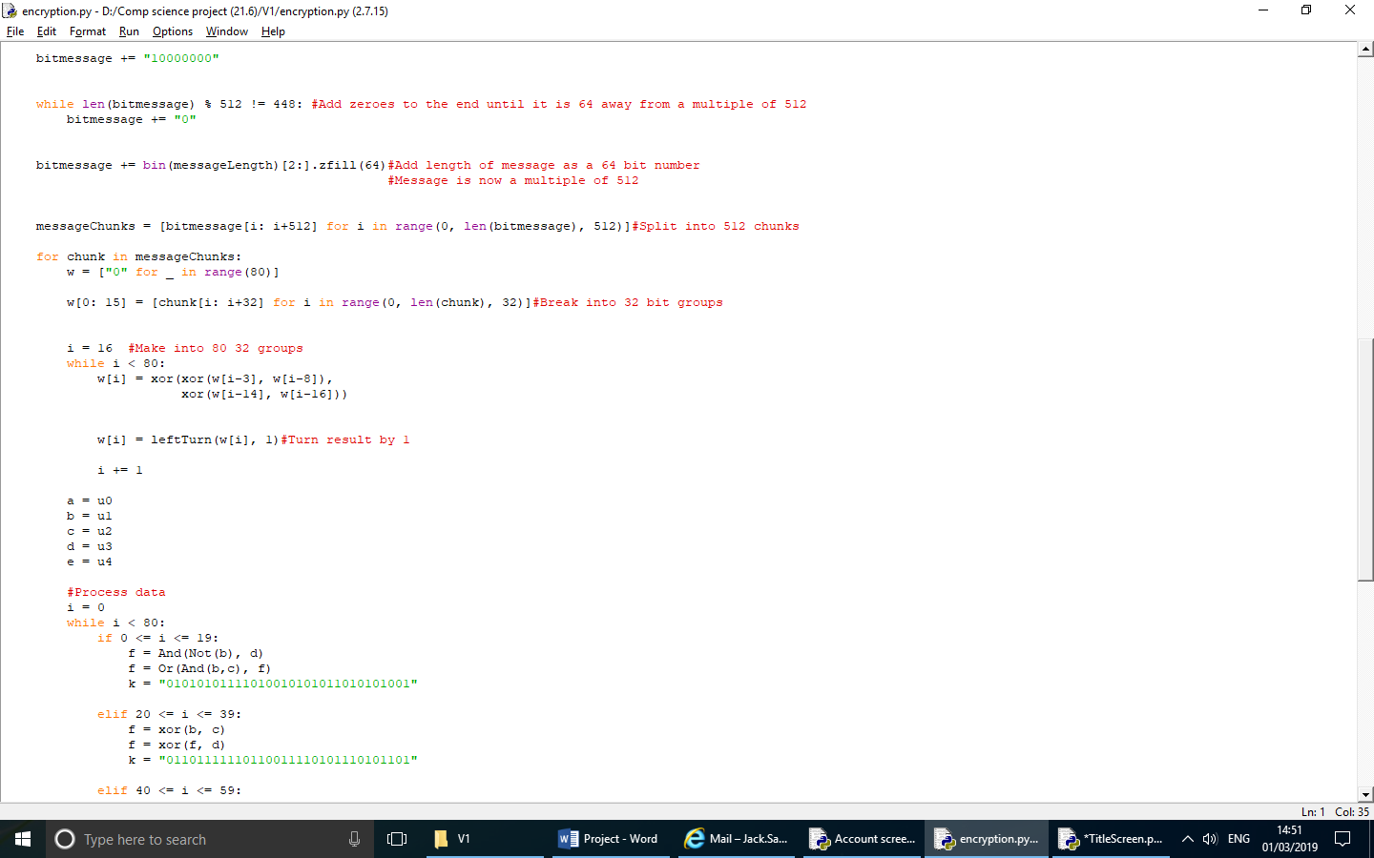

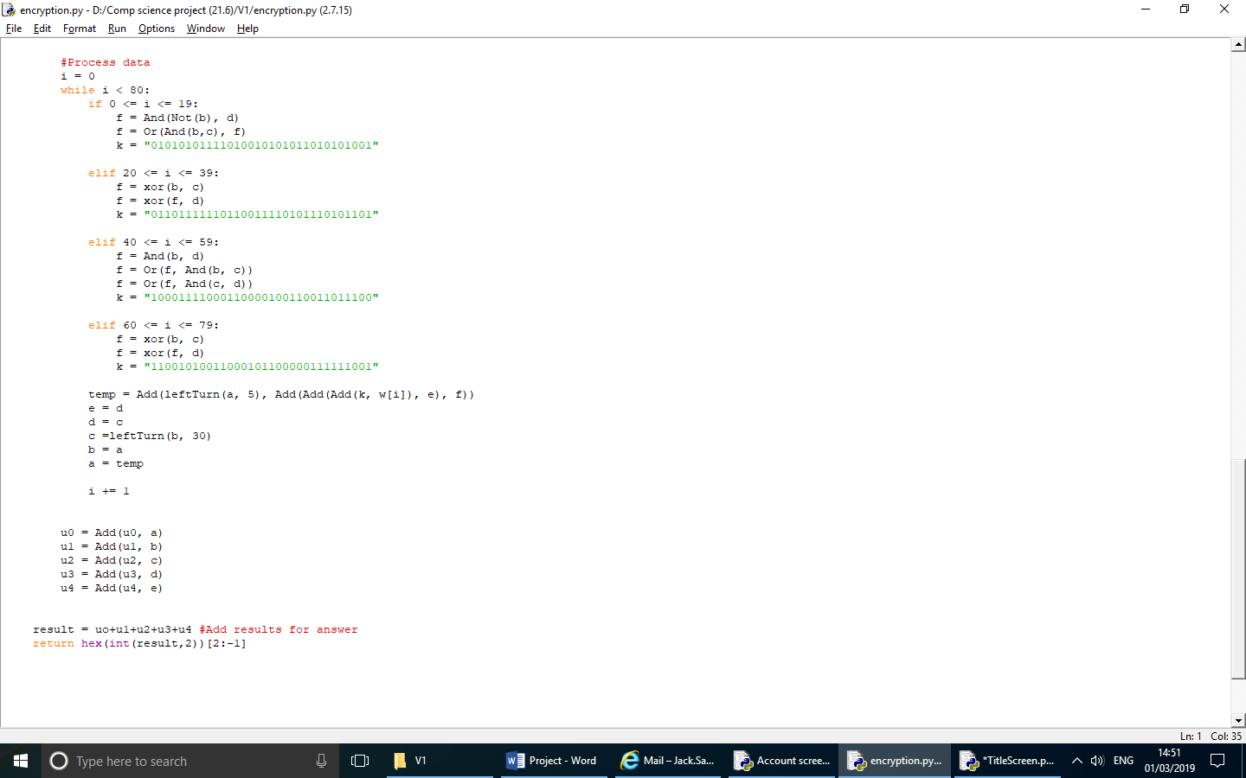

## **Full final code**

### Main Program

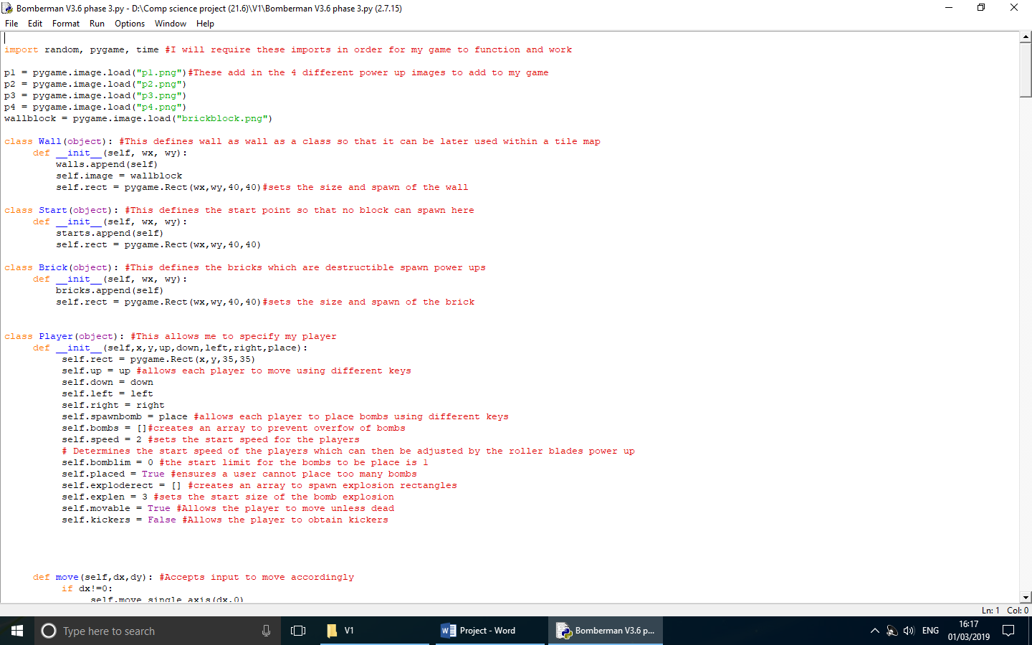

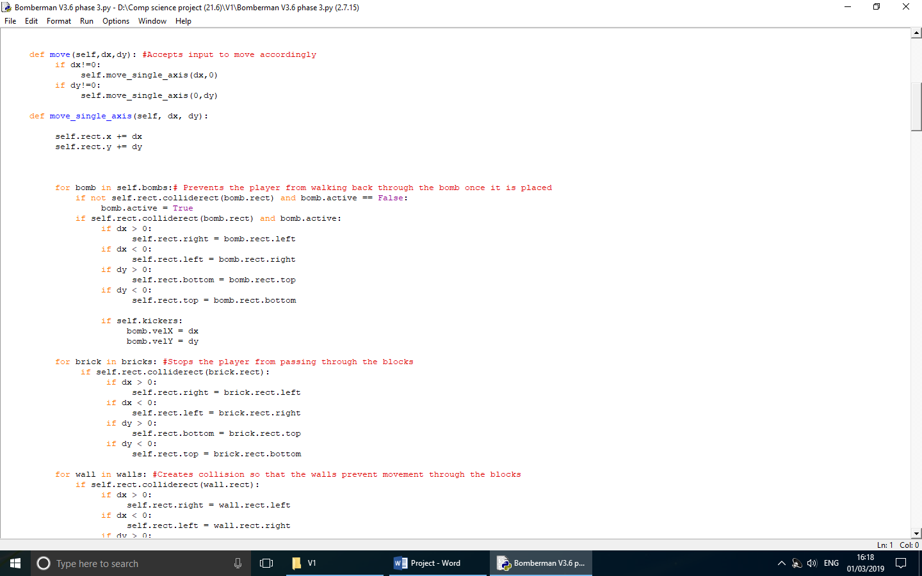

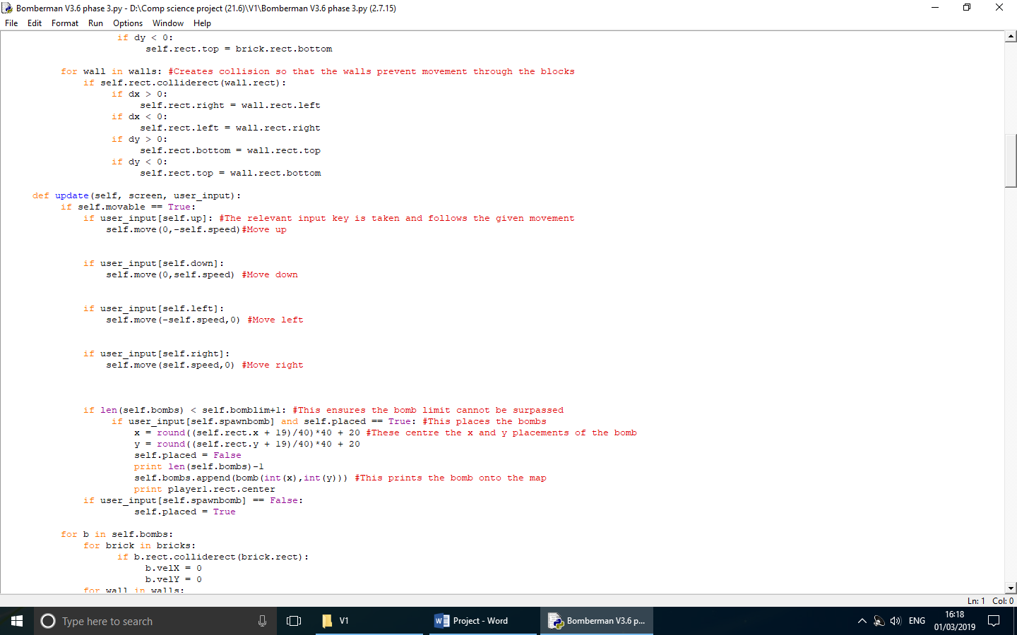

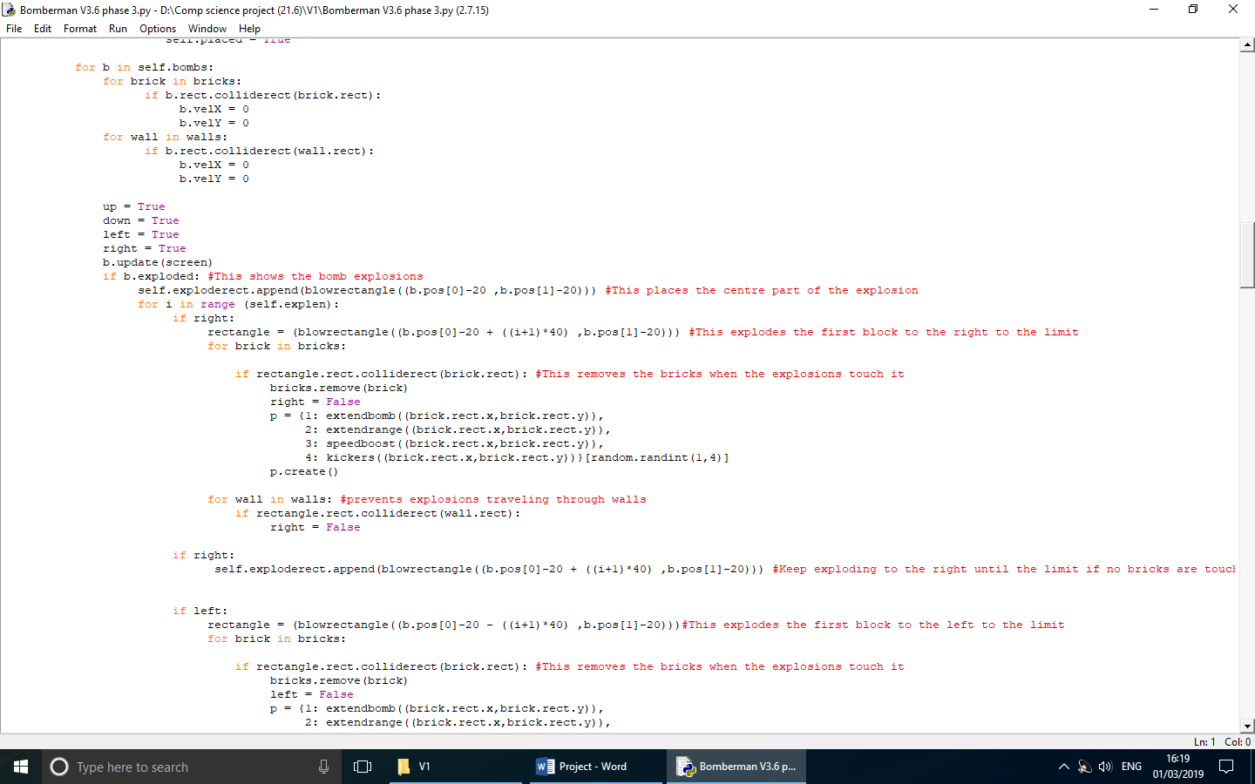

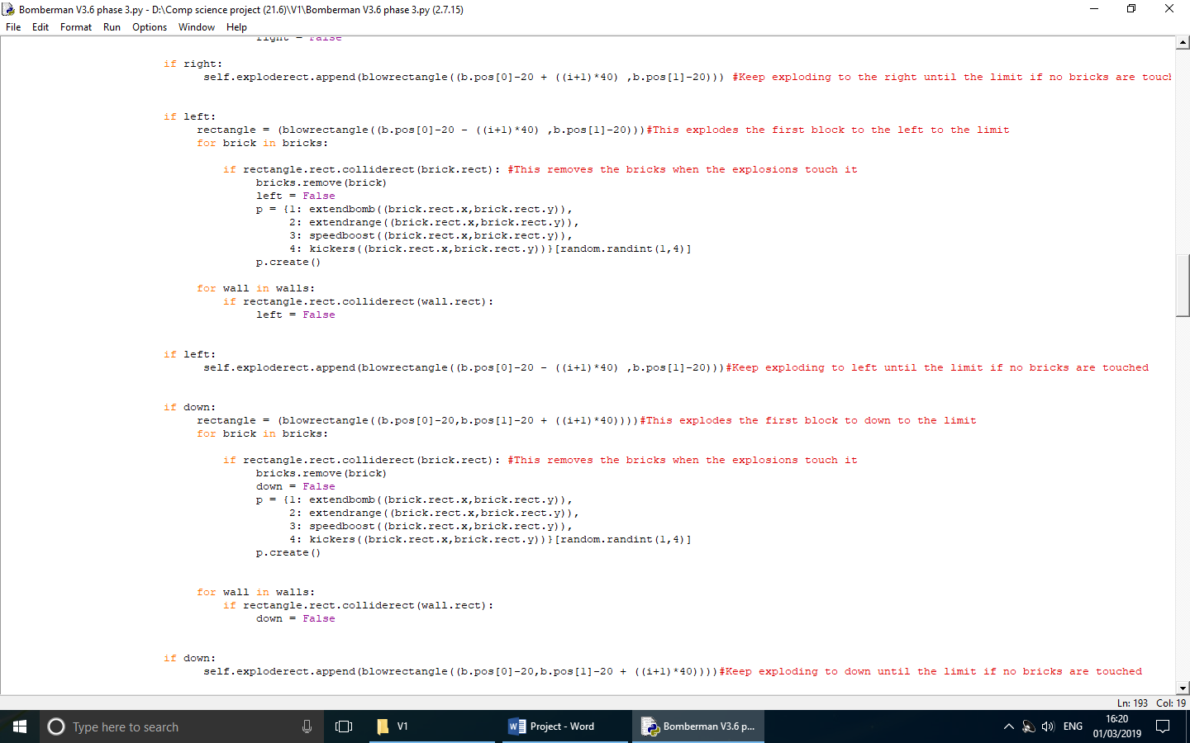

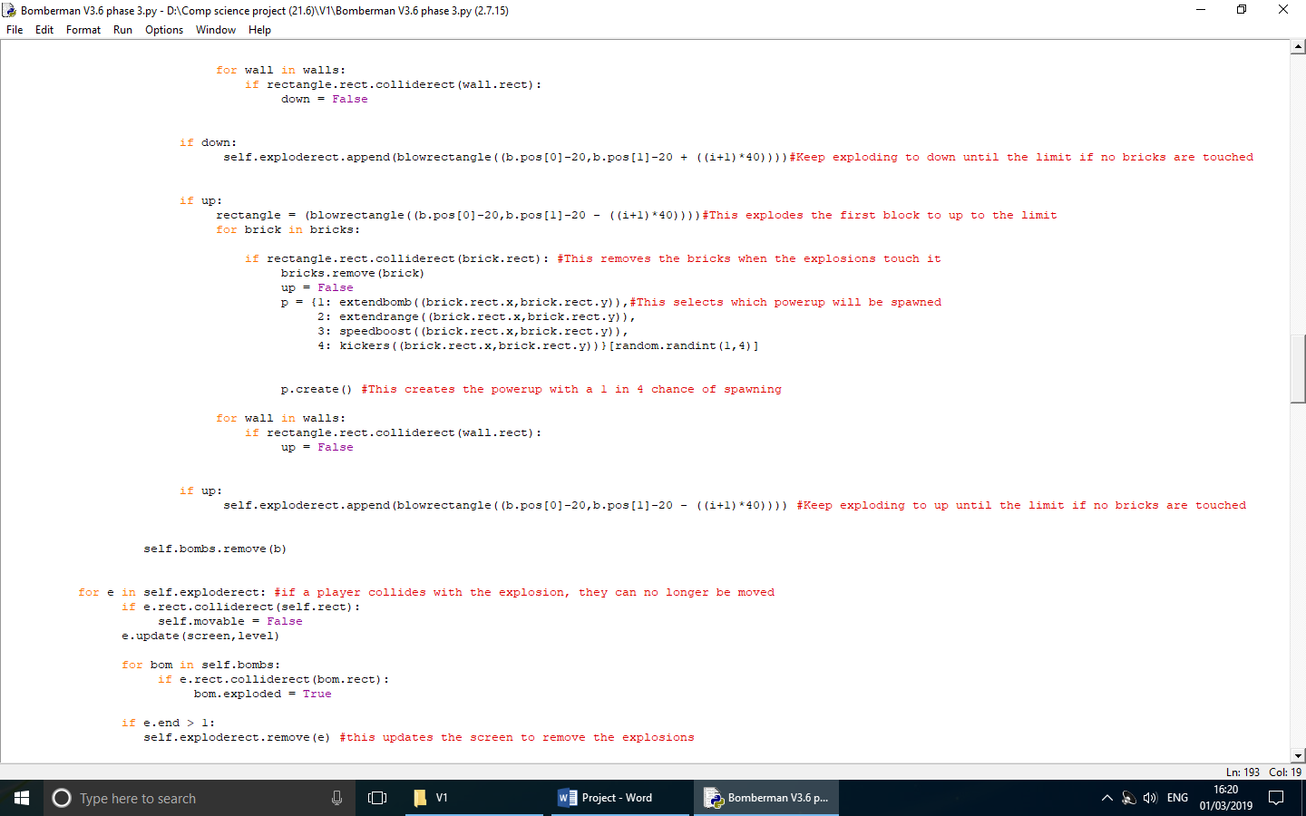

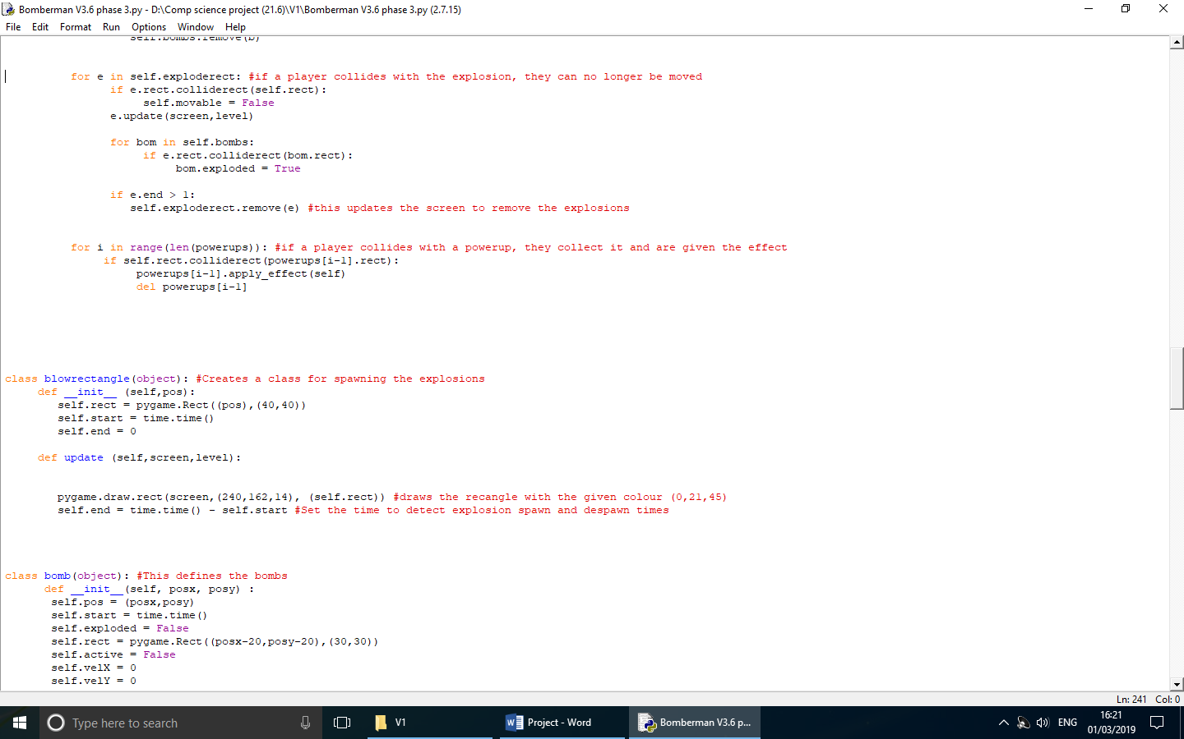

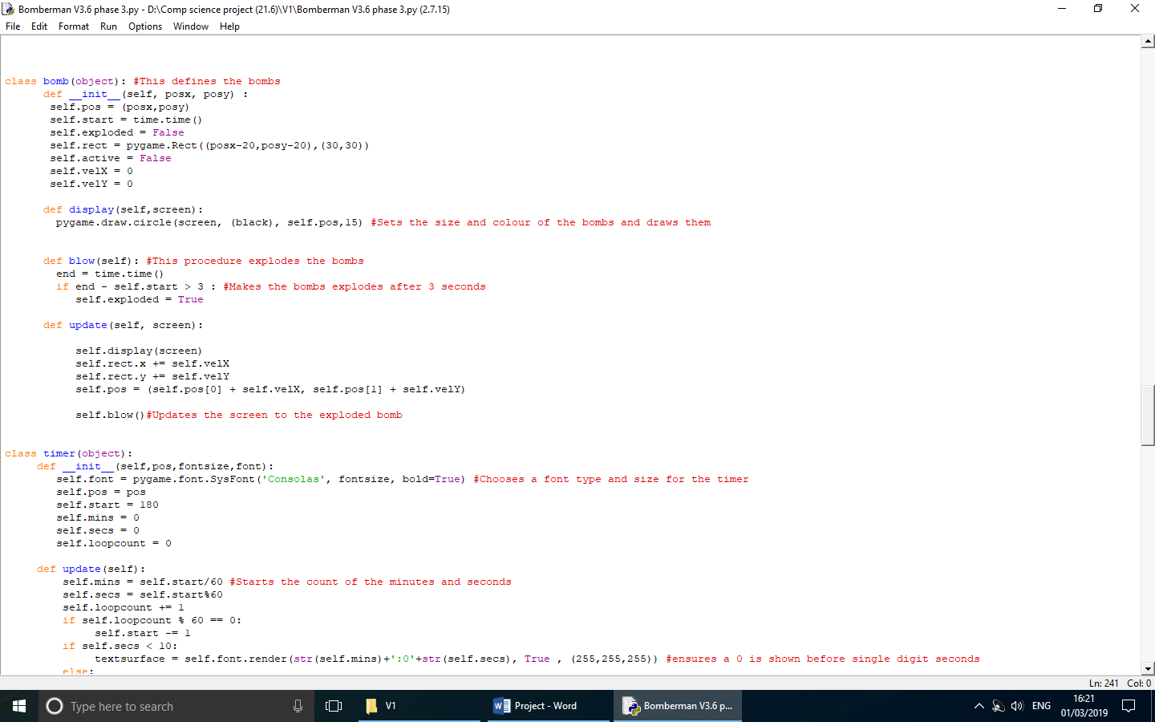

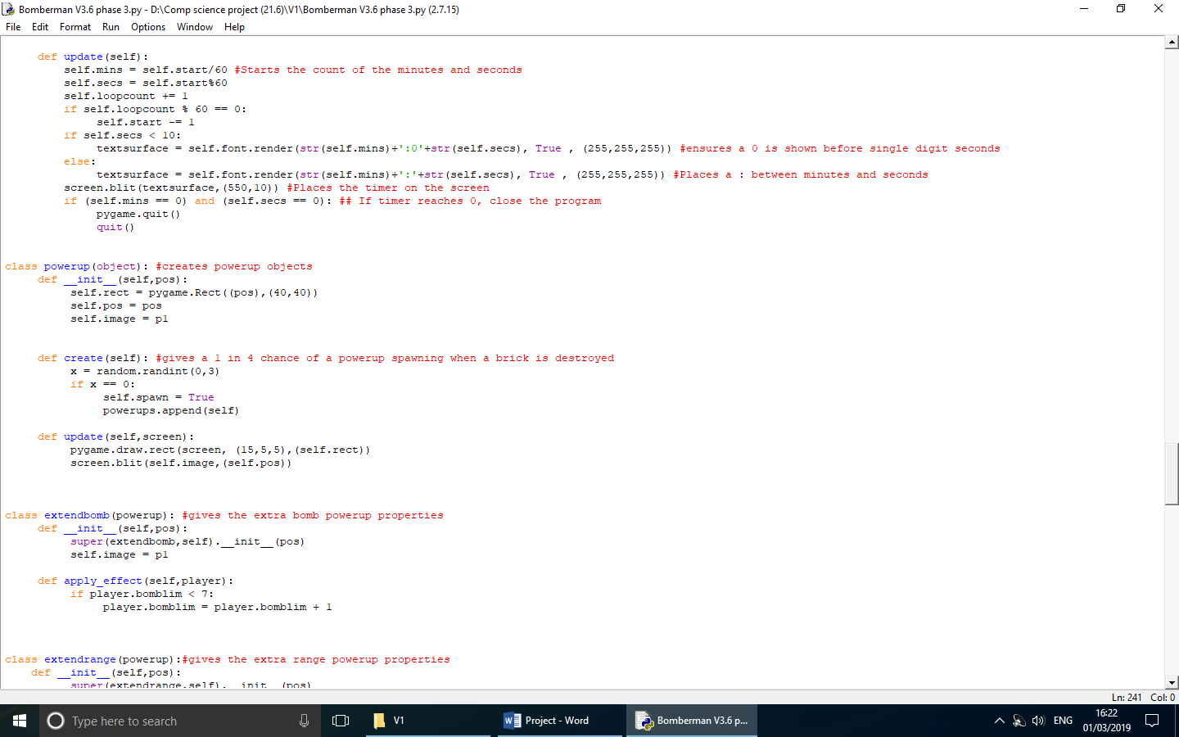

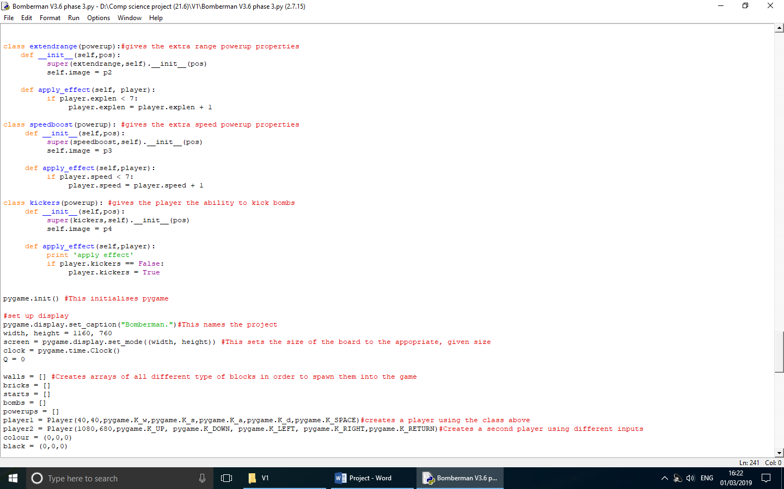

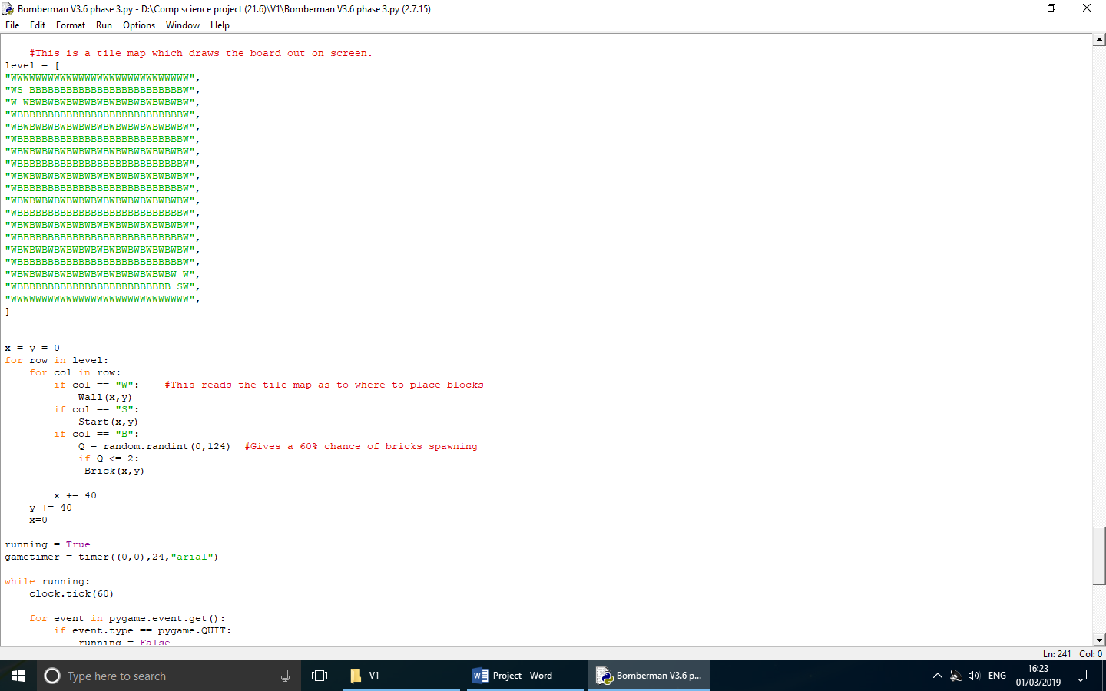

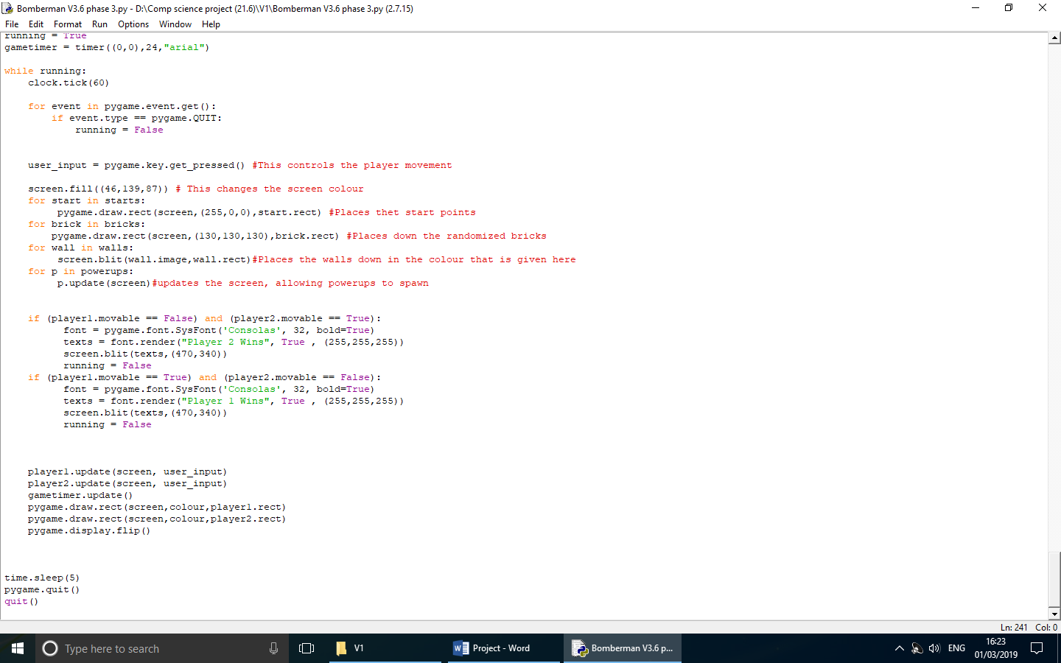

### Account Screen

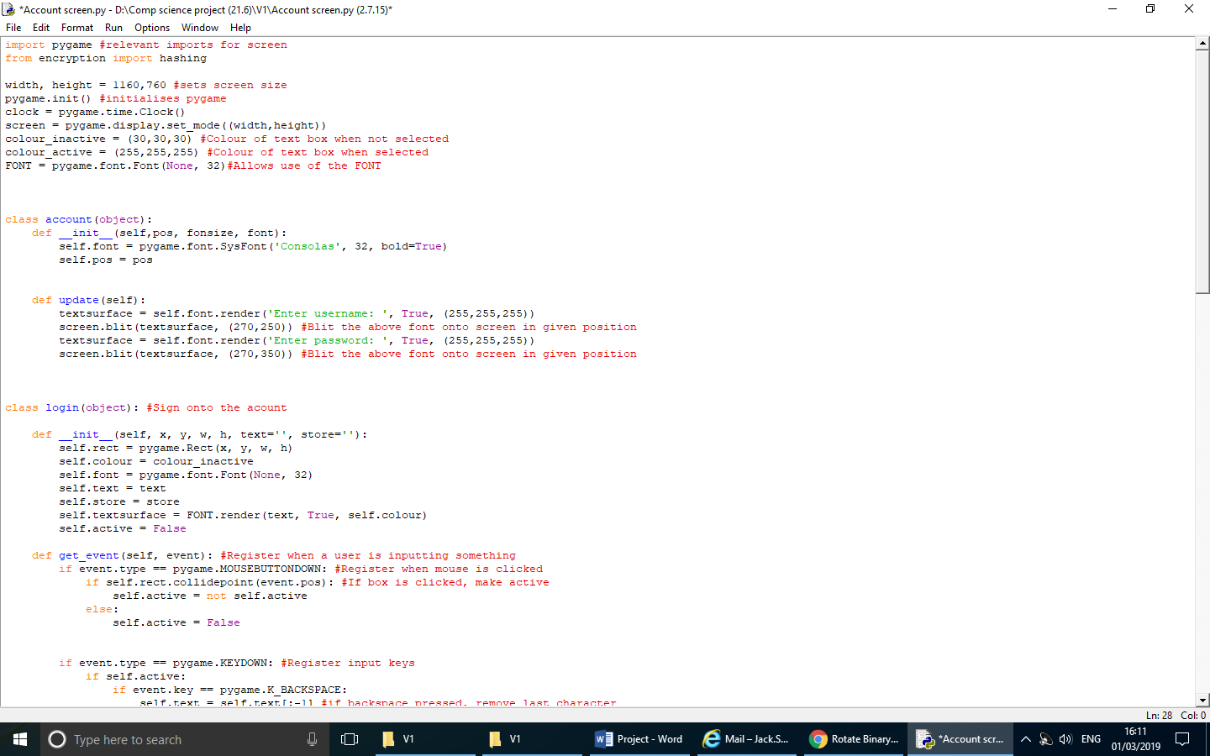

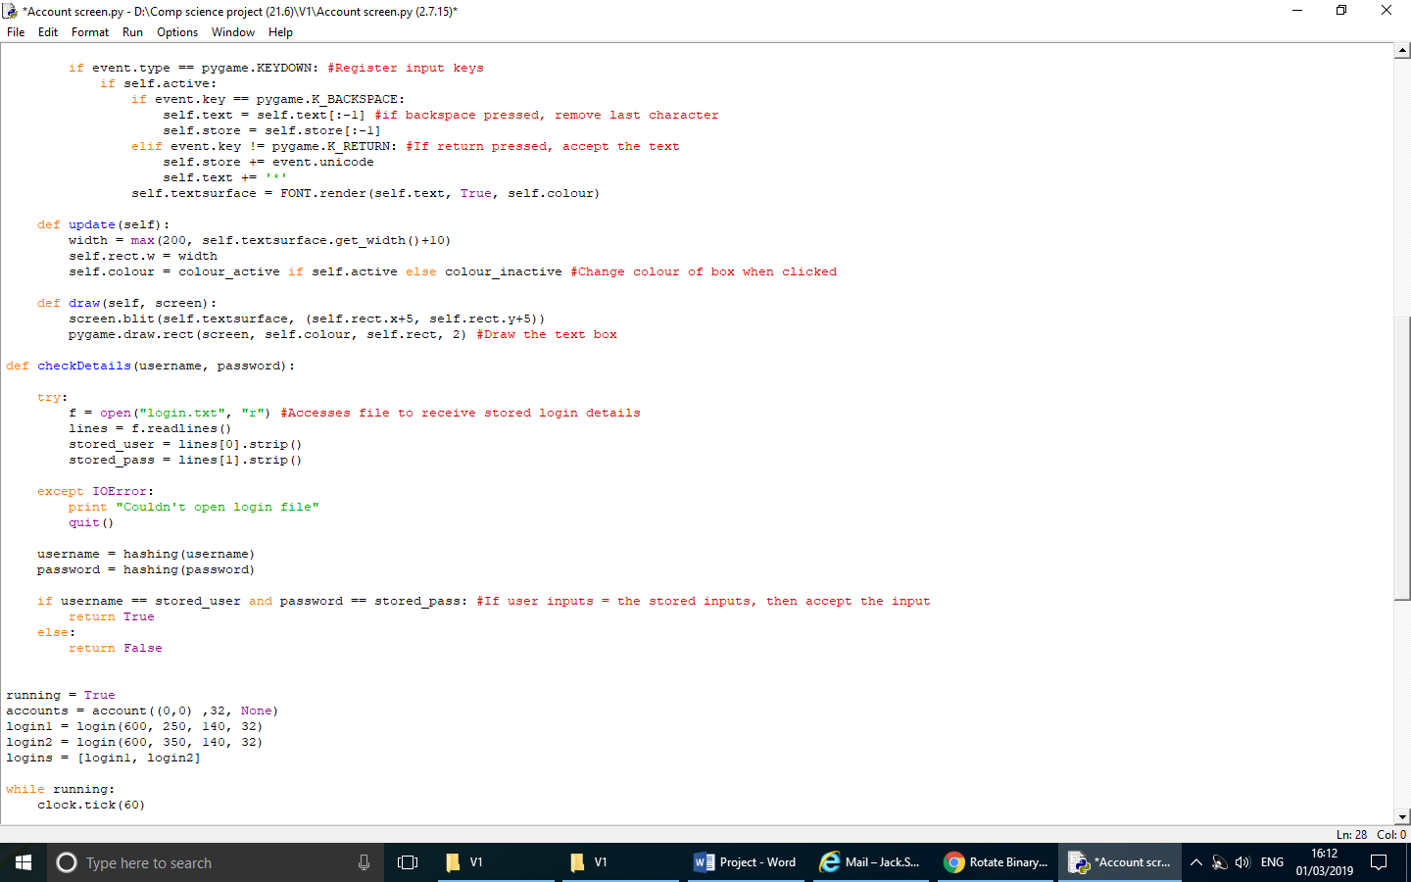

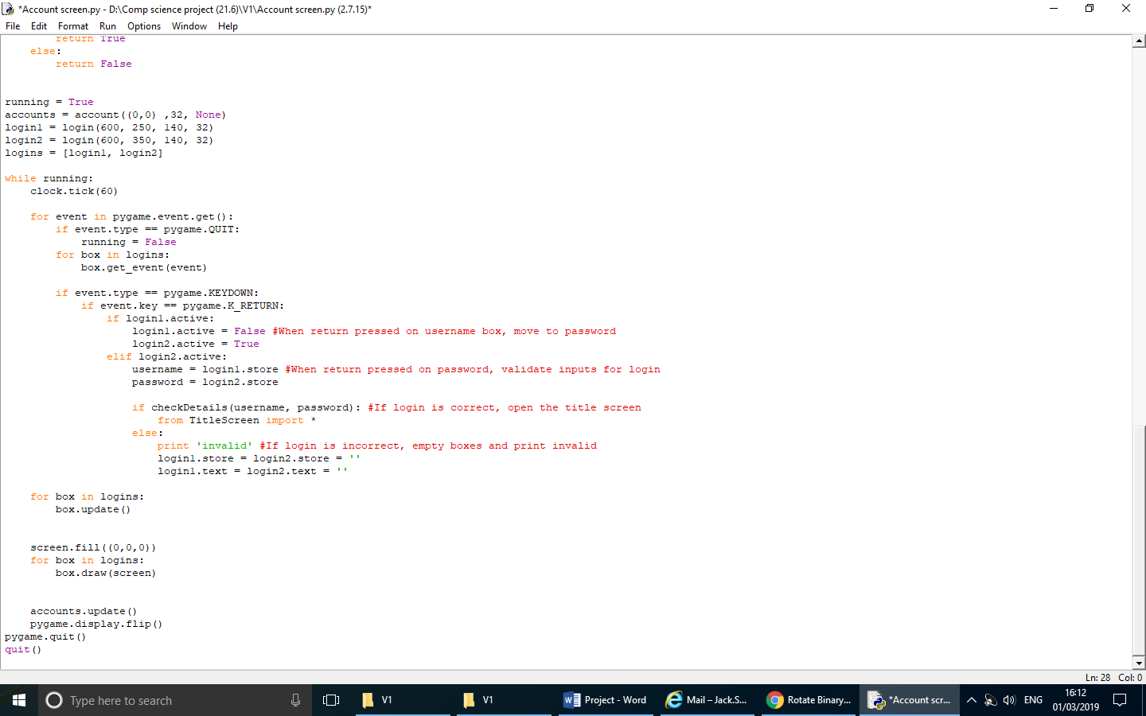

### Title Screen

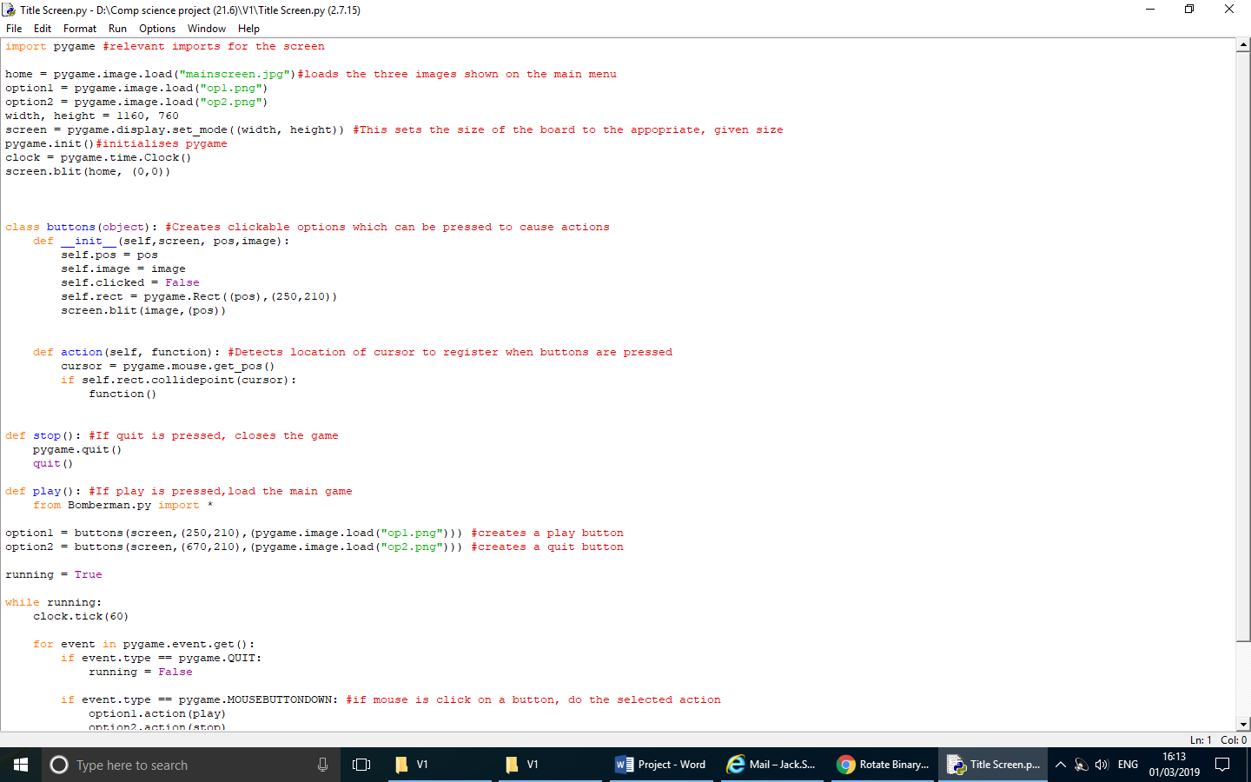

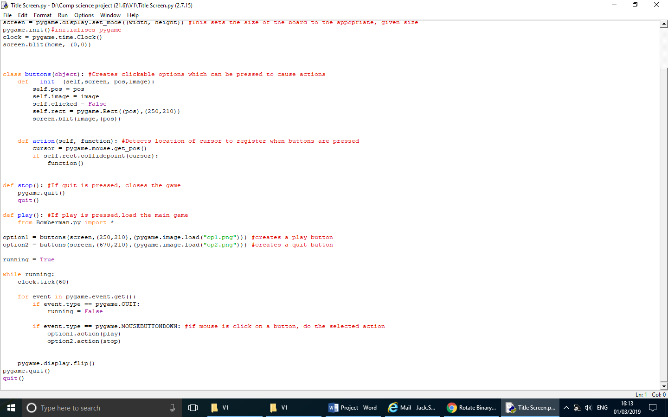

### Encryption

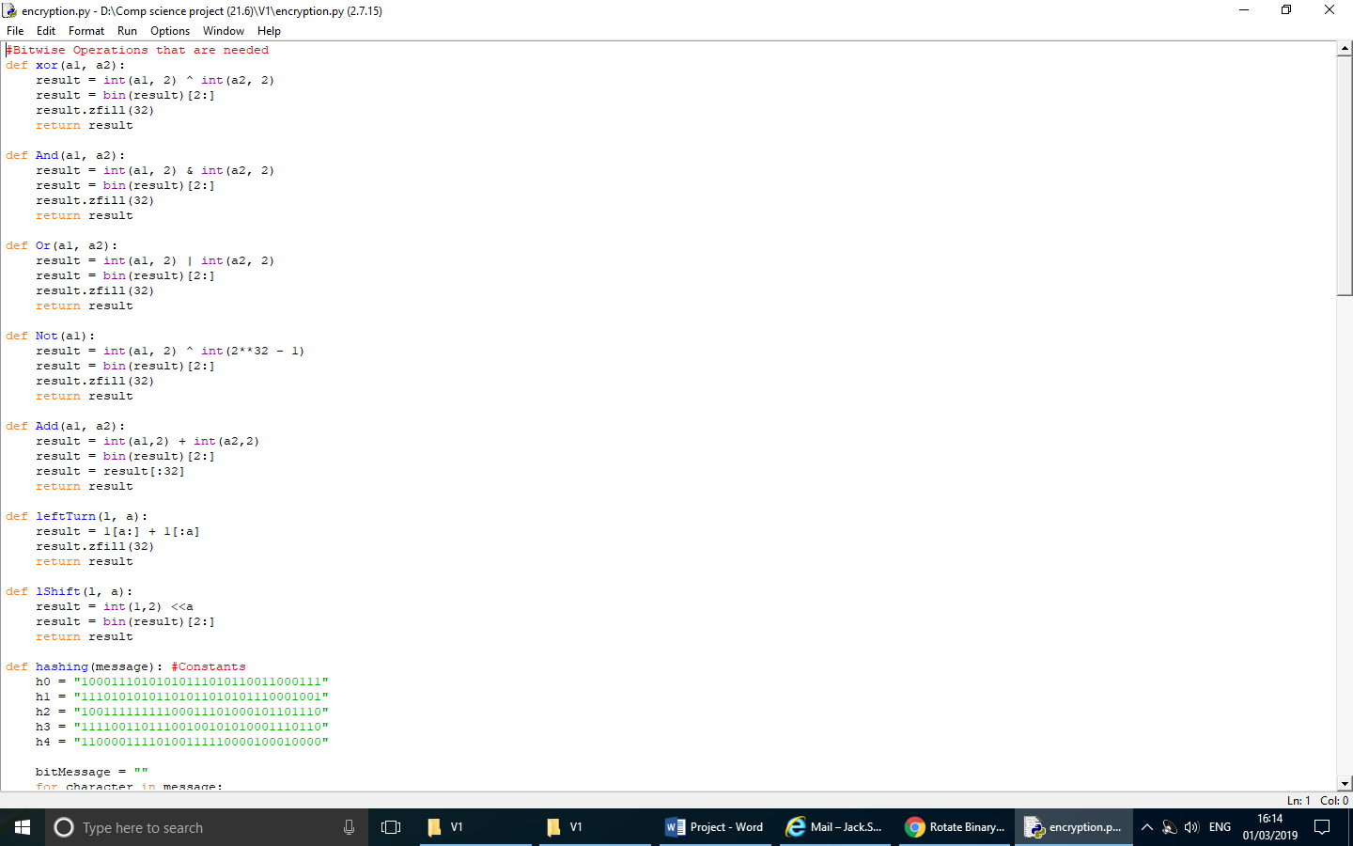

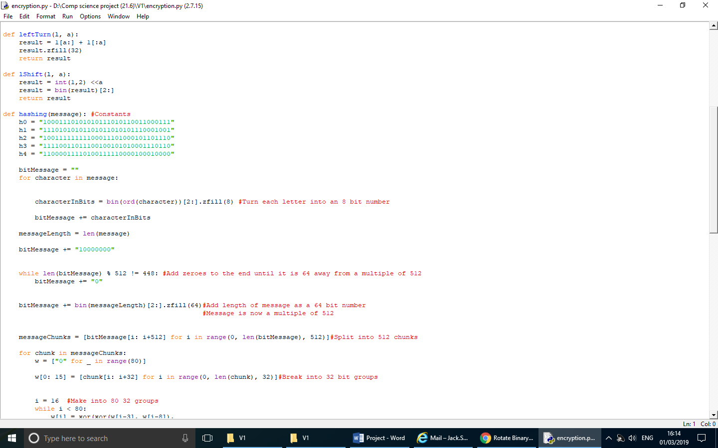

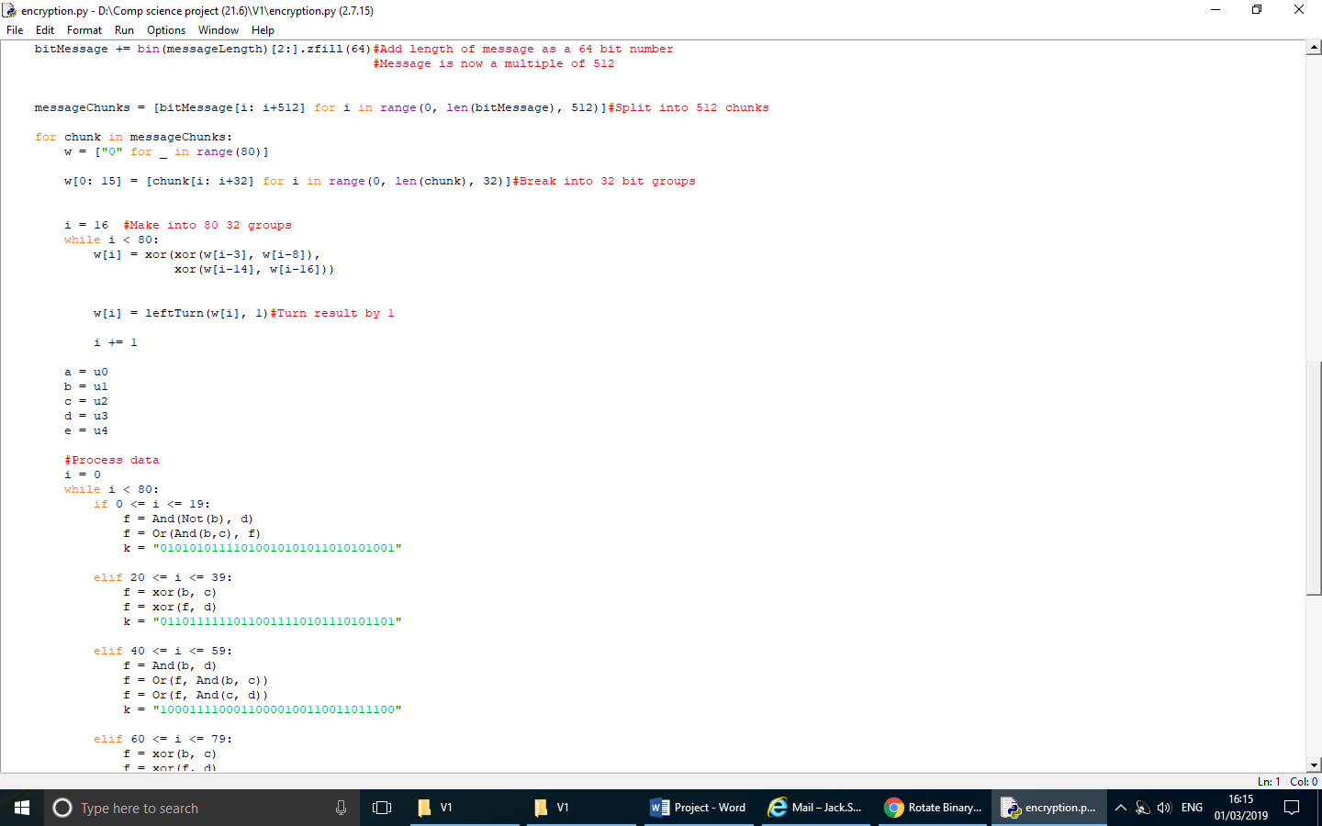

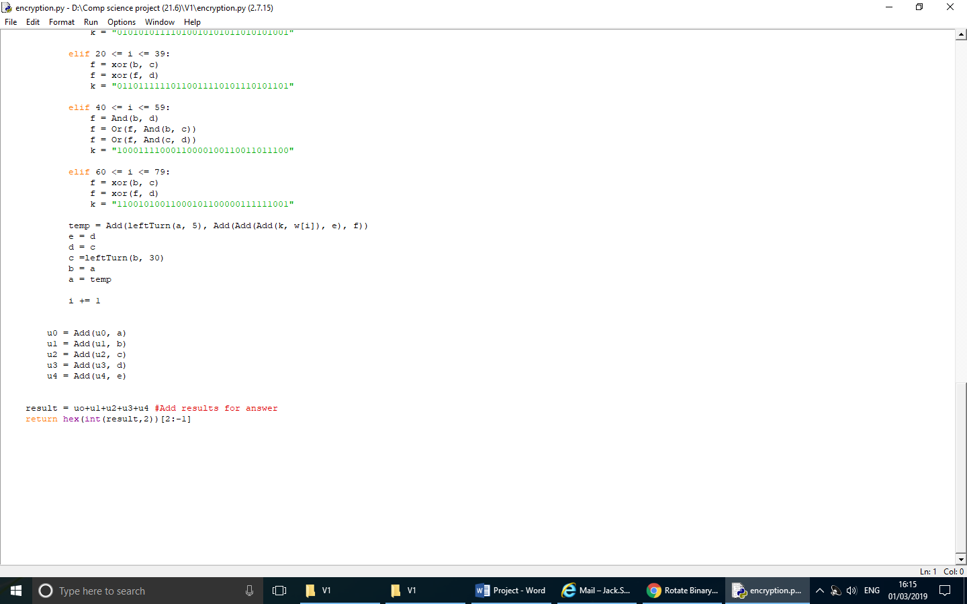

# **Testing**

## Stage 0 (Prototype)

|  |  |  |  |  |  |
| --- | --- | --- | --- | --- | --- |
| Test Number | Description | Expected outcome | Actual outcome | Solution | Test Type |
| 1 | “W” Pressed | Player moves  up | Player moves  up | N/A | Standard |
| 2 | “A” Pressed | Player moves left | Player moves left | N/A | Standard |
| 3 | “S” Pressed | Player moves down | Player moves down | N/A | Standard |
| 4 | “D” Pressed | Player moves right | Player moves right | N/A | Standard |
| 5 | Wall collision working | Player cannot move through walls | Player cannot move through walls | N/A | Standard |
| 6 | “Shift” Pressed | Player movement speed increased | Player movement speed increased | N/A | Standard |

During stage 0, it was found that the end users did not want a key would increase speed as the powerup would do so. It was clear that it would be better to use only the powerup as opposed to allowing both options.

My testing of stage 0 allowed me to begin working on the second of my aims – allowing two players to play simultaneously. I created the first player which was effectively able to move around the board and prepare me to add my second player.

## Stage 1 (Creating a map and a player)

|  |  |  |  |  |  |
| --- | --- | --- | --- | --- | --- |
| Test Number | Description | Expected outcome | Actual outcome | Solution | Test Type |
| 1 | “SPACE” Pressed | Bomb placed | Bomb placed | N/A | Standard |
| 2 | Explosion on brick | Brick removed | Brick removed | N/A | Standard |
| 3 | Explosion on wall | Wall does not change and blocks explosion | Wall does not change and blocks explosion | N/A | Standard |
| 4 | Pressing key with no function | Nothing happens | Nothing happens | N/A | Erroneous |
| 5 | Timer | Game stops and closes when timer reaches 0 | Timer continued past 0 and game was not close | Add a function to register when 0 seconds was reached which would break then close pygame | Standard |

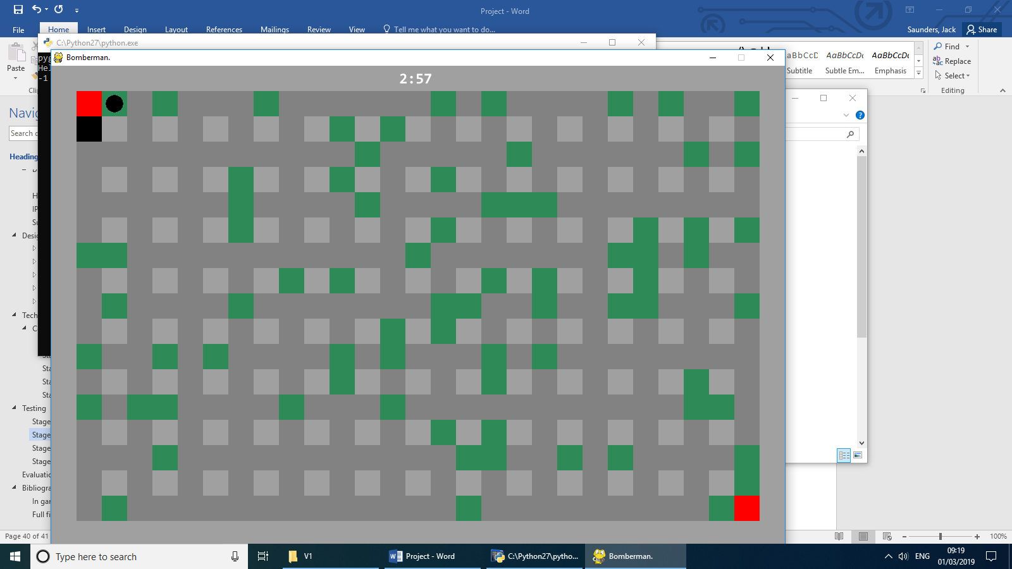 The bomb has been placed using the spacebar.

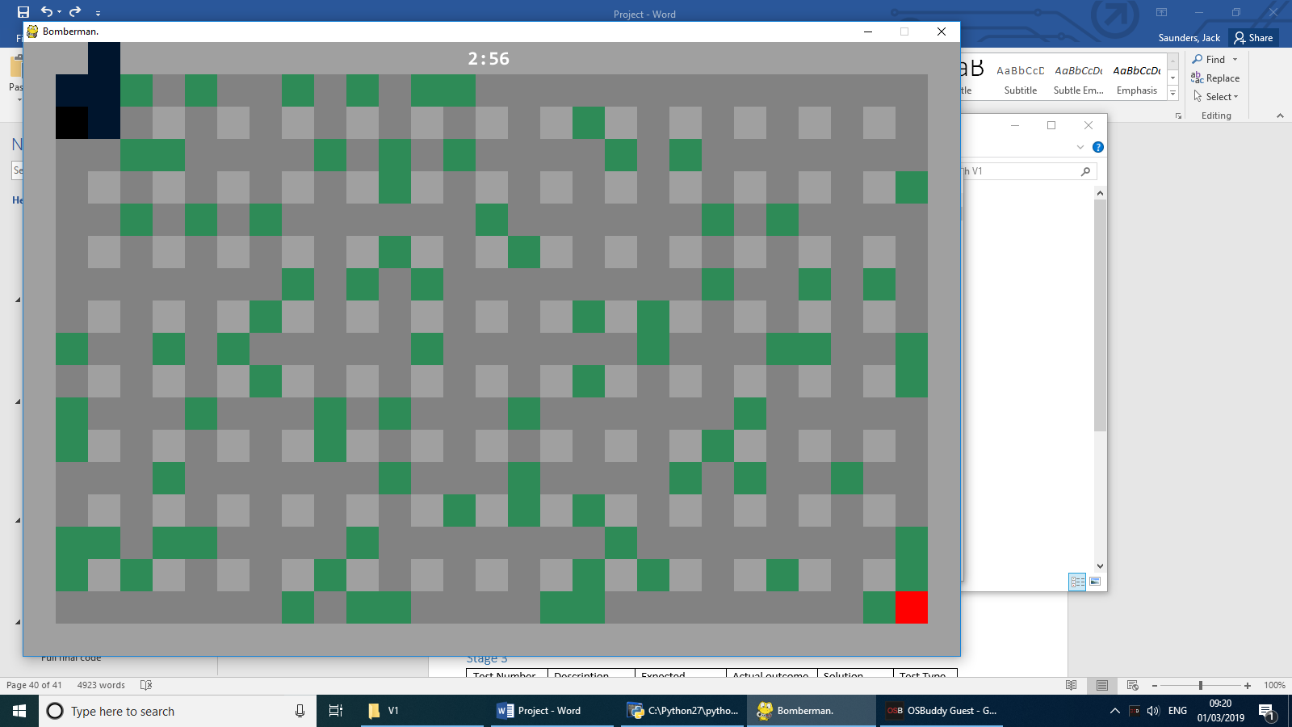The bomb explodes and removes destructible bricks.

Meanwhile, the timer ticks down

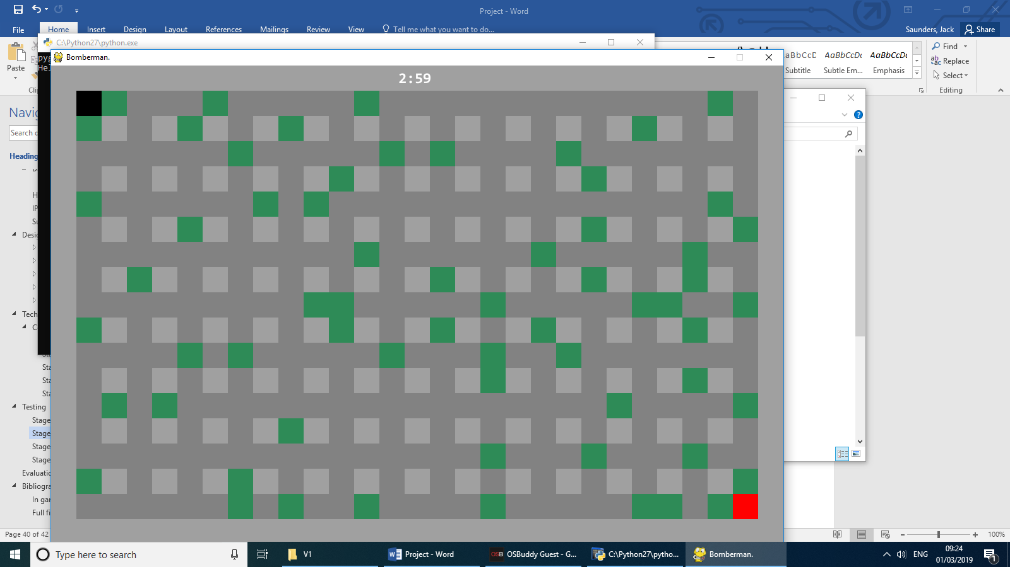

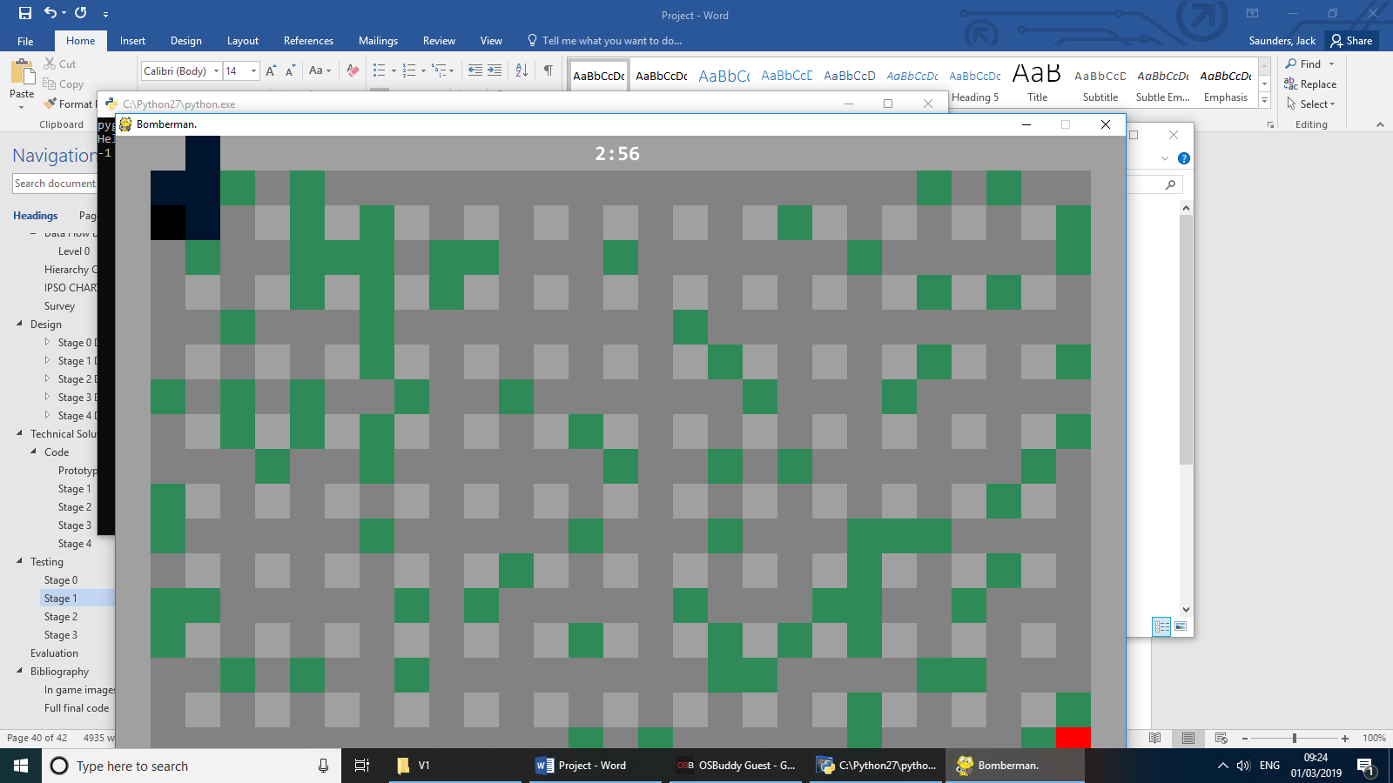

## Stage 2 (Adding a second player)

|  |  |  |  |  |  |
| --- | --- | --- | --- | --- | --- |
| Test Number | Description | Expected outcome | Actual outcome | Solution | Test Type |
| 1 | Arrow keys pressed | Player 2 moves | Player 2 moves | N/A | Standard |
| 2 | Explosion on player preventing movement | Once touched an explosion, player can no longer move | When hit by the other player’s explosion, the player could still move | Each player had personal bombs which only affect them, this was solved in stage 3 by creating two instances of the same class | Standard |

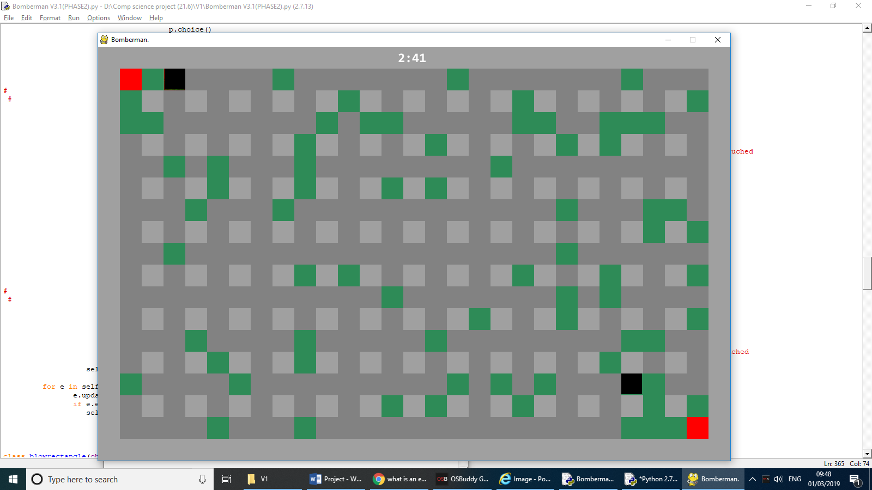

Both players are able to move about the map and independently place bombs.

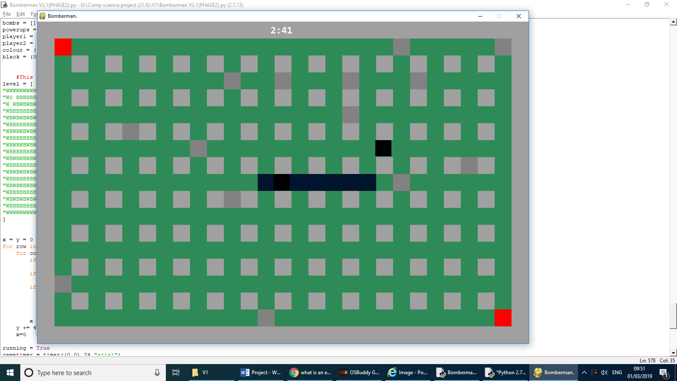 Only the own players bombs originally prevented movement ‘killing’ the player. This was later solved in stage 3.

## Stage 3 (Adding powerups)

|  |  |  |  |  |  |
| --- | --- | --- | --- | --- | --- |
| Test Number | Description | Expected outcome | Actual outcome | Solution | Test Type |
| 1 | Powerups picked up by player | Player collides with powerup, powerup is removed from map and applied to player | Powerup was picked up but not applied to player. | The powerups had to be picked up and applied in the player class so that the local variable can be easily adjusted. | Standard |
| 2 | Explosion on brick | ¼ chance of powerup spawning | ¼ chance of powerup spawning | N/A | Standard |
| 3 | Even variety powerups spawning | Equal amount of each powerups spawn from explosions | Equal amount of each powerups spawn from explosions | N/A | Standard |
| 4 | Instances of players allow two players to play simultaneously | Both players input keys work separately and variables do not affect one another | Both players can move separately and variables do not affect one another | N/A | Standard |
| 5 | Bomb explosions kills players | Player will die if touching any bomb explosion | Player will die if touching any bomb explosion | N/A | Standard |

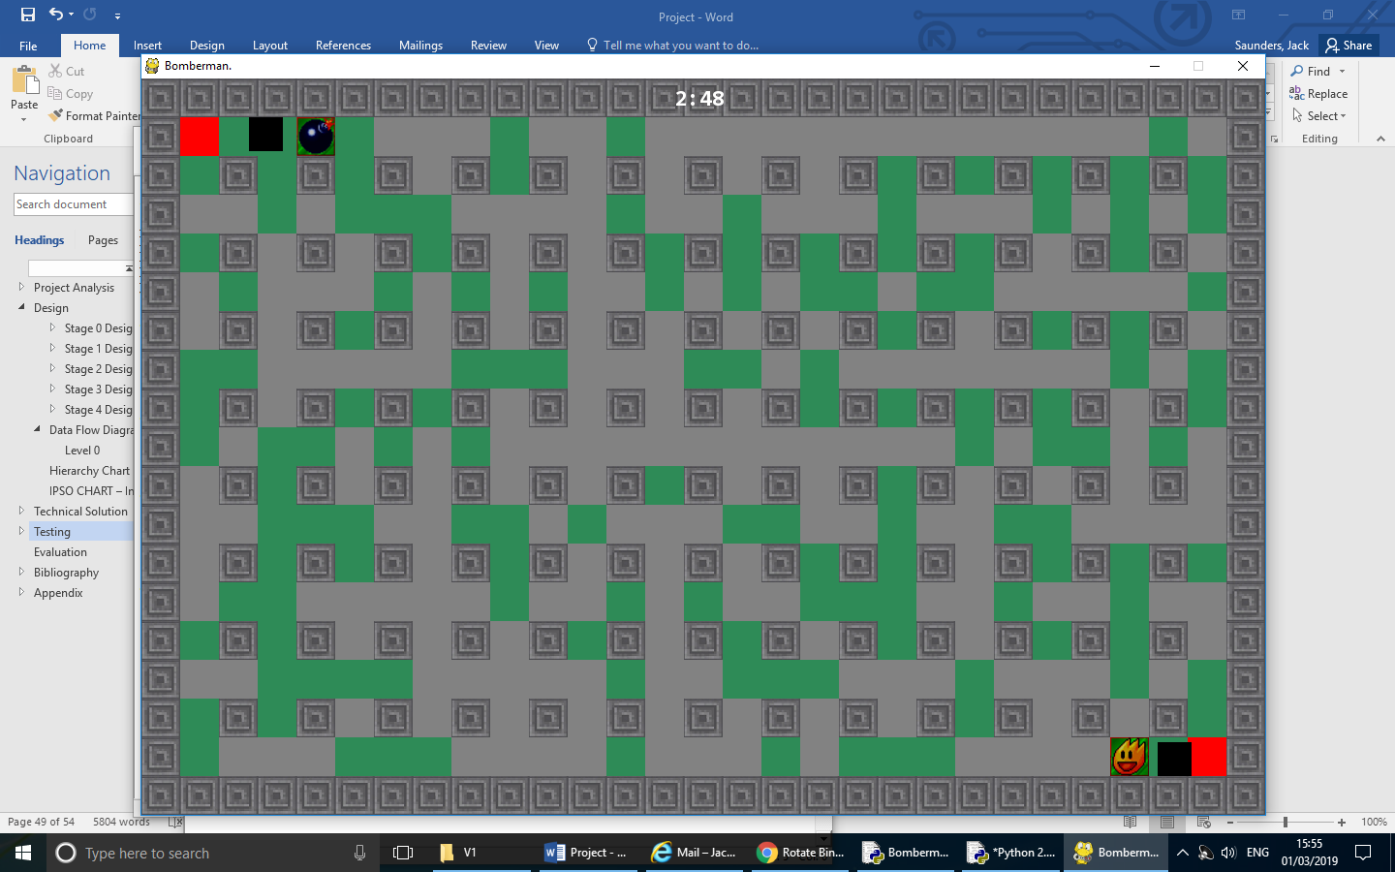

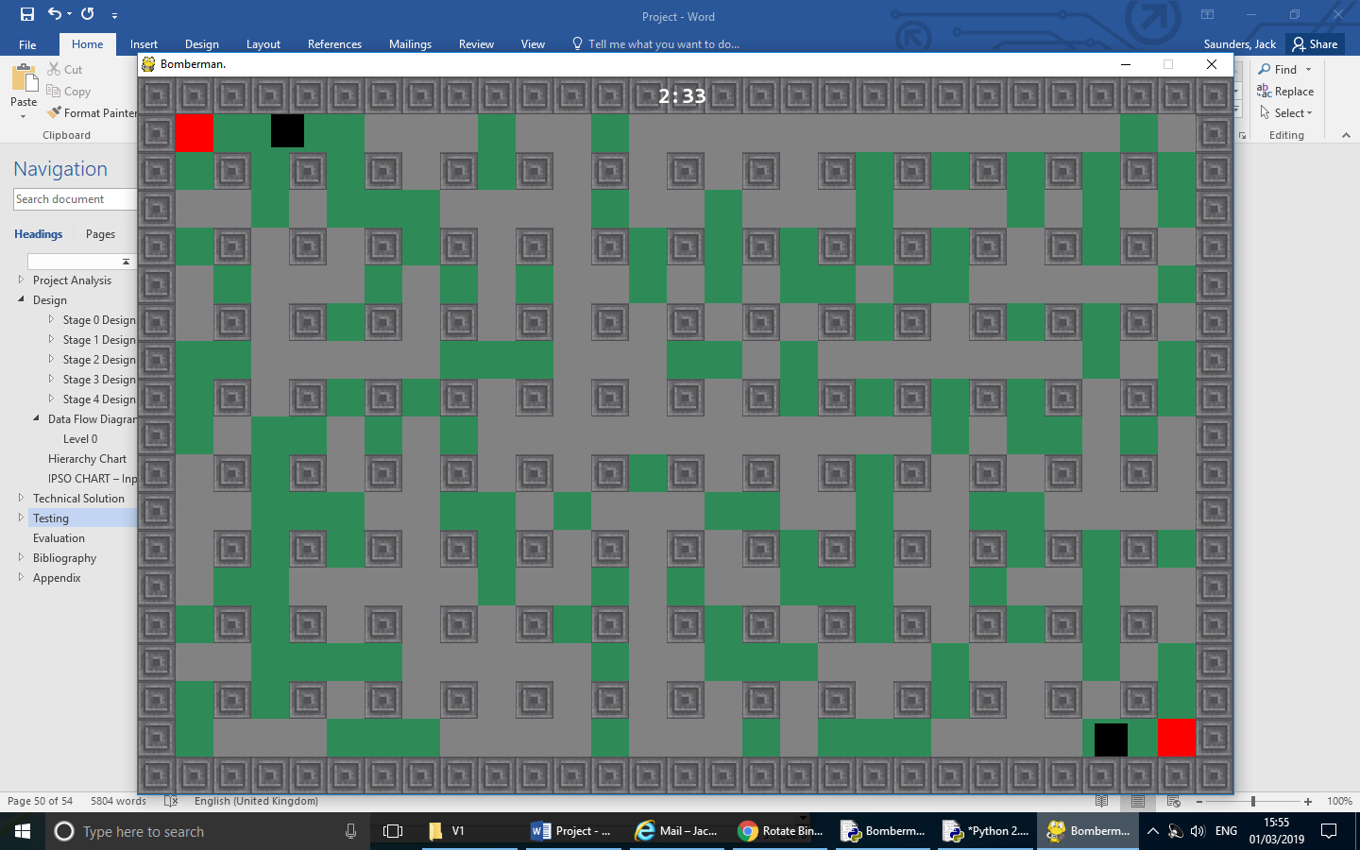

Shows the player picking up a powerup successfully and the chances of a powerup being spawned.

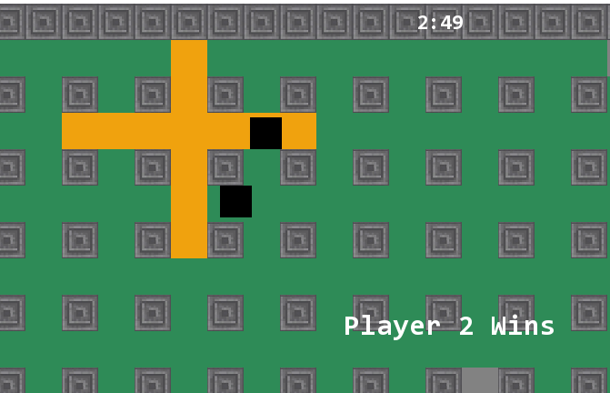

Player 2 has successfully exploded a bomb next to player 1, and player 2 has won the game.

## Stage 4 (Creating a menu)

|  |  |  |  |  |  |
| --- | --- | --- | --- | --- | --- |
| Test Number | Description | Expected outcome | Actual outcome | Solution | Test Type |
| 1 | Name and password input | Inputs are accepted and hidden from a user using * | Inputs are accepted and hidden from a user using * | N/A | Standard |
| 2 | Correct input | Title screen will open for user to play game | Title screen will open for user to play game | N/A | Standard |
| 3 | Incorrect input | Input boxes will empty and a user can retry entry | Input boxes will empty and a user can retry entry | N/A | Standard |
| 4 | User details Encrypted | When entering an input, the characters are encrypted and compared to saved encryption | When entering an input, the characters are encrypted and compared to saved encryption | N/A | Standard |
| 5 | Play/Quit button pressed | Either opens up the game or quit depending on which button has been pressed | Either opens up the game or quit depending on which button has been pressed | N/A | Standard |

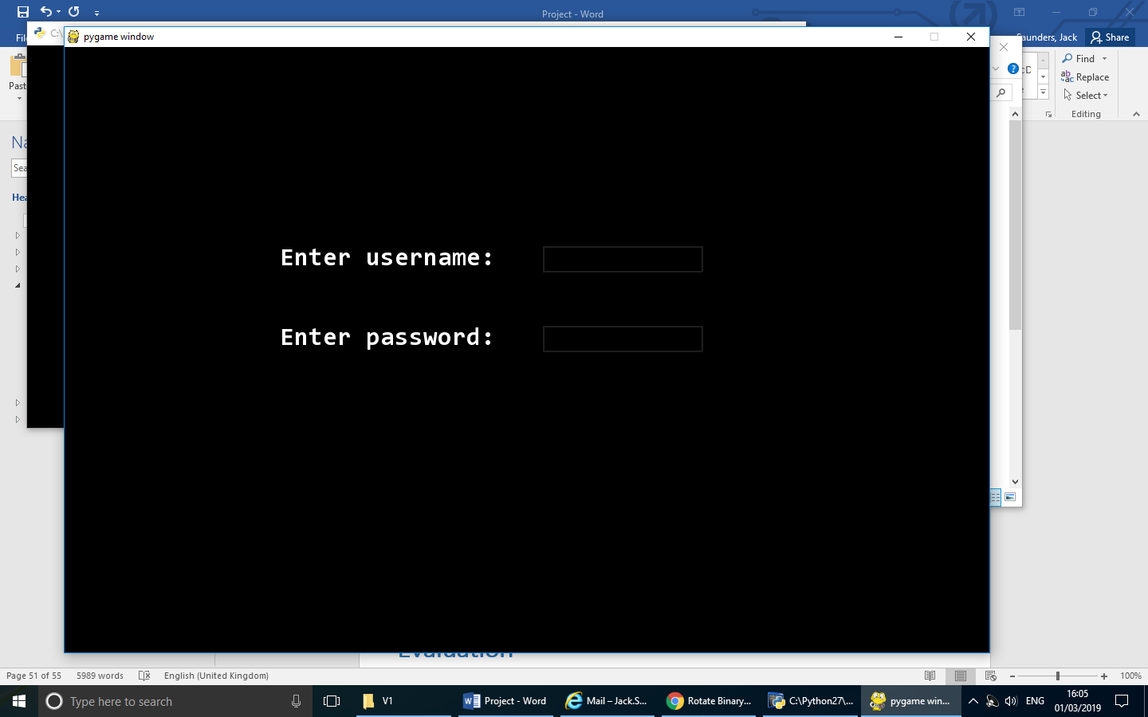Allows a user input for username and password.

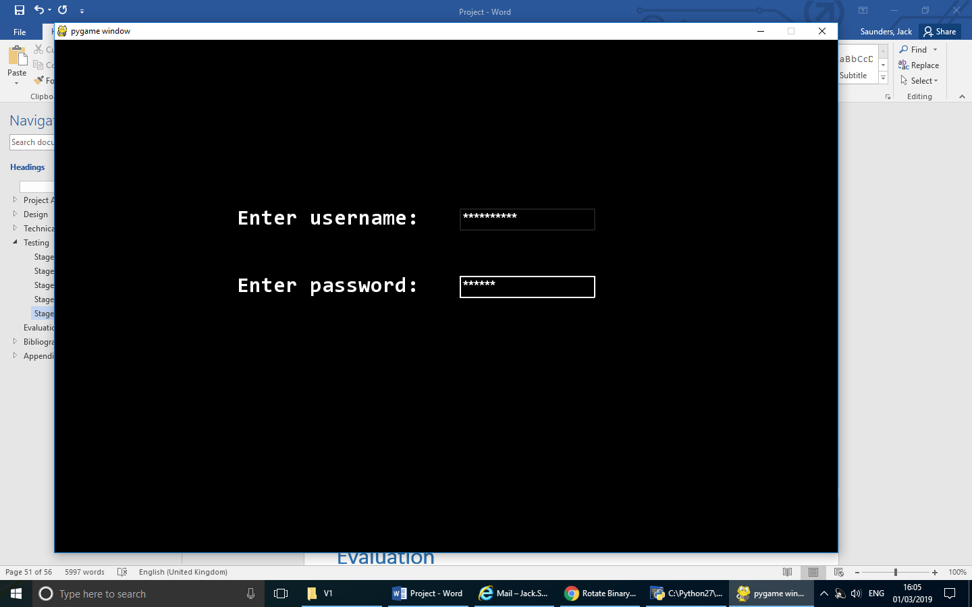 Box highlights and inputted keys are hidden using *

# **Evaluation**

## Did I meet my targets?

Overall, I feel that I suitably met 4 of my 5 aims that I set at the beginning of the project. I feel that I have been able to effectively create complex dynamically spawning objects in the form of powerups. These spawn exactly as planned and worked just as requested by the end users. Secondly, I feel that I have comfortably managed to allow two players to play using the same keyboard while having different controls. Originally my code for this was very inefficient as seen in stage 2, however throughout stage 3 and later I made this code much cleaner and turned it into two instances rather than two copies of the same code. My third objective was to create a login and secure this. I used a hashing algorithm to encrypt the login details used to ensure that a safe account could be made when going into the game. I then created the main menu which allowed me to implement my own personal imports linking the title screen to the account page and main game. The only target which I did not end up achieving was adding LAN to my game. Whilst trying to complete the addition of LAN, I found that the college resources did not allow me to use sockets due to a firewall. This was something which I could not bypass and limited what I could add in. Due to this LAN could not be added.

## Did I manage my time suitably?

I feel that my time management for this project could have been much better. When completing the analysis and early stages of my project, I found that I was very fast and managed to complete a lot of work in a short period of time. However, as I got further into my code, I found that I did not keep up to my predicted timeline, leaving me behind towards the end of the project. Luckily, I have been able to keep up to my deadline to ensure end users are happy.

## Were my end users happy with the product?

The feedback that I have received so far from people that have experienced is very positive. My end users were please with they way there was a secure account to log on with. Not only this, but they also enjoyed being able to play with each other on a single keyboard. This provided users with a nostalgic feeling, just like they would have received back on the SNES when they played on little remotes against one another.

## What would I improve if I were to redo my project?

If I were to redo my project, I would ensure my plans allow me plenty of time for each step. By doing better planning I also can document the project more precisely as I can separate my stage much more defined, such as stage 2 and 3 not carrying over each other. This would have meant I completed all my explosion code in stage 2 and stage 3 could have been much more focused on finishing powerups. I also feel that I could have made areas of my code more efficient, meaning that it is simpler for someone to understand and edit, aswell as making it easier for me to code and create. Feedback from my end users was only gained at the start, early in the project and at the end. This could be improved in future as more regular communication with my end users would allow me to know exactly what I need to accomplish throughout my project.

# **Bibliography**

[1] - <https://en.wikipedia.org/wiki/Bomberman_(1983_video_game)>

Date Accessed - 19/07/18

[2] - <http://www.pygame.org/project-Rect+Collision+Response-1061-.html>

Author – pymike

Date Accessed – 24/08/18

[3] - [http://theologygaming.com/bomberman/](http://theologygaming.com/bomberman/%20)

Author – Zachery Oliver

Date Accessed – 13/09/18

[4][5] - <https://itunes.apple.com/gb/app/bomber-blast-bomberman-game/id1183691909?mt=8>

Author – Nayankumar Patel

Date Accessed – 13/09/18

[6] - <https://gameofbombs.com/>

Author – Ivan Popelyshev

Date Accessed – 13/09/18

[7][8] - <http://store.steampowered.com/app/791930/BombTag/>

Author – David Schneider

Date Accessed – 22/09/18

[9] - <https://stackoverflow.com/questions/46390231/how-to-create-a-text-input-box-with-pygame>

Author – Skrx

Date Accessed – 13/01/19

## Images used in game

Powerup images in game - <http://bomberman.wikia.com/wiki/File:Power_Ups_BDS.png>

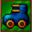

Date Accessed – 12/11/2018

# **Appendix**

## In game images

### Stage 0 (Prototype)

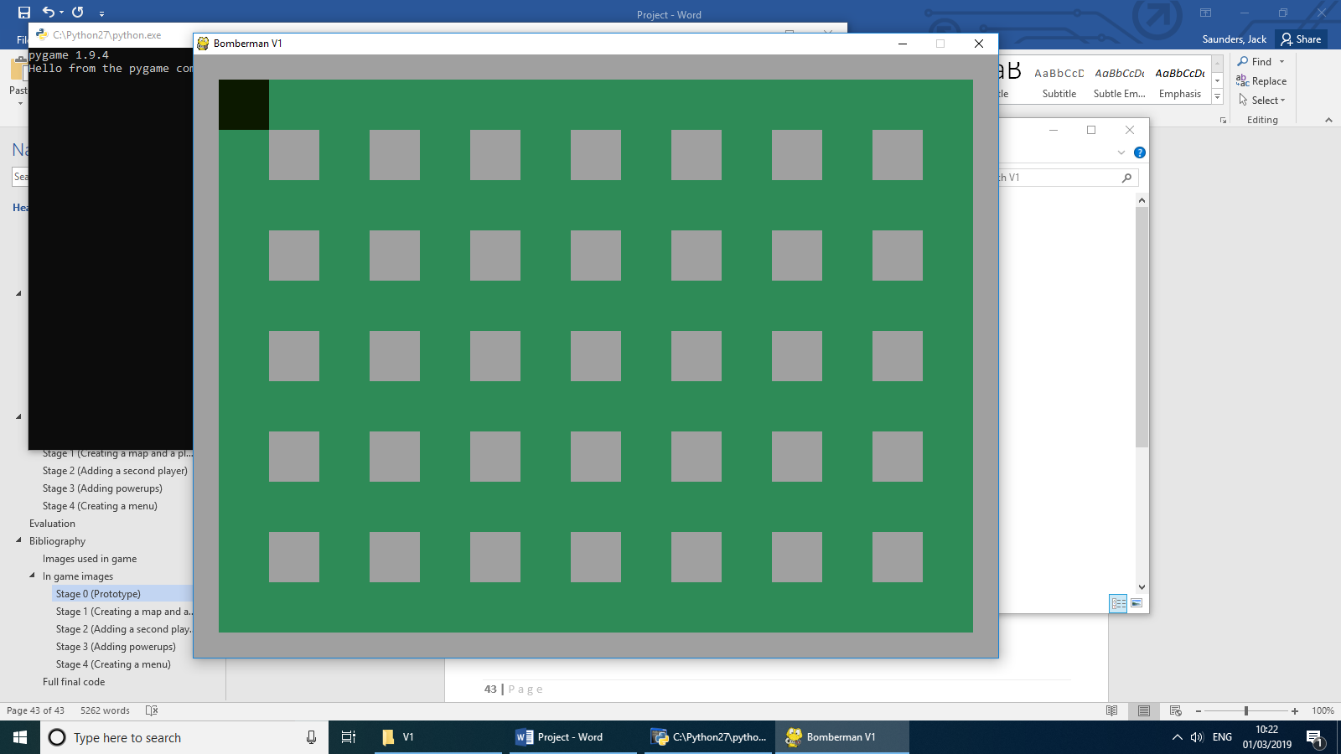

### Stage 1 (Creating a map and a player)

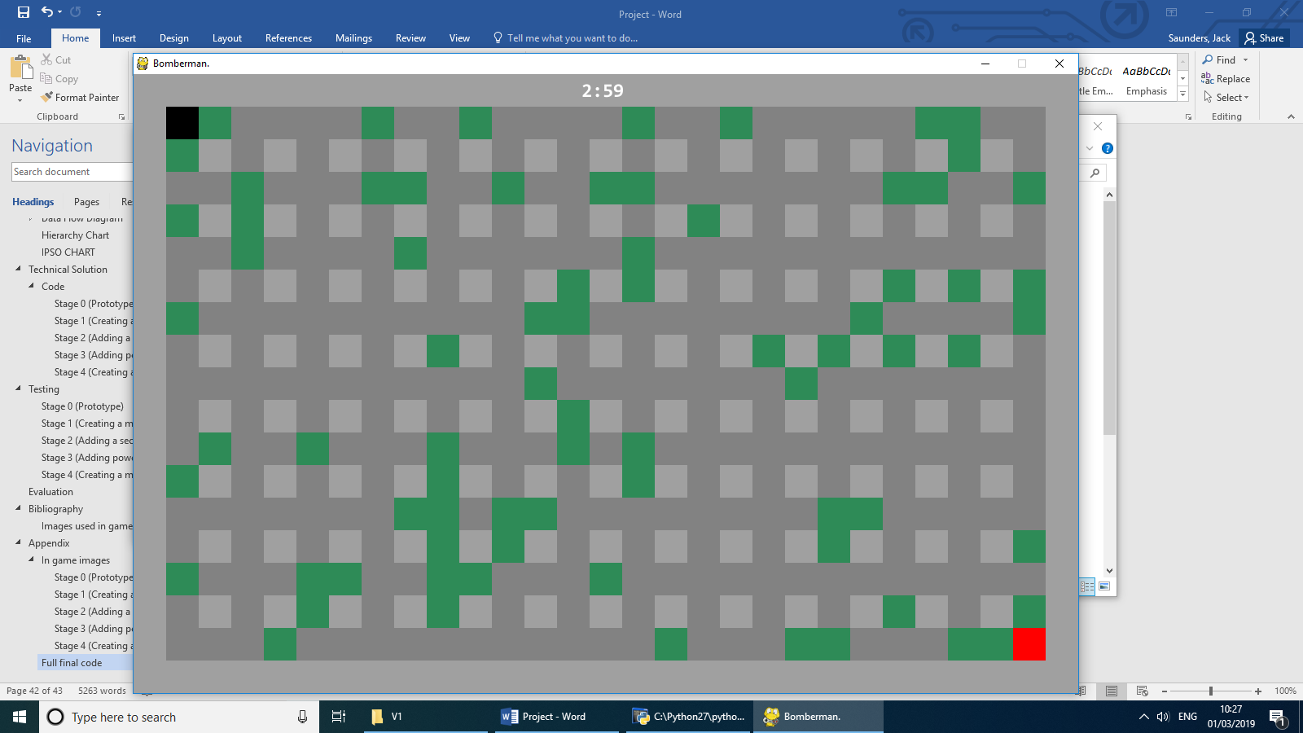

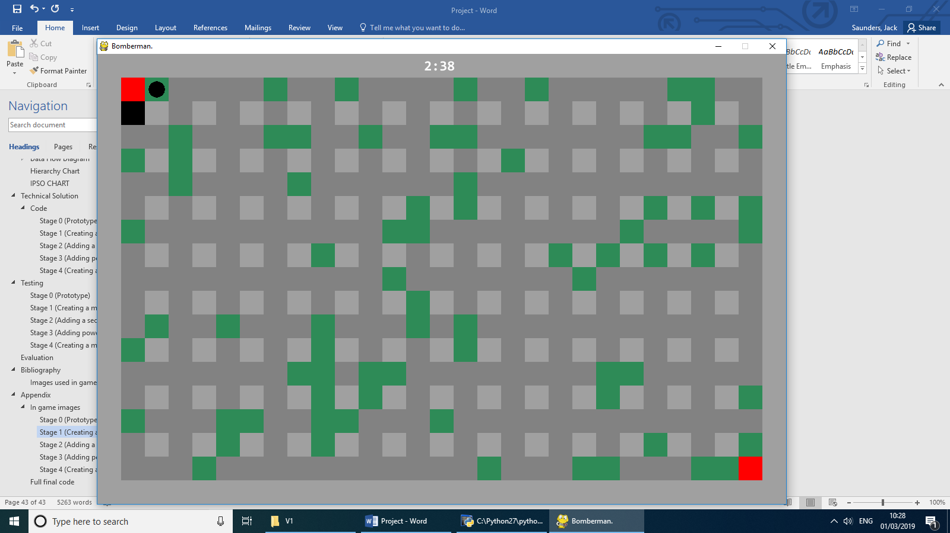

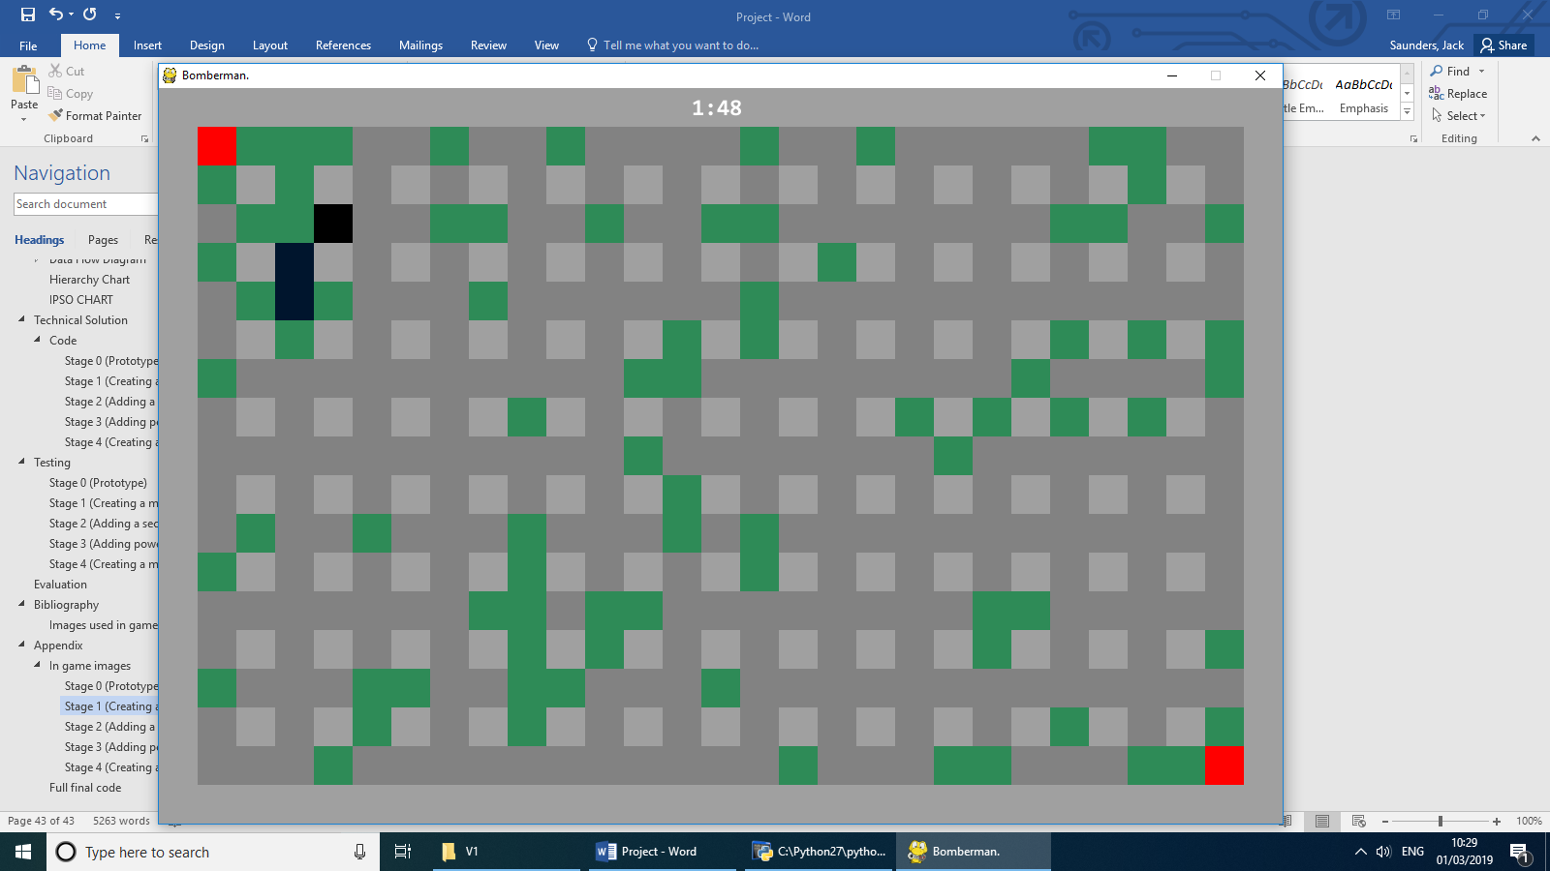

### Stage 2 (Adding a second player)

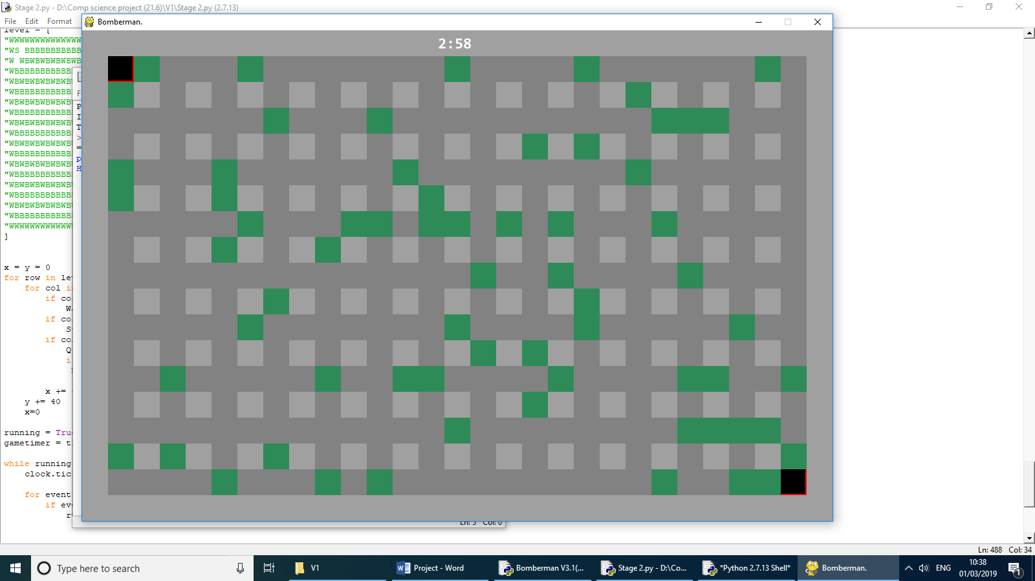

### Stage 3 (Adding powerups)

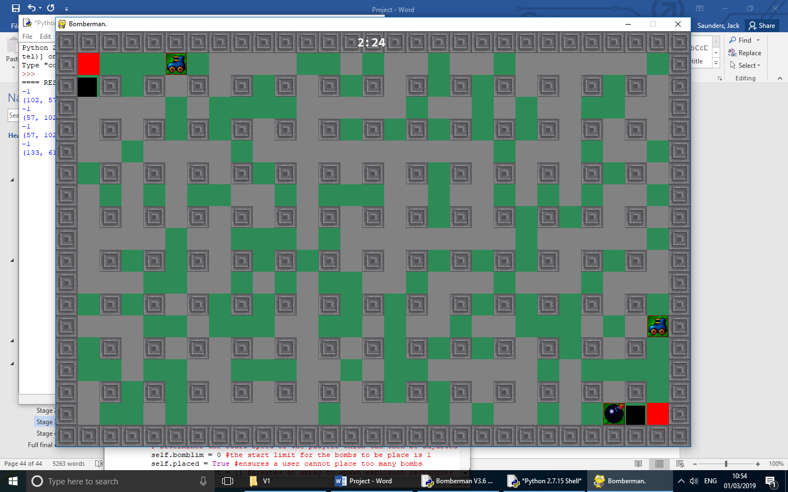

### Stage 4 (Creating a menu)

